FAQs and User Manual – Returns Offline Tool
Goods and Services Tax Network
Designed and Developed by GSTN Page 1 of 117
Table of Contents
FAQs of Returns Offline Tool .................................................................................................. 4
- About Returns Offline Tool ................................................................................................. 4
- Downloading Returns Offline Tool .................................................................................... 6
- Using Returns Offline Tool .................................................................................................. 8
- Using Excel Template for importing data in Offline tool ...........................................11
- Importing Excel in Returns Offline tool..........................................................................13
- Using CSV File Template ...................................................................................................15
- Copy and Paste using the Excel ......................................................................................16
- Generating JSON File by using Returns offline tool ..................................................17
- Uploading JSON File on GST Portal ...............................................................................18
- Generation of Error File and correction of errors .....................................................20
- Preparing Json file by GST Practitioner ......................................................................22
- Preparing IFF (Invoice Furnishing Facility) using Offline tool ...............................23
Manual > Returns Offline Tool ..............................................................................................25
(I) Returns Offline Tool: An Overview ...........................................................................25 (II) Returns Offline tool – Flow Chart ............................................................................26
    - Downloading the latest Returns Offline Tool .........................................................27
    - Installation of the Returns Offline Tool ...................................................................30
    - Creating My Masters .....................................................................................................35
    - Upload Invoice Data (FORM GSTR-1/ IFF) using the Returns Offline Tool ....40
  - Option 1: Manual Entry of Invoice Data in the tool ............................................43
  - Option 2: Import full Excel Workbook consisting of multiple sheets in the
Tool ........................................................................................................................................48

2.1 B2B, SEZ, DE (4A, 4B, 6A, 6C) ................................................................................................................. 50
2.2 Amended B2B (B2BA) ............................................................................................................... 51
2.3 B2CL (B2C Large) ...................................................................................................................... 52
2.4 Amended B2C Large (B2CLA) ................................................................................................ 53
2.5 B2CS (B2C Small) ...................................................................................................................... 54
2.6 Amended B2C Small (B2CSA) ................................................................................................ 55
2.7 CDNR (Credit/ Debit Note) ........................................................................................................ 56
2.8 Amended Credit/Debit Note (CDNRA) ................................................................................... 57
Designed and Developed by GSTN Page 2 of 117
2.9 CDNUR (Credit/ Debit Notes/Refund voucher for Unregistered person) ...................... 58
2.10 Amended Credit/ Debit Note for Unregistered person (CDNURA) ............................... 58
2.11 EXP (Export) .............................................................................................................................. 59
2.12 Amended Export (EXPA) ........................................................................................................ 60 2.13 AT (Liability on Advances on Services) ............................................................................ 61
2.14 Amended Tax Liability on advances Export (ATA) .......................................................... 61
2.15 ATADJ (Advance Adjustments) ............................................................................................ 62
2.16 Amended Advance on Services Adjustments (ATADJA) .............................................. 62
2.17 EXEMP (Nil Rated, Exempted and Non GST supplies) ................................................... 63
2.18 HSN (HSN Summary) .............................................................................................................. 64
2.19 DOCS (List of Documents issued) ....................................................................................... 65
D.3 Option 3: Copy Data from Excel Workbook and Paste in the Tool ................71
D.4 Option 4: Import the CSV file in the Tool ..............................................................76
- Generating JSON File to Upload on GST Portal ....................................................82
- Uploading Generated JSON on GST Portal ............................................................84
- Downloading Error File of FORM GSTR-1/ IFF and Opening it in the Tool ....89 H. Downloading FORM GSTR-1/ IFF Return File and Opening it in the Tool (if
needed) .............................................................................................................................. 97 H.1 Modify Invoices Details ...........................................................................................103 H.2 Add Invoices Details ................................................................................................105
HG.3 Delete Invoices Details .........................................................................................107
- Downloading Form GSTR 2A File and Opening it in the Tool (if required)…110
- Troubleshooting Common Errors Encountered ..................................................115
Designed and Developed by GSTN Page 2 of 117

FAQs of Returns Offline Tool

- About Returns Offline Tool
- Downloading Returns Offline Tool
- Using Returns Offline Tool
- Using Excel Template for importing data in Offline tool
- Importing Excel in Returns Offline tool
- Using CSV File Template
- Copy and Paste using the Excel
- Generating JSON File by using Returns offline tool
- Uploading JSON File on GST Portal
- Generation of Error File and correction of errors
- Preparing Json file by GST Practitioner
- Preparing IFF (Invoice Furnishing Facility) using Offline tool

1.
About

Returns

Offline

Tool

1. What is Returns Offline Tool?

Businesses that generate a large number of invoices in a tax period may find it cumbersome to upload invoices one-by-one. Not only that, it will become a time-consuming activity with huge cost implication. Therefore, to facilitate the upload of invoices in bulk, a Returns Offline tool has been provided for preparing Returns (Form GSTR-1/IFF), in which a taxpayer can add up to 19,000 line items in the offline mode and upload them to the GST Portal in one go.
In case a taxpayer has more invoice data, they can use the Returns Offline tool multiple times to upload the same.
The appearance of the Returns Offline tool is similar to that in the web portal and the functionalities are identical.
Before you download and install the Returns Offline tool, make sure that your desktop meets the system requirements.
This tool can also be used to download and view data in your Form GSTR-2A, auto-populated on basis of returns furnished by your suppliers in their respective Form GSTR.

- Can a taxpayer sign/ submit his/her return in the Offline tool?

No. After upload of the return to the GST Portal, the taxpayer has to generate a summary, verify the correctness of the summary and electronically sign the FORM GSTR-1/ IFF, by either using DSC or EVC. You can also sign/ submit DSC or EVC by logging into the GST Portal www.gst.gov.in.
Note:
  - Click here to know more about Form GSTR-1 online filing.
  - Click here to know more about Furnishing Documents in Invoice Furnishing Facility (IFF) through online mode.

- Is the Offline tool mobile compatible?

No, currently, Offline tool can only be used only on desktops/laptops. Offline tool cannot be used on mobile. For system requirement, please refer (https://www.gst.gov.in/download/returns).

- Where can I find the detailed user manual of the Offline tool?

The detailed user manual gets downloaded along with the Offline tool and the excel workbook template.


2.
Downloading

Returns

Offline

Tool

5. What are the basic system requirements/ configurations required to use offline utility and where can I download them?

The offline functions work best on Windows 7 and above with Internet explorer 10+ and
MSEXCEL 2007 and above. Detailed system required are available at
(https://www.gst.gov.in/download/returns) and also in the readme.txt and the detailed user manual downloaded along with the Offline tool.
If there is any problem in launching the offline tool on some versions of Windows 7, please make sure that the installed browser is Internet Explorer version is 10 or above. It is highly recommended that Internet Explorer 10+ is installed on your system.
Note: One can launch the GST Offline tool by double clicking on the Returns Offline tool icon on the Desktop.

6. How can I download and install the Returns Offline tool in my system from the GST Portal?

- Go to the GST Portal www.gst.gov.in.
- Go to Downloads > Offline tools > Returns Offline tool > Download button.
- Unzip the downloaded files and extract the files from the downloaded zip folder gst_offline_tool.zip. Zip folder consists of the following files as shown below.
  - GST Offline tool.exe file for the Returns Offline tool need to be installed in the local machine (your computer)
  - Section_wise_CSV_files folder which contains .csv file (to upload invoice data entered in the respective files, of all sections, one-by-one for respective tables) Note: CSV file contains some sample data which has been provided for reference purpose only. Sample Data must be deleted before filling the actual data in the template.
  - FORM GSTR-1_Excel_Workbook_Template.xlsx file (to import invoice data entered in the respective worksheets, of all sections, at one go)
  - Readme.txt file that explains in detail the prerequisites for the Returns Offline tool
  - Invoice Upload Offline tool User Manual detailing out the guidance for taxpayers to use Returns Offline tool.

- Install the Returns Offline tool by double clicking the GST Offline tool.exe set up file and browse the location where you want to save the Returns Offline tool files in your computer. Note: Avoid installing the Returns Offline tool in the same location where you have saved the zipped files.

- The shortcut icon of the Offline tool with name GST Offline tool will appear on the desktop.

The Offline tool icon will appear as shown below:



- A free Excel based Returns Offline tool along with the excel workbook template of FORM
GSTR-1/ IFF can be downloaded from the GST Portal
(https://www.gst.gov.in/download/returns) and these can be used to prepare FORM GSTR-1/ IFF, in offline mode without internet connectivity. You can fill the invoice details in the Returns Offline tool manually or use sample templates.

Important Note:
  - In case, User un-installs the Tool and re-installs the Tool, they must ensure that they are using the latest version of the tool (which can be downloaded from GST Portal). They must also delete the previous version of the tool and then re-install the new tool at the same location. In such a case, where previous version of the tool is uninstalled, the data saved in previous version of the tool, will also be deleted.
  - In case, User re-installs the Tool on different location, they have to restart the system, so that Tool refers to the new location. If user doesn’t restart the system, Returns Offline tool will refer to the old path, where the earlier version of the tool was installed and they will not be able to open the new Returns Offline tool, using the latest path of the tool.

3.
Using

Returns

Offline

Tool

7. Can I prepare quarterly return GSTR-1 or IFF using offline tool?

Yes, you can prepare quarterly FORM GSTR-1 or IFF using the Offline tool. You need to select the quarter ending month and include the invoices of the three months in the Offline tool and generate the JSON file and upload it to GST Portal.

- What options are available for the taxpayer to fill Invoice data in the Returns Offline tool?

Once you have downloaded and installed the Returns Offline tool, you can use any of the four options to upload/fill the invoice data.
Option 1: Manual Entry of Invoice Data
Option 2: Import Excel Workbook consisting of multiple sheets
Option 3: Copy and Paste from Excel Workbook Option 4: Import the csv file

- Do I need to generate invoices on computer for preparing the excel sheet?

No, you can prepare FORM GSTR-1/ IFF in case of handwritten invoices also, by either
  - Entering the required details of handwritten invoices in the excel workbook template and then importing them in the Returns Offline tool to prepare the JSON file or
  - Enter the details directly in the Returns Offline tool to prepare the FORM GSTR-1 /IFF file in JSON format.

- Will the offline tool provide appropriate error messages or alerts in case of wrong data entry?

Yes. The Offline tool will provide appropriate error messages or alerts in case of wrong data entry or in case the mandatory field is not filled in.

- How will I know what fields are mandatory and non-mandatory?

Please refer to the Help Instruction Sheet in the excel workbook which mentions about the mandatory and non-mandatory fields. In the Returns Offline tool all the mandatory fields are marked with asterisk “*”.

- How can I update my invoices in the Offline tool?

The invoice details in the Returns offline tool gets updated, if the same invoice details are again entered in the excel workbook template and imported in the Returns Offline tool. Invoices can
of 117
also be updated directly in the offline tool, if the excel workbook data is already imported in the Returns offline tool.

- Can I use the Offline tool to upload only the invoice details of supplies made to registered taxpayers?

Yes. The taxpayer can enter the details only of the invoices of supplies to registered taxpayers in the B2B, SEZ, DE (4A, 4B, 6A, 6C) worksheet of excel workbook template and by importing it in the Returns Offline tool or enter directly in the b2b section of the offline tool, generate a JSON file and then upload it to the GST Portal.

- Can date of shipping bill be later than date of tax invoice?

Date of shipping bill can be prior or after the date of tax invoice in table 6A (Exports) and amendment table 9A, in FORM GSTR-1/ IFF.

- How can I upload the invoice data on the GST Portal using the Returns Offline tool?

After generating the return file in JSON format through Returns Offline tool, login to the www.gst.gov.in URL for uploading the invoices. Navigate to Services > Returns > Returns Dashboard > PREPARE OFFLINE option.
Note: Ensure that you are connected to the Internet to upload the JSON file to the GST Portal.

- How many maximum number of invoices can be uploaded through Returns Offline tool in one go?

You can add up to 19,000 line items comprising of all the different sections like B2B, SEZ, DE (4A, 4B, 6A, 6C) and b2c (large) in an offline return. There may be several line items in an invoice and hence the number of invoices that can be uploaded must be less than 19,000. The file generated for 19,000 or less line items can be uploaded to the portal at one go. In case you have more invoice data, you can use the tool multiple times to generate the JSON file to upload the invoice data.
However, one needs to be careful, if the same record has been uploaded earlier and is also present in subsequent uploads, the earlier record will get overwritten.

- I see differences in summary displayed in the Offline tool and that on the GST portal, after upload of JSON file. What could be the reasons?

Differences in summary displayed in the Offline tool and that on the GST portal, after upload of JSON file, could be because of following reasons:
  - Correctness of GSTIN of Buyers (whether GSTIN is active or not) is checked. If GSTIN is not active, then invoices will be rejected on uploading of JSON on the portal.
of 117

  - Duplicate invoice number is checked, with respect to data uploaded earlier on the portal by the taxpayer. As the data uploaded later, in certain circumstances will over- write the earlier data, as available on the Portal.
Discrepancy may also arise if the summary in the tiles on FORM GSTR-1/ IFF are not updated.
One has to click “Generate FORM GSTR-1/ IFF Summary” button at the bottom left part of FORM GSTR-1/ IFF page, to update the summary.
- I have uploaded 100 invoices but only 85 invoices are visible on the GST Portal. Why?

It means that the remaining 15 invoices have been rejected due to validation failure at the GST Portal. Error log for same will be created & the error file can be downloaded from GST Portal, in a JSON file format and the same can be opened using the tool. After rectifying the errors and generating the JSON, invoices can be submitted again.

- Can I edit invoices uploaded through Returns Offline tool in the GST Portal?

Yes, you can edit the invoices uploaded through Returns Offline tool in the GST Portal, before the return is submitted for processing.
4.
Using

Excel

Template

for

importing

data

in

Offline

tool

20. What is multi section excel and where it is available?

You can add invoice details in the multi section excel (containing multiple workbooks for different tables in a single excel file). It is available as part of the downloadable zip file.

- Is there any fixed format for naming the Excel workbook?

There is no fixed file format, but user can rename as per their convenience.

- Can I use the same Excel workbook Template to prepare files of different GSTINs?

Yes. Separate Excel workbook Template with different name can be prepared by the Taxpayer for different GSTINs on the same computer. These different excel files can be imported in the Returns Offline tool to generate the JSON file for different GSTINs for uploading it on the GST Portal.

- Is it mandatory to fill all sections in multi section excel file? Can I use multi section excel file even though I have limited or only few section data?

Filling all the sections of the excel worksheet is not mandatory. You can use the excel worksheet to enter data only for selected sections. Remaining sections can be kept blank. The Returns Offline tool will generate the JSON file only for the data in filled sections.

- Will the offline excel template do any validation checks? If yes, what are the checks that can be performed?

Structural validations checks that can be carried out in offline mode are done in the Returns Offline tool. The excel tool has only a few format restrictions like date format, GSTIN format.

- In the FORM GSTR-1/ IFF Excel workbook, only tax rate and taxable value are mentioned. Can I edit the tax amount?

Yes. If the tax collected or liable to be paid by the taxpayer is different form the computed tax rate, they can edit the tax amounts displayed in the Returns Offline tool.
- What details to be captured in the Offline tool or excel to update the shipping details? Full invoice details or only the shipping details?

Shipping details are not mandatory at the time of uploading export details. The shipping bill number for the export invoice can be furnished later through the amendment table.
- Are negative values allowed in excel/Offline tool?

No, the Offline tool will not allow any negative values for value, taxable value or tax amounts.
5.

Importing

Excel

in

Returns

Offline

tool

28. | Can I add the new data to previous imported excel data and import again in the Offline
too
l?

Yes, you can add new invoice details to previous imported excel data in the Offline tool by entering new invoice data in the excel workbook template and importing again. The new invoice details will overwrite the earlier details.

29. Can I modify or delete the data imported through excel in the Offline tool?

Yes, the data imported in the Offline tool from the excel workbook template can be modified or deleted in the Returns Offline tool.
30. While importing data in Offline tool - FORM GSTR-1/ IFF, there is discrepancy in the
number of invoices and other details, which are filled in excel and that on the offline
tool. What could be the reason?

This arises because of validation checks performed by the Returns Offline tool, after data from excel sheet is imported into it. The invoices and other data that fail checks/validations are rejected by the offline tool. Use of different format of excel template, without validations, also leads to rejection of data on import to offline tool. Thus, taxpayers are advised to use excel templates provided by GSTN, as part of free offline tool, to avoid such mistakes and rejection of data.

- If I have imported the excel in the Offline tool. Can I change the data in excel and import again? What will happen if I import the excel again? Will the data get overwritten or rejected?

Yes, you can import after changing the data in the excel. If the data is imported again:
  - Then the earlier declared invoice details are overwritten by the later uploaded invoice details.
  - In B2CS section in which consolidated details POS and rate wise has to be furnished, if the lines with same POS and rate are again uploaded, the earlier declaration gets overwritten. However, in this section if for the same POS, details of a rate different from the earlier uploaded rate is again uploaded, it gets added to the earlier uploaded data.
In other sections in which consolidated data has to be uploaded like AT, ATADJ, HSN, Exempted etc., all the details uploaded earlier will be overwritten.
- When I import excel in the tool, with records having invalid details and such fields are non-editable, then records are appearing in red block, as if the data is incorrect. How can I correct this data?
You need to delete the specific invoice and then add a new invoice with the correct invoice details. The unique details cannot be edited by the user.

- In case of summarized information table (Ex: Nil/AT/HSN Summary) other than B2CS summary, what will be the impact of subsequent uploads? When the details will be appended and when it will it replaced?

In case of sections where summarized information is to be uploaded, the later uploads will completely overwrite the data of the whole section uploaded earlier.

- What are the reasons for rejection of data while importing excel or CSV file in offline tool?

Few reasons for rejection of data while importing excel or CSV file in offline tool are:
  - Incorrect data format entered in excel. The date format must be dd-mmm-yyyy only (eg 01-Jul-2017)
  - Incorrect invoice format entered in excel, invoice number must be maximum 16 digit and alphanumeric. Special Characters allowed are / (i.e. forward slash) and – (i.e. Hyphen) only. There must not be any duplicate entry of invoices.
  - Incorrect GSTIN Format entered in excel. GSTIN entered must be of 15 character & alphanumeric with no blanks or special character in between.
  - Incorrect data entered after decimal. Only two digits need to be entered after decimal.

35. I am using third party accounting software for invoice generation. Can I generate
Excel File as per the template from the accounting software and import it in the tool? Or
I need to enter the details again?

If the invoice upload and excel file generated by the third party is in the same format as provided in GSTN’s excel workbook, the same can be uploaded. Else, third-party accounting software can generate details in .csv format which is also supported by the Offline tool. The .csv format file generated by the third-party accounting software can be imported in the Offline tool.
.

6.

Using

CSV

File

Template

36. What is csv file?

Offline Tool support upload of record details in the .csv format. The .csv format refers to comma-separated values format.

37. How many types of csv file are there as part of the Returns Offline Tool?

There are 19 csv files part of the Returns Offline Tool downloadable zip file.
- B2B, SEZ, DE (4A, 4B, 6A, 6C)
- B2BA
- B2BCL
- B2BCLA
- B2CS
- B2CSA
- CDNR
- CDNRA
- CDNUR
- CDNURA
- EXP
- EXPA
- AT
- ATA
- ATADJ
- ATADJA
- EXEMP
- HSN
- DOCS
7.

Copy

and

Paste

using

the

Excel

38. How can I use the copy excel and paste facility in the returns offline tool?

You need to select data from an excel worksheet (available as part of the downloadable zip file (and not any other excel)) from the topmost left corner to the bottom most right corner which needs to be copied and click copy and then paste it in the Offline tool in the window indicated for copying after selecting the tab of “copy from excel” in the “import file” tab.

39. Copy & Paste excel option is showing error as invalid input. What it means?

Please ensure while copying the data you have copied the header sections (Top 4 rows of sheet) along with the Header data from Row1 of the sheet.
8.

Generating

JSON

File

by

using

Returns

offline

tool

40. What will be file extension of generated file from Offline tool for FORM GSTR-1/ IFF?

A JSON file with file extension .JSON gets generated from the Offline tool. Once the JSON file is generated from Offline Tool, by default the JSON file will be named in the below format:
retruns_ReturnPeriod_Returns_GSTIN of Supplier_offline.json
Note: Maximum size of the JSON file must not exceed 5 MB. Right click on the file and click on Properties to see the size of the JSON file.

- What will happen if the file size of generated JSON is more than 5 MB?

GST Portal doesn’t allow the JSON file to be uploaded with file size more than 5 MB. If the JSON file is more than 5 MB, then:
  - Delete some of the invoices in order to generate the JSON again with file size less than 5 MB.
  - As a next step, you can add the deleted invoices afresh in the returns offline tool and generate the JSON file again, to upload the same on the GST Portal.
  - You can follow the same process to generate multiple JSON files with file size less than 5 MB unless all invoices are converted into JSON format to be uploaded on GST Portal. You must be careful while naming the saved JSON files to distinguish them.

- Can I generate multiple JSON files for a single tax period?

Yes. You can generate multiple JSON files for a single tax period depending on the volume of data to be captured for the return.
By default, generated JSON will be saved in the Downloads folder. You can also choose a different location to save the same.
9.

Uploading

JSON

File

on

GST

Portal

43. What happens if I am not connected to Internet while uploading the JSON file on the GST Portal?

JSON file generated through the Returns Offline tool can be uploaded to the GST common portal only when you are connected to the GST Portal through the Internet.

- Can a taxpayer prepare his/her FORM GSTR-1 /IFF by preparing the .JSON file of different sections of FORM GSTR-1/ IFF and upload it to the GST portal?

Yes, a taxpayer can prepare his/her FORM GSTR-1 /IFF by preparing the .JSON file of different sections of FORM GSTR-1/ IFF and upload it to the GST portal.

- Will the JSON file created by Offline tool directly get upload to GST Portal?

JSON file created by Offline tool can be uploaded to GST Portal by:
  - Logging in to the GST Portal using valid credentials.
  - Navigating to PREPARE OFFLINE button available on return dashboard in FORM GSTR-1/ IFF tile.

- What are the basic checks that I have to do in the Returns Offline tool to ensure successful upload of JSON file on the GST Portal?

You need to check that section wise all fields are filled properly without any error or omission. Offline Tool will highlight fields having errors in RED color. Please ensure you fill the template as per the instructions provided in the Excel template.

- I am using third party tool for invoice generation. Can I generate JSON file directly from the Tool and upload?

If the JSON format generated by the third-party tool is in the same format specified by the GST portal, then you can upload the JSON directly.

- When I uploaded the JSON on the GST portal it has generated the reference ID but I am unable to see the Invoice details added?

GST Portal will take few minutes to display the invoice details in the summary.

- How can I verify whether my invoices have successfully uploaded or not?

If the number of invoices visible on the top right corner of B2B, SEZ, DE (4A, 4B, 6A, 6C) tile increases by the number of invoices for which JSON file was created, then all the invoices have been successfully uploaded.
Note:
  - You can view the uploaded invoice details online by double clicking on the B2B, SEZ, DE (4A, 4B, 6A, 6C) tile if the number of invoices is less than 500.
  - You can see upto 500 invoices in each section of FORM GSTR-1/ IFF.
  - If the number of uploaded invoices is more than 500, you need to download the invoices and view the details in the Offline tool.
  - You need to download the uploaded invoice and delete or modify them in the offline tool and again create the JSON file and upload on to the GST Portal. The invoices with delete flag will get deleted.

- Where can I see my uploaded invoices on the GST Portal?

The uploaded invoices can be seen by logging on to the GST Portal with valid credentials and clicking the B2B, SEZ, DE (4A, 4B, 6A, 6C) tile on the FORM GSTR-1/ IFF page. The top right corner of the tile displays the total number of invoices successfully uploaded on the GST Portal.

- How can I check the status of uploaded invoices, if I have submitted the same through Returns Offline tool?

You can check the status of the uploaded invoice details on the Portal once JSON file is uploaded to the Portal. As soon as the JSON file is uploaded to the Portal, a reference id is generated, along with its status on the Portal. Once the upload is successful, the summary of the invoices uploaded is updated in the respective section of the draft return.
Designed and Developed by GSTN Page 19 of 117

10.

Generation

of

Error

File

and

correction

of

errors

52. What is error file?

If the upload of invoice details is processed with error after uploading it to the GST Portal, then the status will change to Processed with Error and the Error Report column will display a link to Generate error report. This error files are downloaded in JSON format. You can open the downloaded error files in Returns offline tool and correct the errors. Some of the validations on GST Portal while uploading JSON are:
  - The Returns Offline tool requires the taxpayer to enter his/her own GSTIN as Supplier and the generated JSON file will contain the GSTIN of the particular supplier. In case you try to enter a different GSTIN and attempt to upload the JSON, the GST Portal will throw an error. JSON file with supplier’s GSTIN other than theirs will not be allowed to be uploaded in their login.
  - Date mentioned in invoice is earlier than the date your supplier got his/her GSTIN registration done.

- Where can I find the error file if some error occurred during upload JSON?

If the upload is processed with error, a generate error link would be visible on the upload page, clicking which will generate an error file after around 15 minutes. Once the error file is generated a link will be visible for downloading the error file.
The error file has the extension .zip. And it can directly open in the Returns Offline tool.

- How can I make changes to transactions already uploaded on GST Portal?

You can make changes in the excel and generate JSON file and upload the JSON again on the GST Portal as the data will be overwritten on the GST Portal. This is possible only before the filing of return on the GST Portal using DSC/EVC.

- When will the GST Portal display "Enter valid GSTIN/UIN" error message?

In case taxpayer has entered invalid/wrong GSTIN or the structure of GSTIN is not in specified format, then the GST Portal will display “Enter valid GSTIN/UIN” error message in the error report.

- How do I open and correct my incorrect invoices rejected by the GST Portal while uploading JSON?
The error files can be downloaded in JSON format. The downloaded error file can be opened in the Returns Offline tool and correction and modification can be made, in the opened error file.
You can view one error file at a time in offline tool.
11. Preparing Json file by GST Practitioner
57. I am a GST Practitioner. I used to prepare Excel workbook for more than one
taxpayer. Suppose I wrongly generated the JSON fie pertaining to X taxpayer instead of Y
taxpayer. Is there a mechanism for restricting such wrong upload?

Yes. The Returns Offline tool requires the taxpayer to enter the GSTIN of the taxpayer whose return is being prepared and the generated JSON file will contain the GSTIN of the particular tax payer i.e. X. If by mistake JSON of X taxpayer is attempted to be uploaded for taxpayer Y after log in, the GST Portal will throw an error.
JSON file of X taxpayer will not be allowed to be uploaded in Y taxpayer’s login.

58. Can the taxpayer or GST Practitioner prepare return of several registered entities of the same PAN or different PAN after installing the Offline tool on his/her computer?

Yes. A taxpayer or GST Practitioner can prepare FORM GSTR-1/ IFF of several registered GSTINs from a common Offline tool. The tool prepares JSON files for different GSTINs in with different name in the default format DD-MM-YYYY _FORM GSTR-1_SupplierGSTIN. This format can be changed by the taxpayer or GST Practitioner as per his/her convenience.

Thus the ‘default name’ of JSON file generated from the tool will have details of GSTIN and Tax period for easy identification.

12.

Preparing

IFF

(
Invoice

Furnishing

Facility)

using

Offline

tool

59. What is Invoice Furnishing Facility (IFF)?

Invoice Furnishing Facility (IFF) is a facility provided to quarterly taxpayers to file their details of outward supplies in first two months of the quarter (M1 and M2). The facility will be similar to FORM GSTR-1 but will allow filing for details related to only following tables:
- B2B, SEZ, DE (4A, 4B, 6A, 6C)
- 9B – Credit/ Debit Notes (Registered)
- 9A – Amended B2B Invoices
- 9C – Amended Credit/ Debit Notes (Registered)
In case, you have selected Quarterly filing, only above 4 tables will be available as a drop- down list in Returns Offline Tool for M1 and M2 of the quarter for preparation of IFF.

60. What are the pre-requisites for filing IFF?

Pre-requisites for filing IFF are:
- The taxpayer must be a registered taxpayer as regular or opted in or opted out of composition.
- The taxpayer must have a valid User ID and password.
- The taxpayer must have opted to file Form GSTR-1 on quarterly frequency.
Note: Invoice Furnishing Facility (IFF) for Form GSTR-1 is effective only from January 2021 onwards.

- Will IFF option be available every month?

No, IFF option will be available for first two (2) months (M1 and M2) of every quarter. The option to file such invoices will expire by the 13th of the next month. For example, the facility for the month of January will expire by 13th of February. For the third month (M3) of the Quarter, the taxpayer is expected to file the normal Form GSTR-1.
Note: In case you have selected M3 of any quarter, IFF option will not be available to you in Returns Offline Tool.

- Do I have to re-enter the details entered in IFF in the Form GSTR-1 (M3) for the quarter?

No, once details have been filed in IFF, the same need not be filed again in Form GSTR-1 (M3) for the quarter. For Example: If record INV-101 is entered and filed in Jan 2021 in Form IFF, then you do not need to provide same details for INV-101 in March 2021 in Form GSTR-1.

- Does IFF include all the tables that are there in Form GSTR-1/ IFF?
No, IFF includes only following tables, in which you are expected to fill details.
- B2B, SEZ, DE (4A, 4B, 6A, 6C)
- 9B - Credit / Debit Notes (Registered) - CDNR
- 9A - Amended B2B Invoice - B2BA
- 9C - Amended Credit/ Debit Notes (Registered) – CDNRA

- Do I need to compulsorily file my invoices in M1 and M2 of every quarter in the IFF?

No, IFF is an optional facility provided to quarterly taxpayers only. However, if IFF is in Submitted status, then filing of IFF is mandatory. In case, submitted IFF is not filed then taxpayer cannot file their Form GSTR-1 for the quarter.

Note: In case you have generated JSON in Returns Offline Tool for IFF and uploaded on GST Portal and submitted the same, then filing of IFF is mandatory on GST Portal.

- What happens if I import excel that has all the tables that are there in Form GSTR-1/ IFF?

In case, you import excel that has tables other than 4A, 4B, 4C, 6B, 6C - B2B Invoices, 9B – CDNR, 9A – B2BA, and 9C – CDNRA then entire excel file will be rejected.

- When is the End date to submit IFF?

The End date to submit IFF is 13th of succeeding month.
For example, the End date to submit IFF for the month of January is 13th of February.

Click here to know more about IFF.

Manual > Returns Offline Tool
(I) Returns Offline Tool: An Overview

Businesses that generate a large number of invoices in a tax period may find it cumbersome to upload invoices one-by-one on GST Portal while filing their Form GSTR-1. Therefore, to facilitate the upload of invoices in bulk, a Returns Offline tool has been provided for preparing Returns, in which a taxpayer can add up to 19,000 line items in the offline mode and upload it on the GST Portal in one go.
  - In case a taxpayer has large invoice data to upload, they can use the Returns Offline tool multiple times to upload the same, for the same tax period.
  - The appearance of the Returns Offline tool is similar to the online interface that is in the web portal and the functionalities are identical.
  - Before you download and install the Returns Offline tool, make sure that your desktop meets the system requirements as given below:

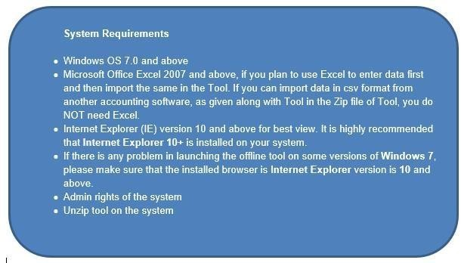

(II) Returns Offline tool – Flow Chart

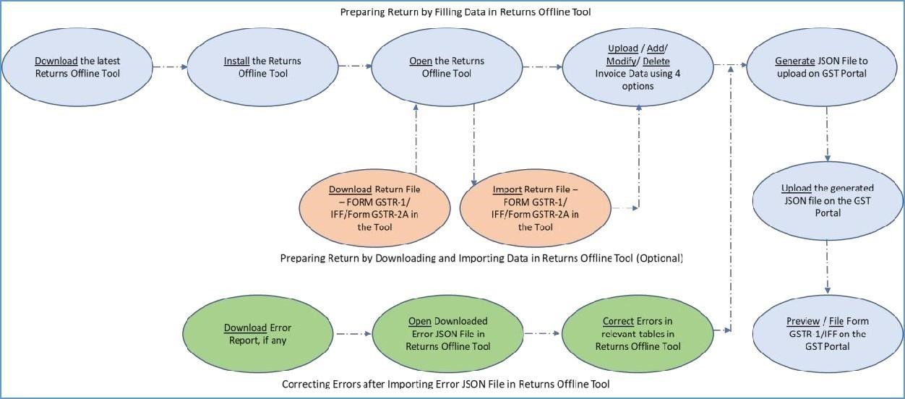

- Downloading the latest Returns Offline Tool
- Installation of the Returns Offline Tool
- Creating My Maters
- Upload Invoice Data (FORM GSTR-1/ IFF) using the Returns Offline Tool
  - D.1 Option 1: Manual Entry of Invoice Data in the Tool
  - D.2 Option 2: Import full Excel Workbook consisting of multiple sheets in the Tool
  - D.3 Option 3: Copy Data from Excel Workbook and Paste in the Tool
  - D.4 Option 4: Import the CSV file in the Tool
- Generating JSON File to Upload on GST Portal
- Uploading Generated JSON on GST Portal
- Downloading Error File and Opening Downloaded Error File – FORM GSTR-1/ IFF in the Tool, if required
- Downloading Form GSTR-1/IFF Return File and Opening it in the Tool (if required)
- Downloading Form GSTR2A File and Opening it in the Tool (if required)
J.Troubleshooting Common Errors Encountered
Designed and Developed by GSTN Page 26 of 117

A. Downloading the latest Returns Offline Tool

Downloading the Returns Offline tool is a one-time activity, however, it may require an update in future, if the Tool is updated at the GST Portal. Please check the version of the offline tool used by you with the one available for download on the GST Portal at regular intervals. Ensure to download and install the latest version of the Returns Offline Tool.

To download and install the Returns Offline tool to create new data for return, perform following steps:
Note: You can download the Returns Offline tool from the Portal without login to the GST Portal.
- Access the https://www.gst.gov.in/ URL. The GST Home page is displayed. Click the Downloads > Offline tools > Returns Offline tool.

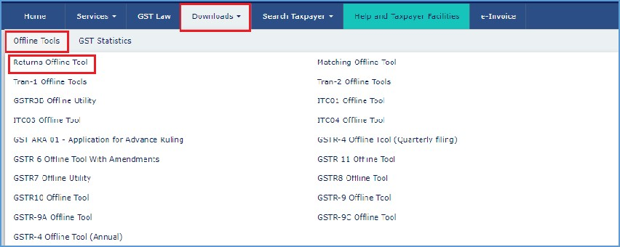

- The Returns Offline tool page is displayed. Click the Download button.

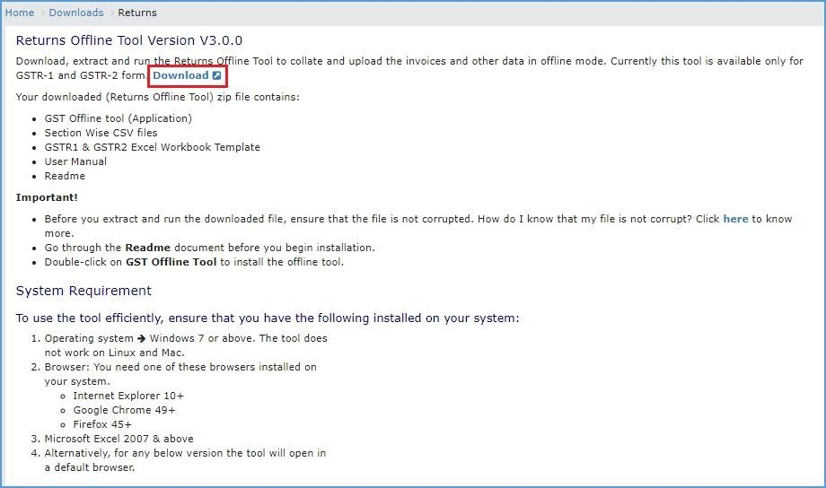

Note: The download of the Returns Offline tool usually takes 2-3 minutes to download depending on the Internet speed.

- A confirmation message is displayed on the screen. Click the PROCEED button to download the Returns Offline tool from the GST Portal.

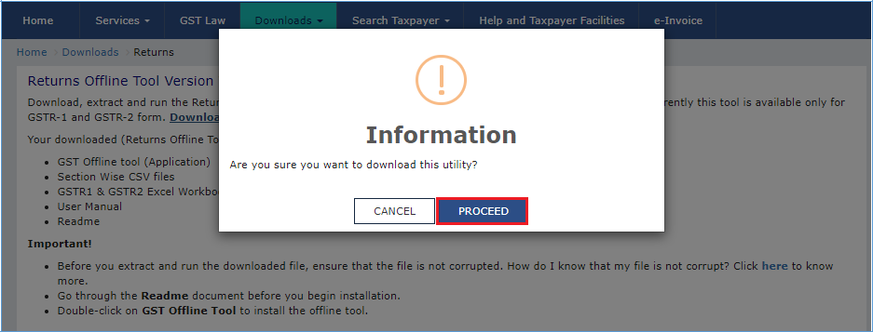

- You can notice that the offline tool has been downloaded.

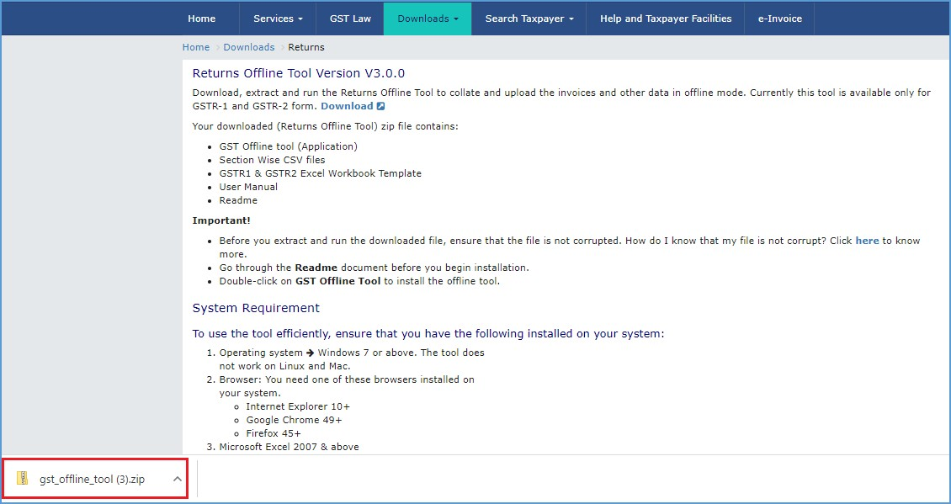
- Browse and select the location where you want to save the downloaded files.

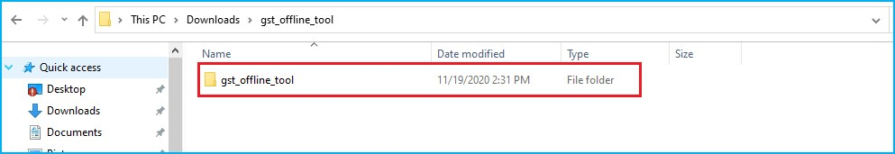

Note: In some machines, depending on your browser settings, the files are downloaded in the folder Downloads on your machine.

Click here to go back to Main Menu

B. Installation of the Returns Offline Tool
Once the download of the Returns Offline tool is complete, you need to install these downloaded files on your machine.

- Unzip the downloaded files and extract the files from the downloaded zip folder gst_offline_tool.zip. Zip folder consists of the following files as shown in the screenshot below.

  - GST Offline tool.exe file for the Returns Offline tool need to be installed in the local machine (your computer)
  - Section_wise_CSV_files folder which contains .csv file (to upload invoice data entered in the respective files, of all sections, one-by-one for respective tables) Note: CSV file contains some sample data which has been provided for reference purpose only. Sample Data must be deleted before filling the actual data in the template.
  - FORM GSTR-1_Excel_Workbook_Template.xlsx file (to import invoice data entered in the respective worksheets, of all sections, at one go)
  - Readme.txt file that explains in detail the prerequisites for the Returns Offline tool
  - Invoice Upload Offline tool User Manual detailing out the guidance for taxpayers to use Returns Offline tool.

Note: Save Excel file and CSV files on your machine as these contain the templates in which data can be entered to be used by the Returns Offline tool.

Note:
  - The taxpayer can fill the excel workbook template only for the applicable sections of the return and then import the excel file to the offline tool.
  - In a case the taxpayer does not have data for all sections, those sections can be left blank and the offline tool will take the data from the filled in sections only.
  - If the taxpayer have opted for quarterly filing of Form GSTR-1/ IFF then they have to enter data only for 4 sections for M1 and M2: B2B, SEZ, DE (4A, 4B, 6A, 6C), 9B – Credit/ Debit Notes (Registered), 9A – Amended B2B Invoices & 9C – Amended Credit/ Debit Notes (Registered.) Rest of the sections data have to be deleted from the excel workbook. Taxpayer need to file Form GSTR-1 for M3.
  - The data in the excel file must be in the specified format and in respective sections.
Designed and Developed by GSTN Page 30 of 117

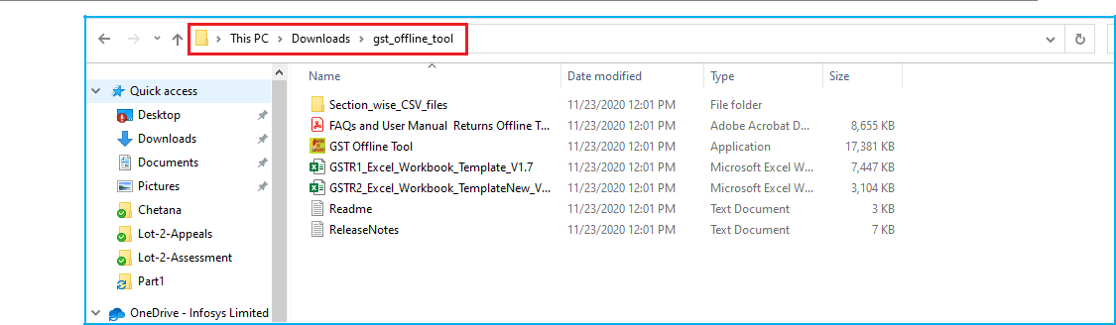

- Open the Readme.txt file to get the information of the Returns Offline tool installation process.

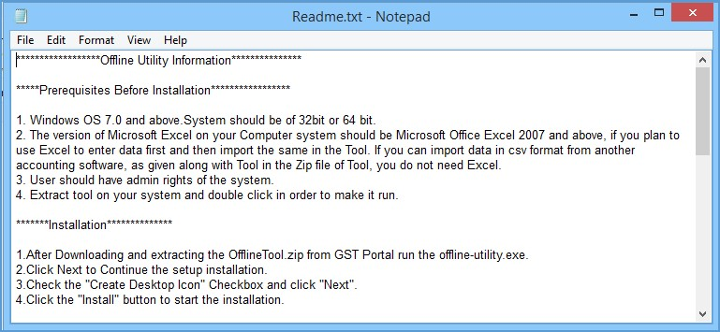

- Double click the GST Offline tool set up file.

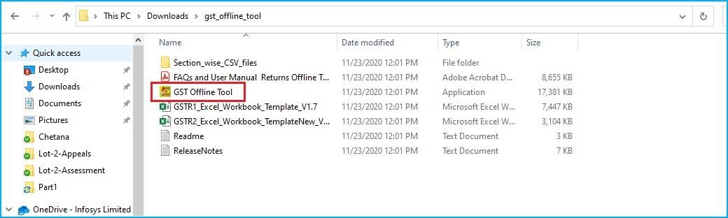

- Click the Yes button to install the Offline tool.
Designed and Developed by GSTN Page 31 of 117

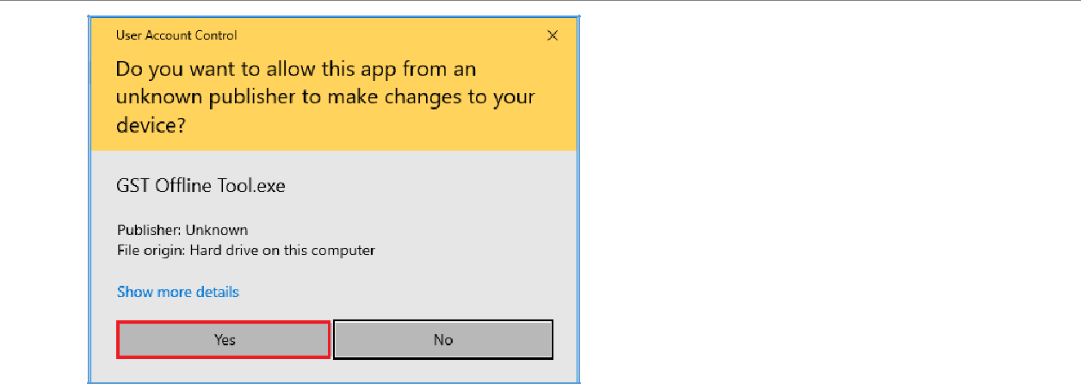

- Click the Browse button to select the destination location of your choice to install the Returns Offline tool. Click the Next button.

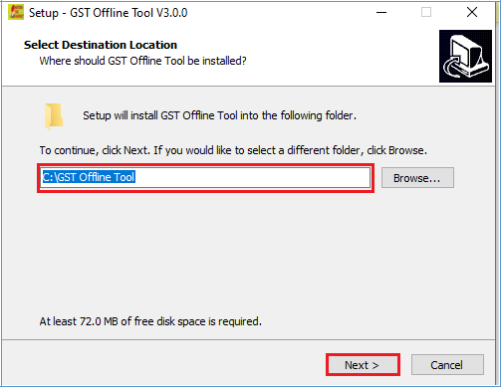

Note: The needed disk space for installing the Returns Offline tool is displayed. Ensure that the required space is available on your machine for the installation of the tool. If the required space is not available on your machine, then Download and installation of the offline tool will not complete and error will be shown on the screen.

- Select the checkbox for Create a desktop icon to create an icon for the Returns Offline tool on the desktop as a short cut. Click the Next button.
Designed and Developed by GSTN Page 32 of 117

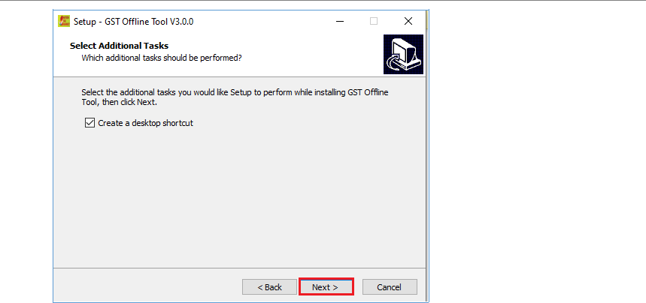
- Click the Install button.

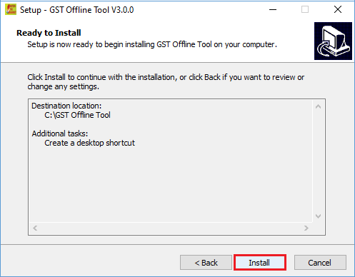
Designed and Developed by GSTN Page 33 of 117

Note: Setup will be installed along with the required software in your machine. The installation of the Returns Offline tool usually takes 2-3 minutes depending on the System speed.

- Returns Offline tool set up is completed. Ensure that both the checkboxes are selected in order to start the tool. Click the Finish button.

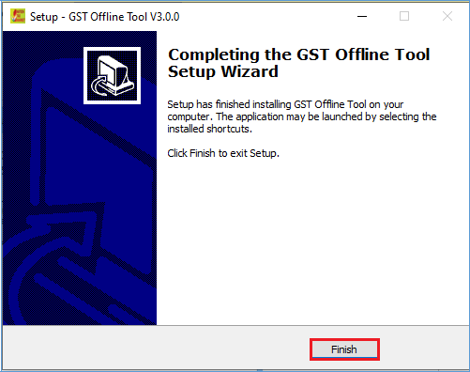

Important Note: - In case, you un-install the tool and then re-installs the tool, you mustmust re-install the tool at the same location.

In case, you re-install the tool on different location you need to restart your system so that tool refers to new location. If you will not restart your system, the Returns Offline tool will refer the old path and the tool will not open.

- Notice that the desktop icon for the tool is created on the desktop. Double click the Offline tool icon on your desktop to open the Tool using this icon.

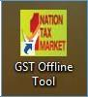

Click here to go back to Main Menu
Designed and Developed by GSTN Page 34 of 117



C.

Creating

My

Masters

To create My Masters, you first need to login to the offline tool. Once you have logged in the screen shown below will appear. The My Masters tile has two options: PREPARE/VIEW and OPEN DOWNLOADED JSON FILE.

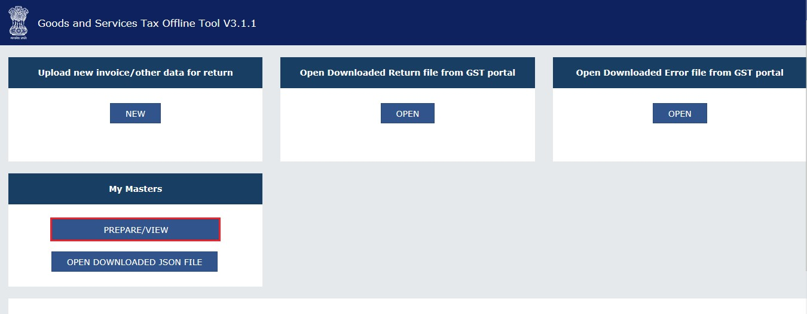

- PREPARE/VIEW- To prepare Masters offline, click on the PREPARE/VIEW button on the tile.

- Enter the GSTIN in the field. Click the PROCEED button.

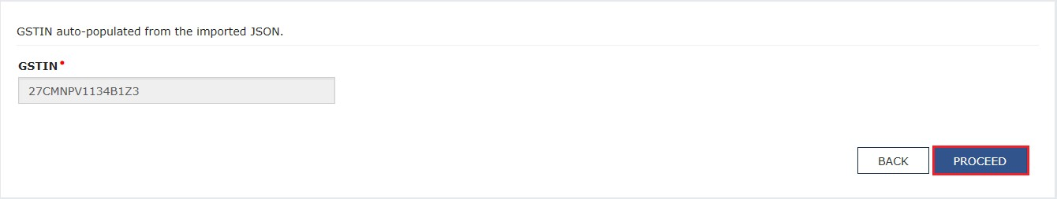
Designed and Developed by GSTN Page 35 of 117
Returns Offline Tool

- My Masters page will be displayed. This page has two tabs: Product Master and Supplier/Recipient Master.

The Product Master screen is selected by default.

Enter details in Product Master and Supplier/Recipient Master by following the similar process as of online facility.

- For Product Master: Add the HSN codes in the ‘Add product(s)’ table. Enter HSN Code by selecting from generated list of codes and HSN description will be auto populated. Enter a unique Product name for your product, select IGST rate (%) and UQC from the drop-down list. Click the SAVE button. If you have to add more than one HSN code, then click the ‘+’ symbol to add one or more HSN codes. The records that have been saved successfully will be available in the ‘Added product(s)’ table.

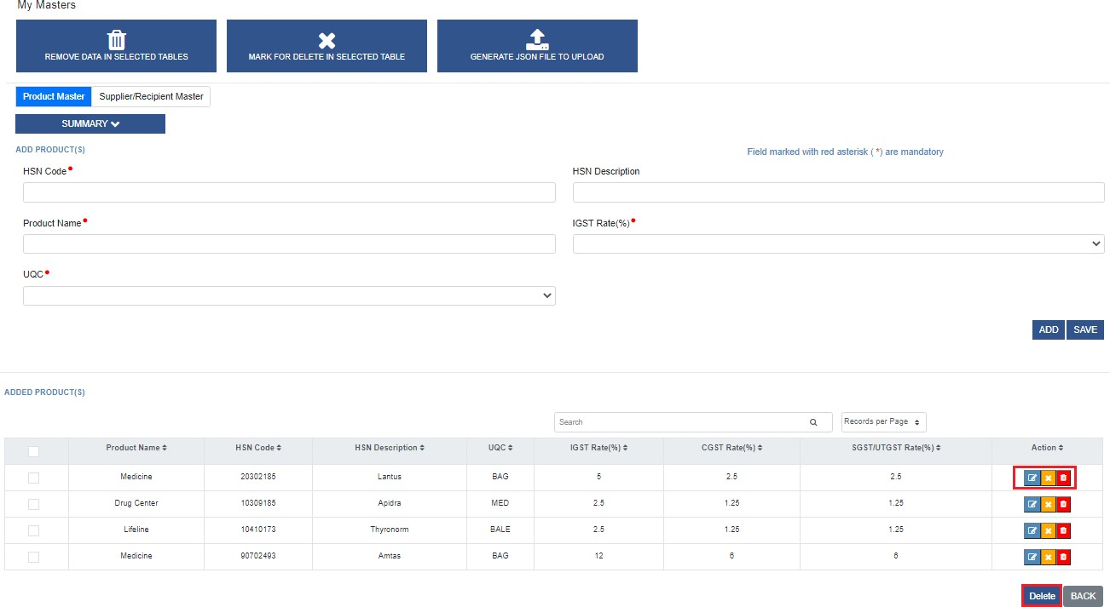

- For Supplier/Recipient Master: Enter details in GSTIN field and Trade/Legal Name will be auto- populated Enter a unique Supplier/Recipient Name, and check the box for Recipient or Supplier to specify the category. Click the SAVE button. The records that have been saved successfully will be available in the ‘Add supplier(s)/recipient(s)’ table.
Designed and Developed by GSTN Page 36 of 117

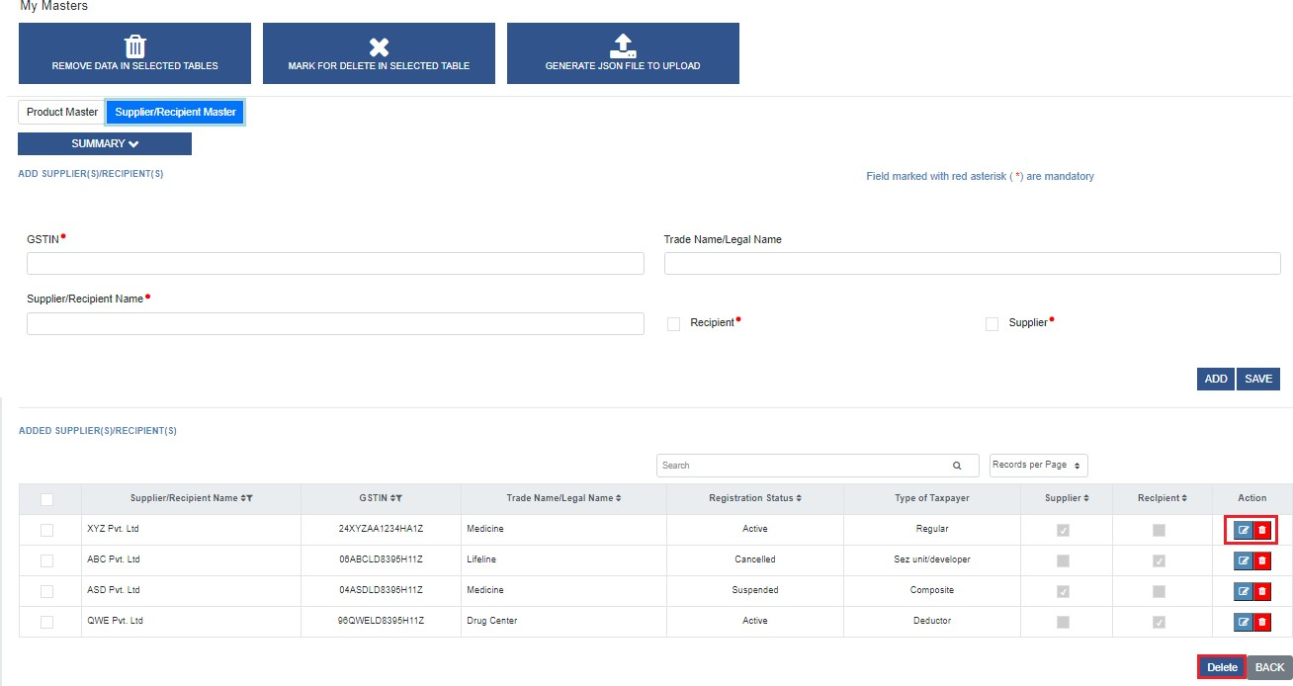

Note:
You can click the ADD button to add all records at once and then click the SAVE button to save the list. You can edit the list by clicking on the edit button.

- Click the REMOVE DATA IN SELECTED TABLES button to remove records added in offline tool.



- Click the MARK FOR DELETE IN SELECTED TABLES button to mark records for deletion that were added on online portal and uploaded by JSON to offline tool. These records cannot be deleted in offline tool.


Designed and Developed by GSTN Page 37 of 117

- h. Click the GENERATE JSON FILE TO UPLOAD button to generate the list in JSON format.



- The OPEN DOWNLOAD JASON FILE button in the My Masters tile allows you to open the JSON file present in your system.

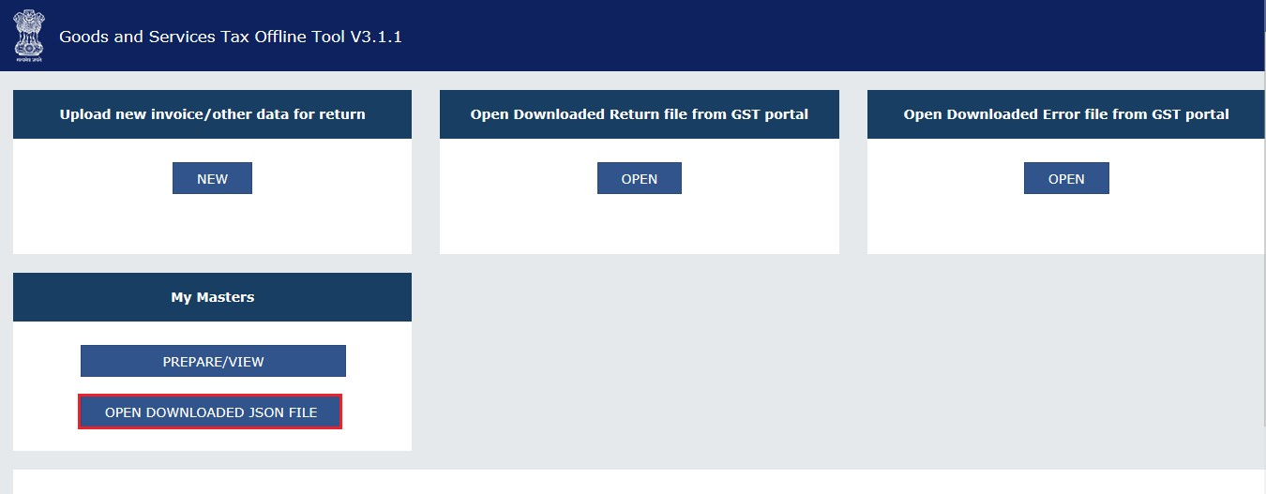
  - When you click this button a file explorer will open.

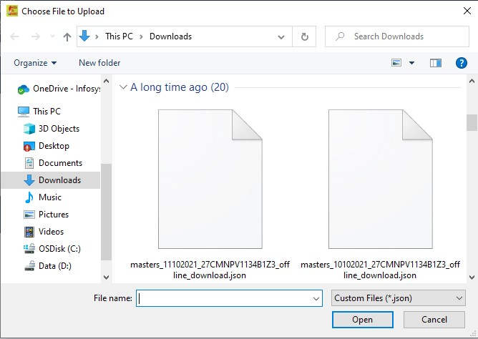
  - From here select the JSON file that you want to open. Once you have selected the file, the GSTIN page will be displayed. Click the PROCEED button.
Designed and Developed by GSTN Page 38 of 117

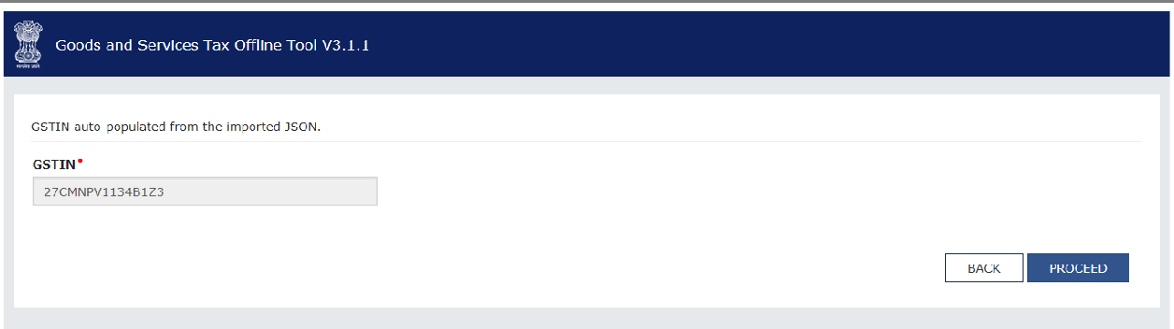

  - You will now see the My Masters page. From here you can add products, supplier or recipient and also view the summary.

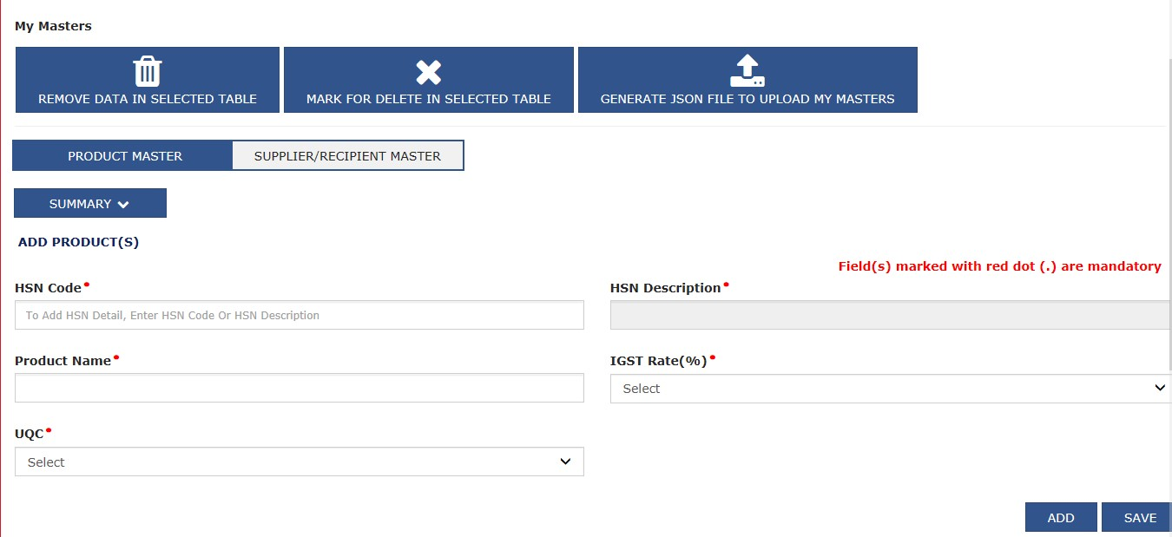

Click here to go back to Main Menu
Designed and Developed by GSTN Page 39 of 117

D. Upload Invoice Data (FORM GSTR-1/ IFF) using the Returns Offline Tool

Let us take an example where you need to upload the Outward Supplies invoices in the FORM GSTR-1/ IFF for the Financial Year 2020-21 and Return Filing Period as January on the GST Portal using the Returns Offline tool.

To add the B2B, SEZ, DE (4A, 4B, 6A, 6C) invoices in the FORM GSTR-1/ IFF on the GST Portal using the Returns Offline tool, perform the following steps:

- When you double click the Offline tool icon on your desktop, the Offline tool Home Page will be displayed. This page has following four tabs:
o Upload new invoice/ other data for return: The NEW button is used to Upload New Invoice/ upload other data for return in the tool. (Return will be populated on the GST Portal based on the data uploaded using the tool. Taxpayer can upload invoice data as many times as needed.)
    - Open Downloaded Return file from GST portal: The OPEN button is used to open Return Form GSTR-1/ IFF file downloaded from GST portal to accept, reject, modify or add missing invoice details. Uploaded invoice details can be corrected by editing or deleting the invoices. Invoices can be deleted through bulk selection also. Taxpayer can also add any invoice details if any invoice is missing.
    - Open Downloaded Error File from GST portal: The OPEN button is used to open error file downloaded from GST portal, to correct the invoice data which are not processed GST Portal. Taxpayer can take necessary action to rectify the invoices rejected by GST Portal by editing or deleting the invoices.
    - My Masters: The PREPARE/VIEW button under My Masters tab can be used to prepare or edit Master list of Products and Supplier / Recipient that can be used for preparation of GSTR-1 online and offline.

- To upload invoice details for filing return, click the NEW button.
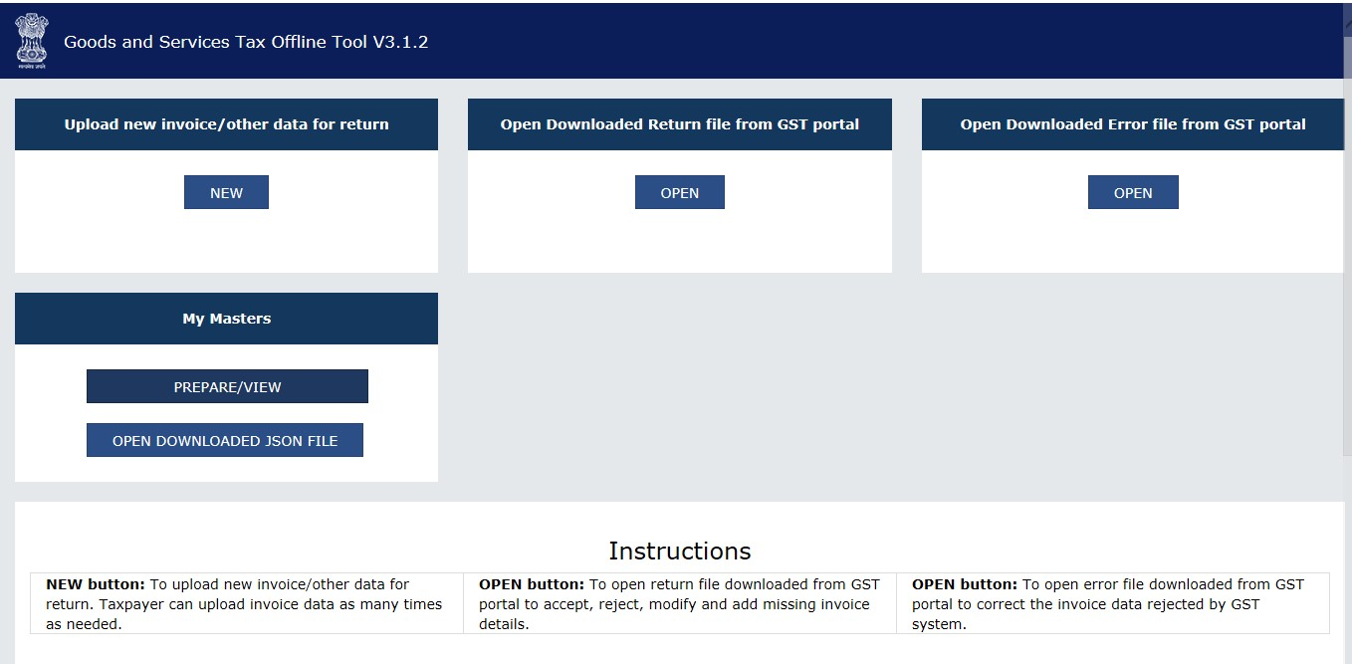
Designed and Developed by GSTN Page 40 of 117

- The File Returns page is displayed.
- From the GST Statement/Returns drop-down list, select the FORM GSTR-1/ IFF option.
- In the GSTIN of Supplier field, enter your GSTIN (Being a supplier when you are preparing data for FORM GSTR-1/ IFF). Say for example your GSTIN is 27KLJIP1168B1ZB, enter this data in GSTIN field.
- In the Financial Year drop-down list, select the financial year for which the return has to be prepared using the tool. In this example, we select it as 2023-24.

Note: At any point of time, all financial years will be available in the drop-down list starting from 2018-19 till current financial year.

- From the Tax Period drop-down list, select the tax period for which return for which the return has to be prepared. In this example, the tax period is selected as January.
- Select Yes or No if you are SEZ Taxpayer. Select Yes or No if you are Quarterly Taxpayer.
- Click the PROCEED button.

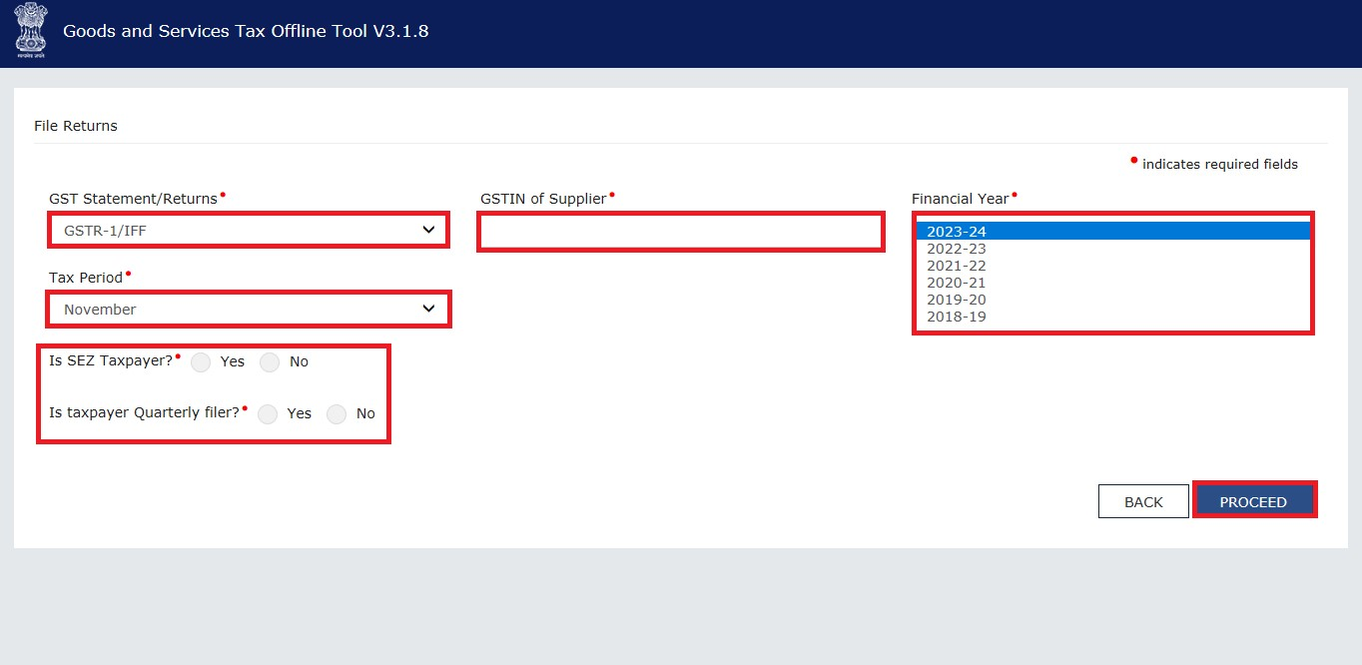

- Click the Yes button to proceed.
Designed and Developed by GSTN Page 41 of 117

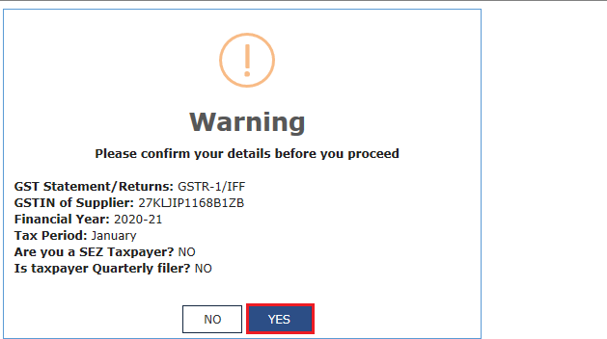

- Next step is to upload the invoice data. There are four options available to user to enter the data

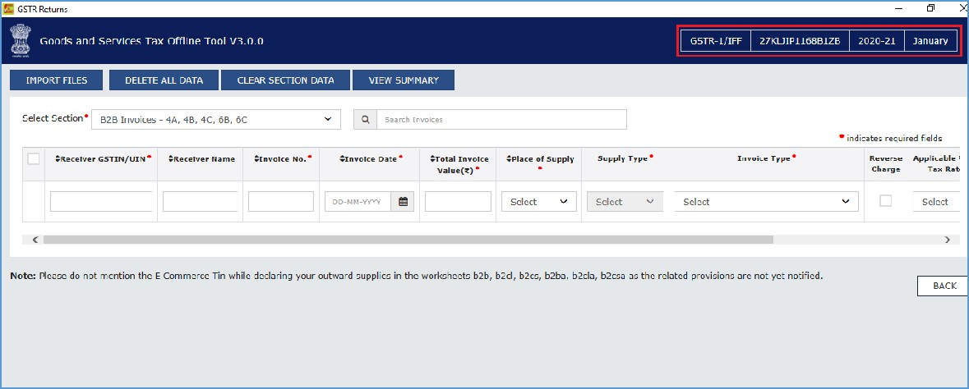

  - Option 1: Manual Entry of Invoice Data in the Tool
  - Option 2: Import full Excel Workbook consisting of multiple sheets in the Tool
  - Option 3: Copy and Paste from Excel Workbook C.4 Option 4: Import the CSV file in the Tool

Note: Option 2, 3 uses an Excel template that is explained in the later section of this document & option 4 uses CSV template.

Click here to go back to Main Menu
Designed and Developed by GSTN Page 42 of 117

D.1 Option 1: Manual Entry of Invoice Data in the tool

To enter the invoice data manually in the Returns Offline tool directly, perform the following steps. By this method you can enter details of one invoice at a time.
1. From the Select Section drop-down list, select the applicable section where the invoice data needs to be entered.
Note: Below screen will be displayed for monthly taxpayers for each month selected and quarterly taxpayers only for last month of the quarter (M3) period.

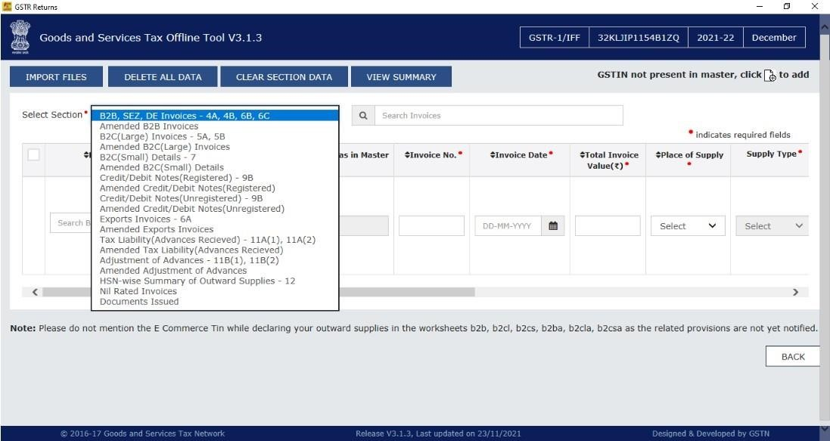
Designed and Developed by GSTN Page 43 of 117

Note: In case taxpayer have opted for quarterly filing of Form GSTR-1/IFF then for the first two
(2) months (M1 & M2) of the quarter only 4 applicable tables of IFF will be available. Reference screenshot is provided below.

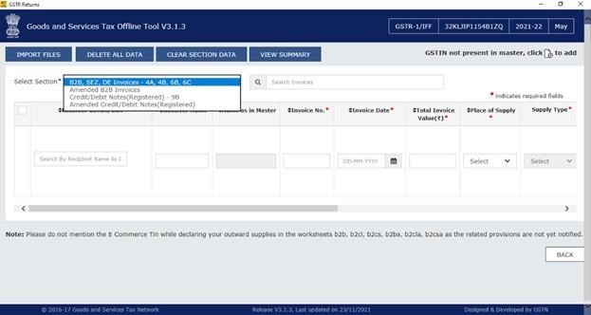

- Enter the invoice details in each column like Receiver GSTIN/UIN, Invoice No. etc.
- Click the Plus icon (Highlighted in Red square under Actions column) on the right side in order to fill the item level details for this invoice.

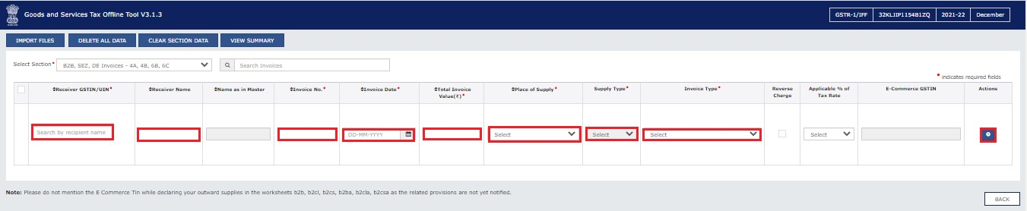
Designed and Developed by GSTN Page 44 of 117

Note:
  - Enter the GSTIN in the correct format. In case you have entered the invalid/wrong GSTIN, then GST Portal will display an error message, once the invoice is uploaded on the GST Portal.
  - In case an invoice is already entered in the same tax period, in the Returns Offline tool, then the Tool will overwrite the earlier details with the latest ones entered, with Import Excel/CSV option within the Tool.
  - However, if the same invoice is existing in earlier filed tax period in the GST Portal, then Returns offline tool may not be able to identify the duplicate invoices. But when the invoice is uploaded on the GST Portal, an error message in the error JSON file, is displayed for such duplicate invoices. Taxpayer can then download and open the error JSON file and delete/ amend the duplicate invoices in the Returns Offline tool and then create the JSON again and upload the same on the GST Portal.
  - Ensure that you have selected correct section from the drop-down list and then enter the invoice data.

- The Add Items page is displayed. Enter the item level details and click the Save button at the right side of the screen bottom in order to save the line items.

Note: All line items of same rate must be reported as one line item. In the screenshot below, only IGST is available for entry as recipient and supplier are from different states.
Designed and Developed by GSTN Page 45 of 117

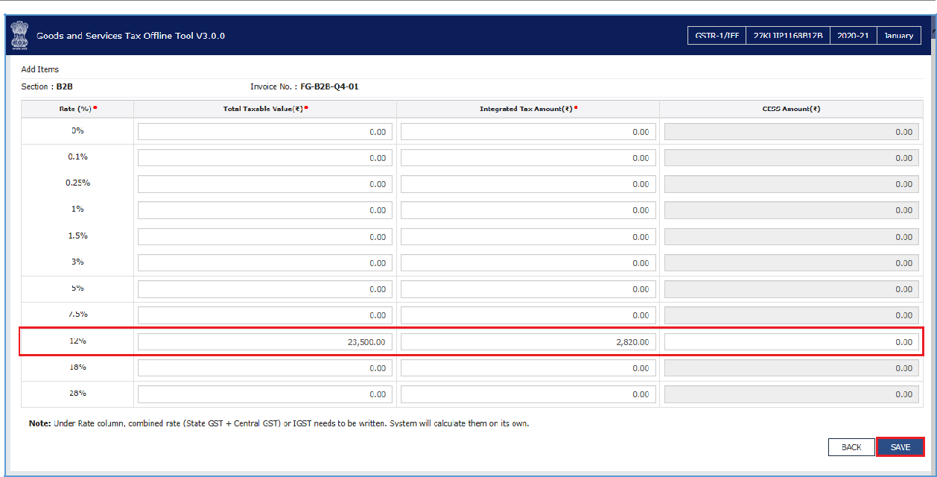

Note: In the screenshot below, only CGST and SGST is available for entry as recipient and supplier are from same states.

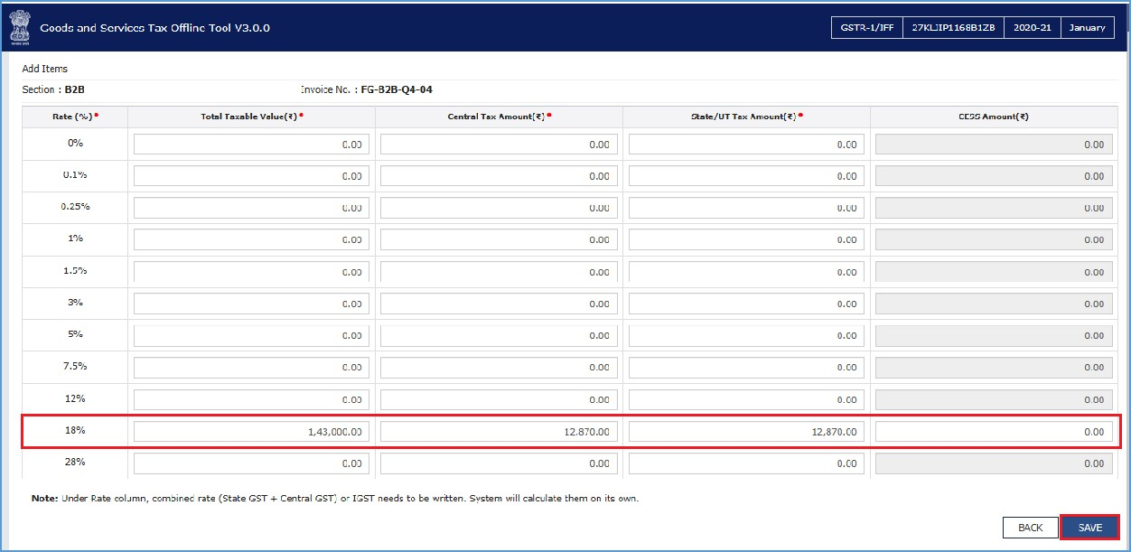
- Once the invoice details are saved, the success message is displayed. Ensure to save the data on a time to time basis to avoid any loss of data.
Designed and Developed by GSTN Page 46 of 117

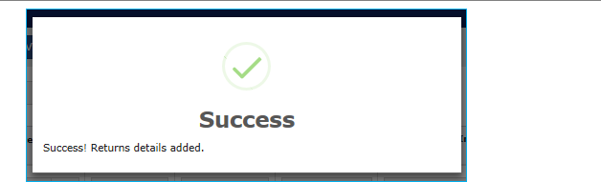

- Notice that the invoices added manually are populated on the screen. The EDIT button allows to edit the data. The Delete button allows deleting a record that has been added erroneously. To delete the data, select the checkbox for the invoice and click the DELETE button.

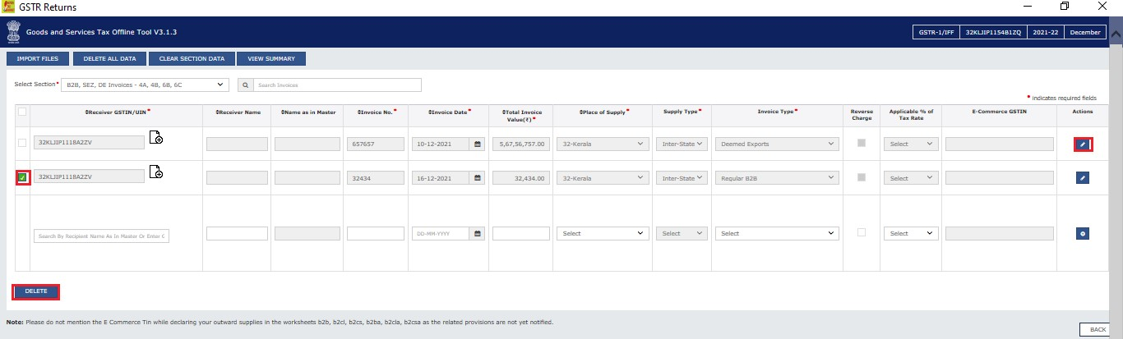

Click here to go back to Main Menu
Designed and Developed by GSTN Page 47 of 117

D.2 Option 2: Import full Excel Workbook consisting of multiple sheets in the Tool

- The multi excel sheet has eleven worksheets covering different tables in FORM GSTR-1/ IFF. When you first download the excel sheet, there is a header in each sheet along with some sample data. You need to delete the sample data in each section and enter data which you want to upload. You need to manually enter the data in these sheets. Do not change any sheet or field name in the header or format of the Excel file.

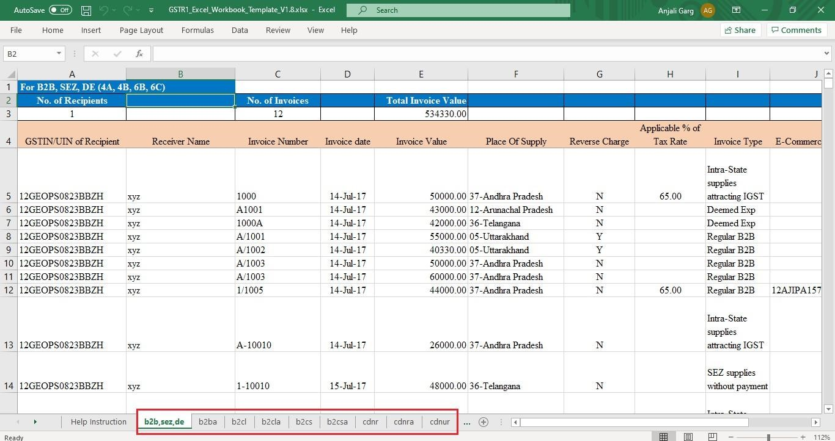

- The table below provides the name, full form and detailed description for these worksheets. Let us see how to fill data in the different worksheets:

S.No. Worksheet  Name |  | Full Form of  Worksheet Name | Description
2.1 | B2B, SEZ, DE | B2B, SEZ, DE  (4A, 4B, 6A,  6C) | Details of invoices of Taxable supplies made to other registered taxpayers
2.2 | b2ba | Amended B2B | Amended details of invoices of Taxable supplies made to other registered taxpayers
2.3 | b2cl | B2C Large | Invoices for Taxable outward supplies to consumers where the place of supply is outside the state where the supplier is registered and the total invoice value is more that INR 2,50,000.
2.4 | b2cla | Amended B2C  Large | Amended details of Invoices for Taxable outward supplies to consumers where
Designed and Developed by GSTN Page 48 of 117

S.No. Worksheet Full Form of Description Name Worksheet Name
- The place of supply is outside the state where the supplier is registered and
- The total invoice value is more that INR 2,50,000
2.5 | b2cs | B2C Small | Supplies made to consumers and unregistered persons of the following nature  - Intra-State: any value  - Inter-State: Invoice value INR 2.5 lakh or less
2.6 | b2csa | Amended B2C  Small | Amended details of supplies made to consumers and unregistered persons of the following nature  - Intra-State: any value  - Inter-State: Invoice value INR 2.5 lakh or less
2.7 | cdnr | Credit/ Debit Note | Credit/ Debit Notes/Refund vouchers issued to the registered taxpayers during the tax period.  Debit or credit note issued against note supply type, hence fill the details of note supply type also which was furnished in B2B, SEZ, DE (4A, 4B, 6A, 6C), B2CL section of earlier/current period tax period. If none is selected it must be regular B2B Supply.
2.8 | cdnra | Amended Credit/  Debit Note | Amended details of Credit/ Debit Notes/Refund vouchers issued to the registered taxpayers during the tax period.
2.9 | cdnur | Credit/ Debit Note for Unregistered Persons | Credit/ Debit Notes issued to the unregistered taxpayers
2.10 | cdnura | Amended Credit/ Debit Note for  Unregistered  Persons | Amended details of Credit/ Debit Notes issued to the unregistered taxpayers
2.11 | exp | Export | Supplies exported
2.12 | expa | Amended Export | Amended export supplies including supplies of SEZ/ SEZ developer or deemed exports
2.13 | at | Advance Tax | Tax liability arising on account of receipt of payment before issuance of invoice in the same period (on advance receipt/ on account of time of supply) excluding tax amounts will be reported here as Gross advance received.
2.14 | ata | Amended Tax Liability on  advances | Amended details of Tax liability arising on account of receipt of payment before issuance of invoice in the same period
Designed and Developed by GSTN Page 49 of 117

S.No. | Worksheet | Full Form of | Description
 | Name | Worksheet Name
2.15 | atadj | Advance  Adjustments | Adjustment of Tax Liability for tax already paid on advance receipt of consideration and invoices issued in the current period for the supplies
2.16 | atadja | Amended Advance Adjustments | Amended details of Adjustment of Tax Liability for tax already paid on advance receipt of consideration and invoices issued in the current period for the supplies
2.17 | exemp | Nil Rated,  Exempted and Non  GST supplies | Details of Nil Rated, Exempted and Non GST supplies made during the tax period
2.18 | hsn | HSN Summary | Harmonized System Nomenclature (HSN) wise summary of goods/services during the tax period
2.19 | docs | List of Document issued | Details of various documents issued by the taxpayer during the tax period

Sample File and Field details for each table are provided below.
2.1 Sample file for B2B, SEZ, DE
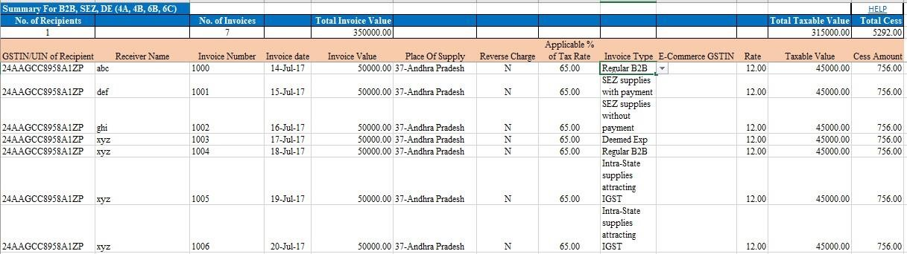
Sample File for B2B:

Designed and Developed by GSTN Page 50 of 117

Returns Offline Tool

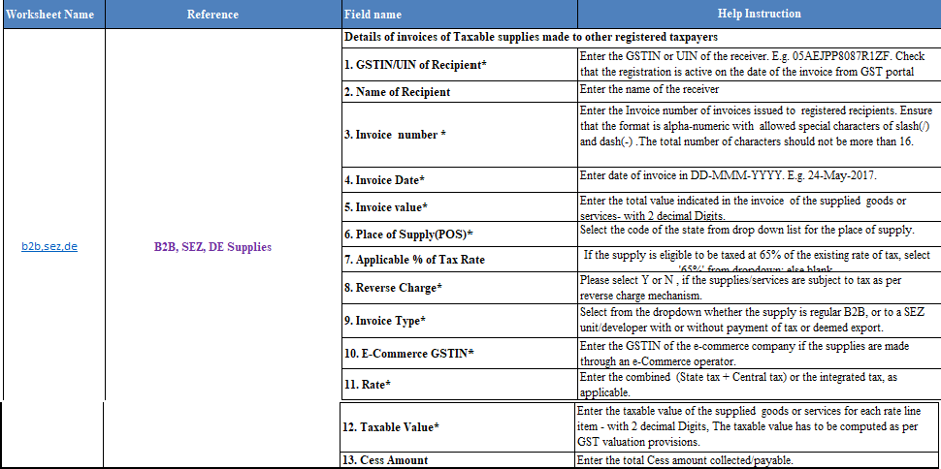
Field

details

for

B2B,

SEZ,

DE:

2.2

B2BA

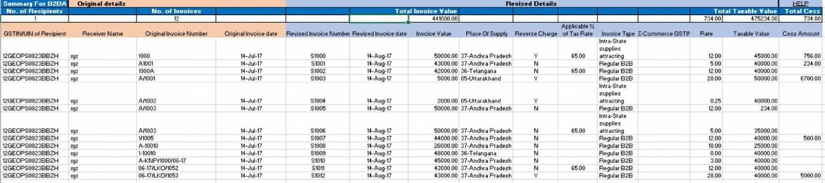
Sample

File

for

Amended

B2B:

Designed and Developed by GSTN Page 51 of 117
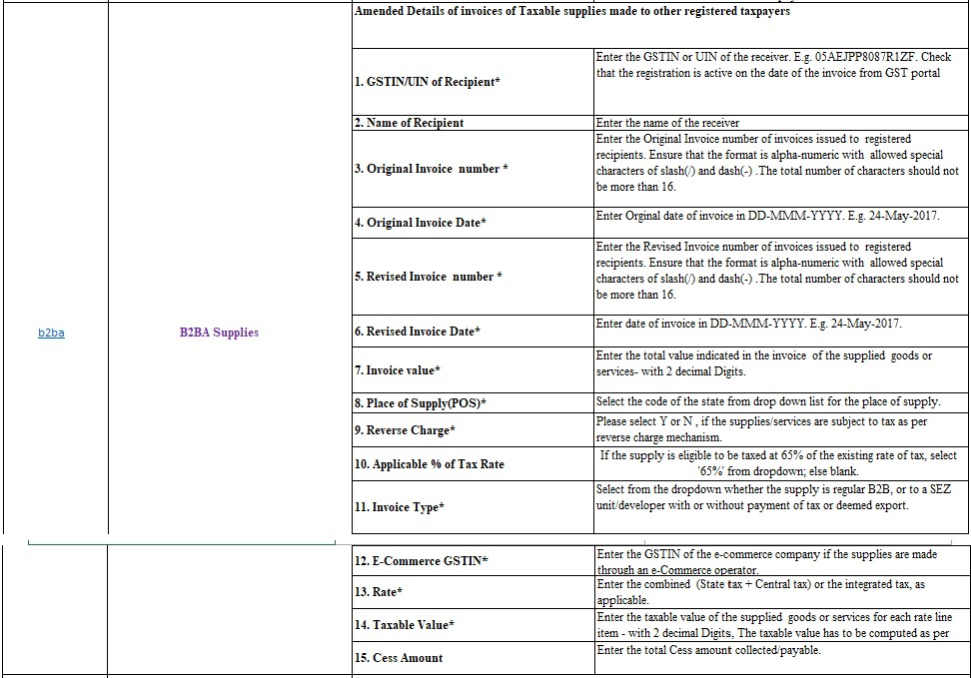

Note:

Field

details

for

Amended

B2B:

  - Amendments can be done for the invoices of earlier Tax periods only.
  - GSTIN/UIN of Recipient field of B2BA is non-amendable.
  - B2CL (B2C Large)
Sample File for B2CL:

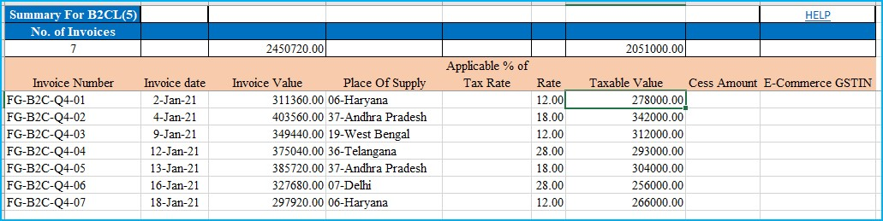
Designed and Developed by GSTN Page 52 of 117

Field details for B2CL:

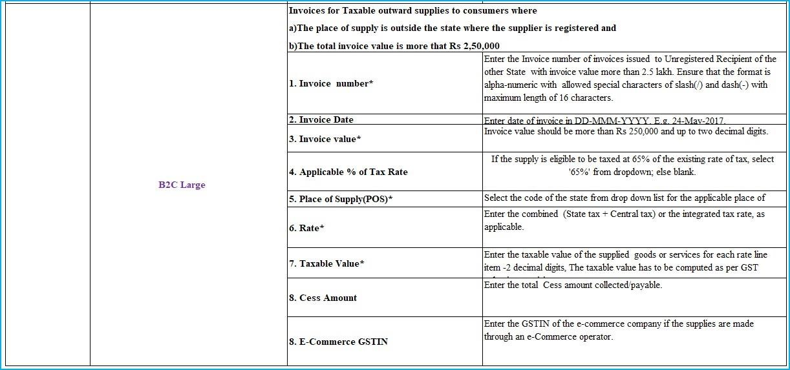
  - Amended B2C Large (B2CLA)
Sample File for B2CLA:

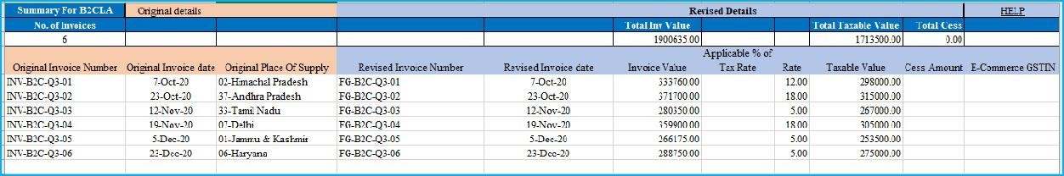
Designed and Developed by GSTN Page 53 of 117
Field details for B2CLA:
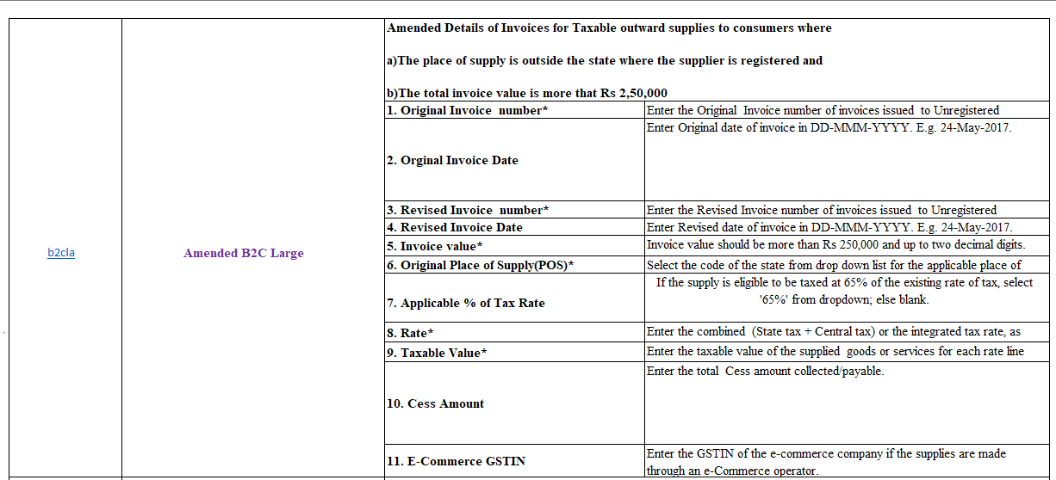

Note: Original Place of Supply field of B2CLA is non-amendable.

  - B2CS (B2C Small)
Sample File for B2CS:

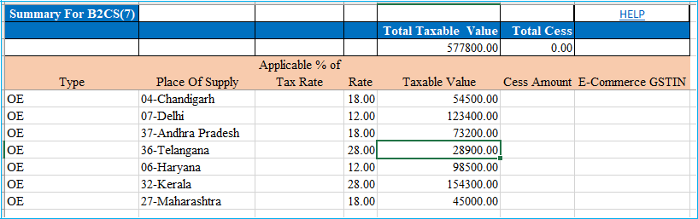
Designed and Developed by GSTN Page 54 of 117
Field details for B2CS:

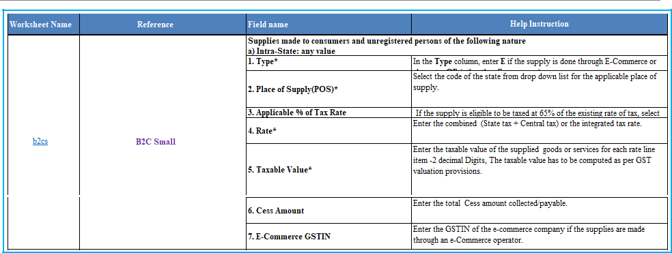

  - Amended B2C Small (B2CSA):
Sample File for B2CSA:

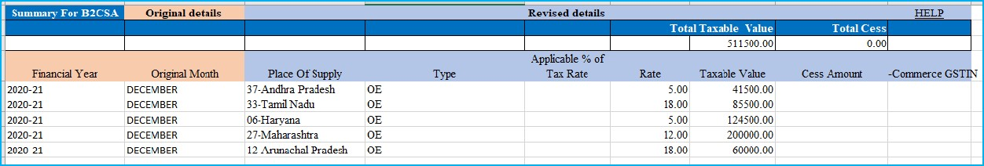

Field Details for B2CSA:

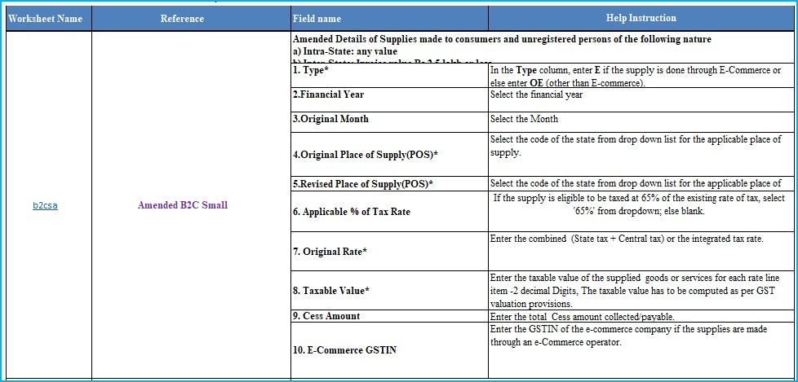
Designed and Developed by GSTN Page 55 of 117
Note: Original Place of Supply field of B2CSA is non-amendable.

  - CDNR (9B)
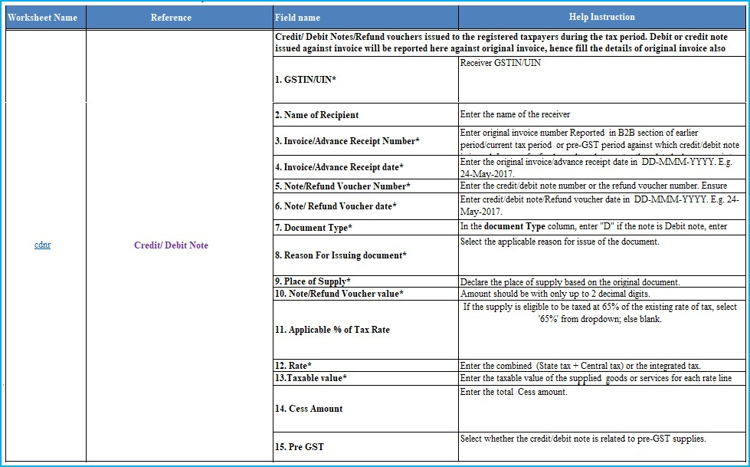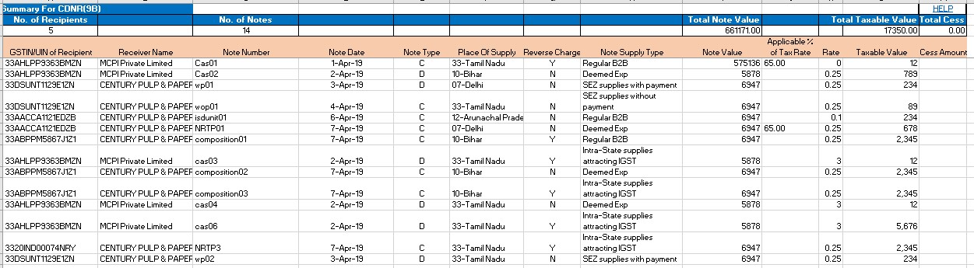

Field

details

for

CDNR:

Sample

File

for

CDNR:

Designed and Developed by GSTN Page 56 of 117

  - CDNRA
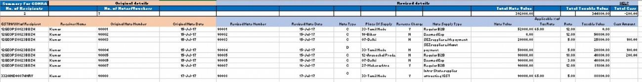

Field

details

for

CDNRA:

Sample

File

for

CDNRA:

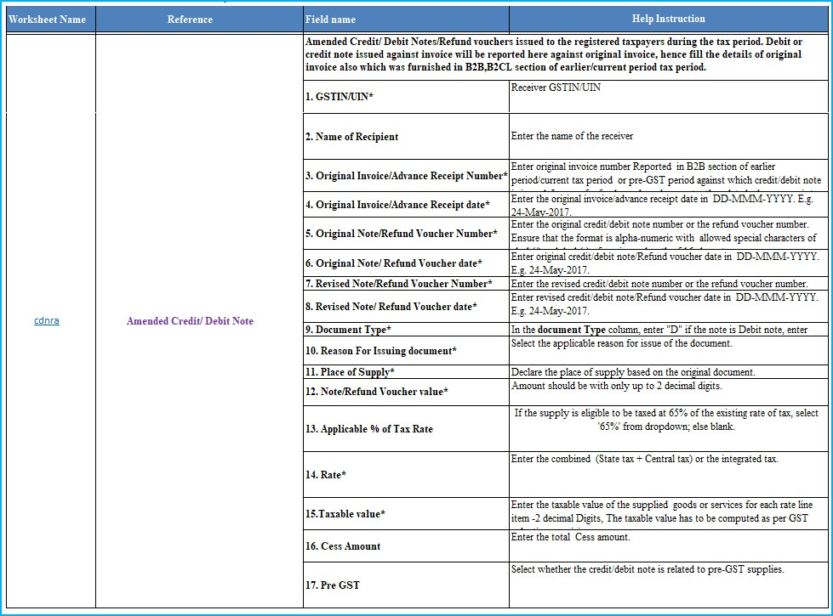

Note: GSTIN/UIN field of CDNRA is non-amendable.
Designed and Developed by GSTN Page 57 of 117

  - CDNUR (Credit/ Debit Notes/Refund voucher for Unregistered person) Sample File for CDNUR

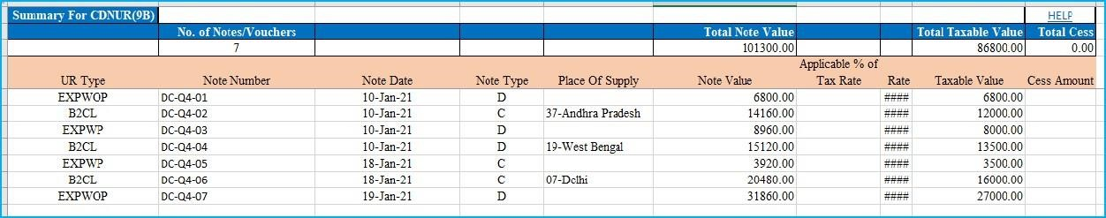

Field details for CDNUR

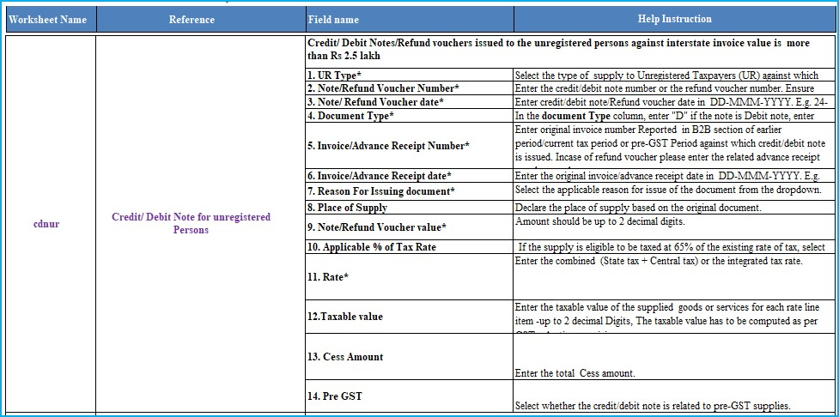
  - Amended Credit/ Debit Note for Unregistered person (CDNURA)
Sample File for CDNURA:

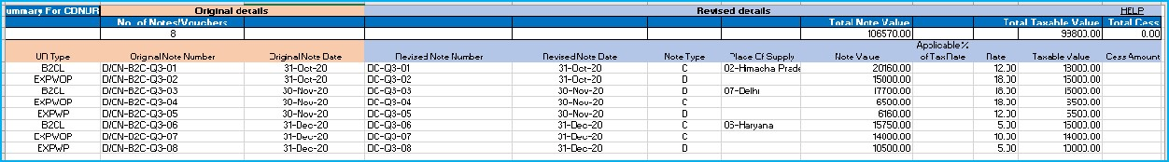

Field details for CDNURA:

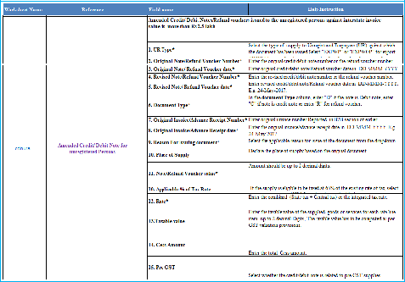

Note: UR Type field of CDNURA is non-amendable.

  - EXP (Export)
Sample File for EXP:
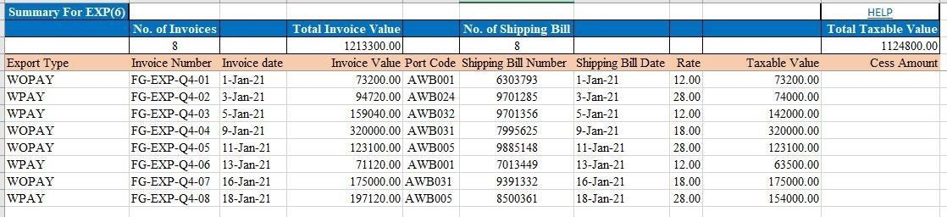

Field details for EXP:

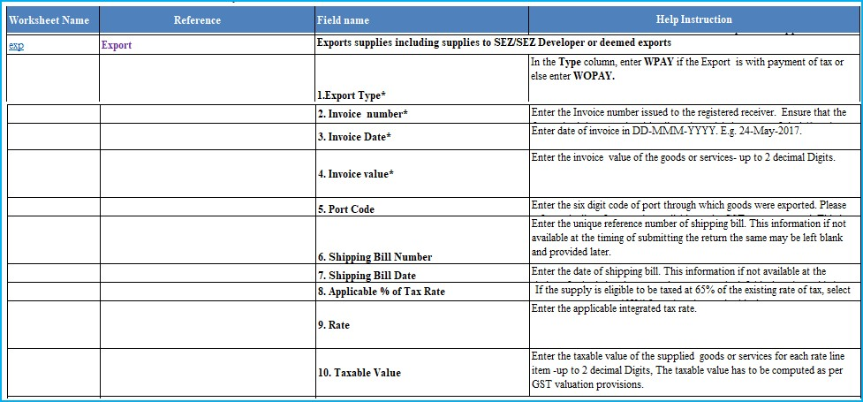

  - Amended Export (EXPA) Sample Files for EXPA:

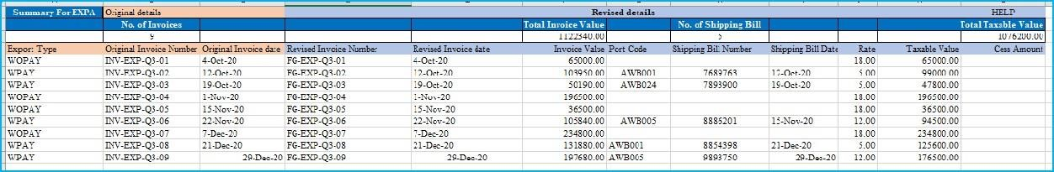

Field Details for EXPA:
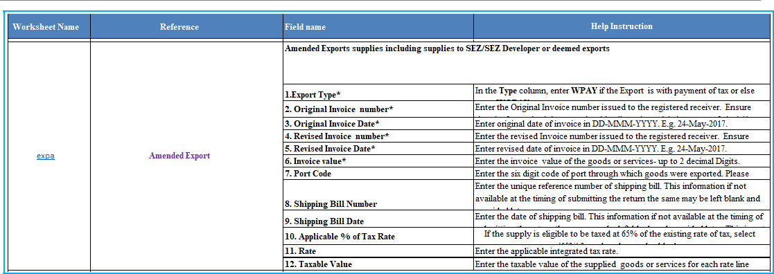

Note: Export Type field of EXPA is non-amendable.

  - AT (Liability on Advances on Services) Sample files for AT:

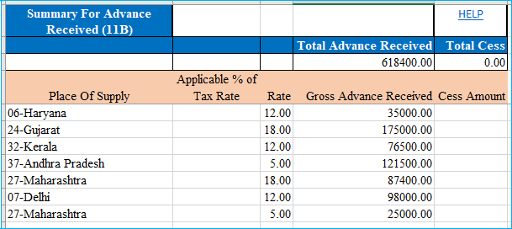

Field Details for AT:

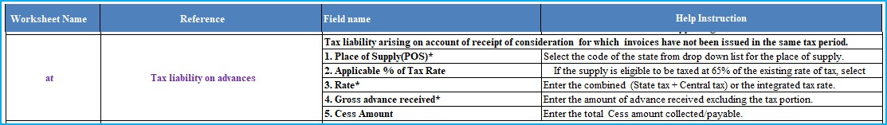

  - Amended Tax Liability on advances Export (ATA) Sample File for ATA:

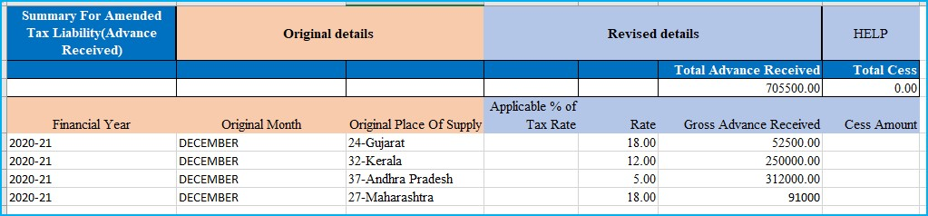
Designed and Developed by GSTN Page 61 of 117

Field Details for ATA:

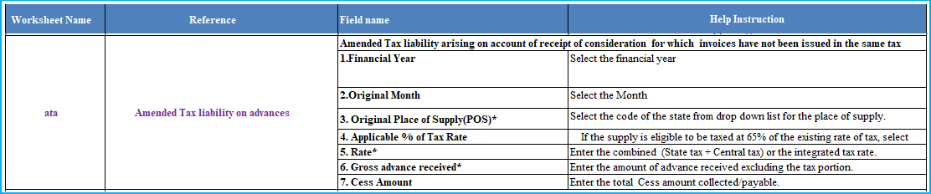

Note: Original Place of Supply field of ATA is non-amendable.
  - ATADJ (Advance Adjustments) Sample files for ATADJ:

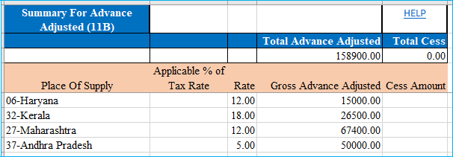

Field details for ATADJ:

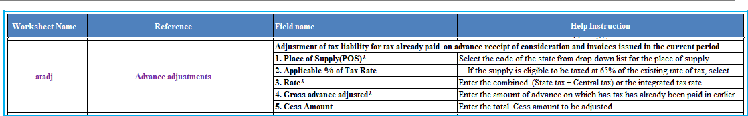
Designed and Developed by GSTN Page 62 of 117

  - Amended Advance on Services Adjustments (ATADJA) Sample files for ATADJA:

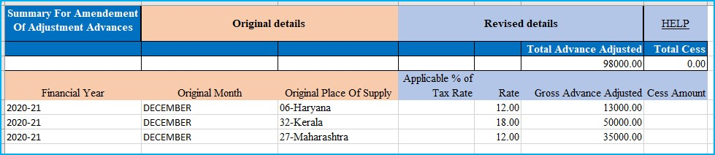

Field Details for ATADJA:

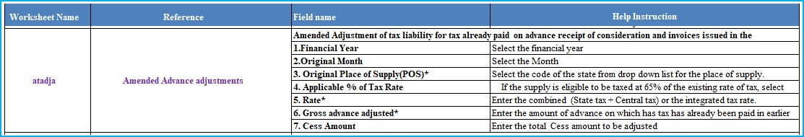

Note: Original Place of Supply field of ATADJA is non-amendable.

  - EXEMP (Nil Rated, Exempted and Non GST supplies) Sample files for EXEMP:
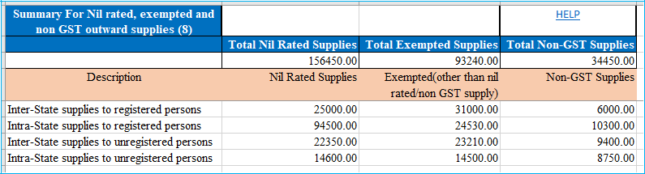

Field Details for EXEMP:
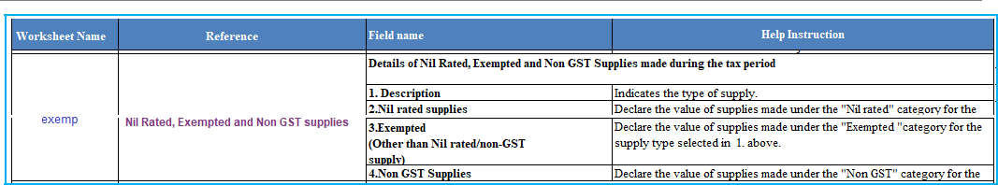
Designed and Developed by GSTN Page 63 of 117

  - HSN (HSN Summary) Sample Files for HSN:

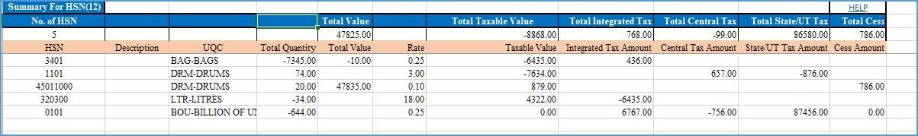

Field Details for HSN:

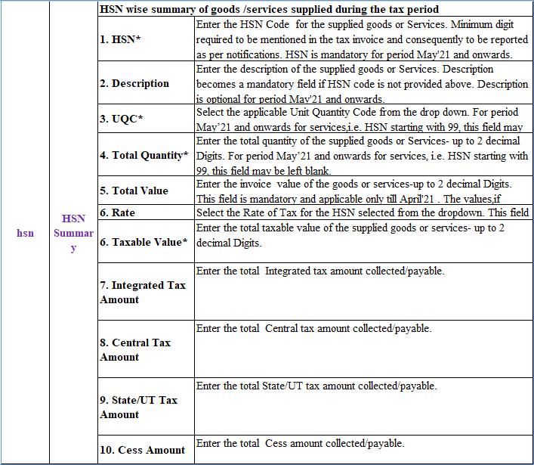
Designed and Developed by GSTN Page 64 of 117
  - DOCS (List of Documents issued) Sample file for uploading DOCS:

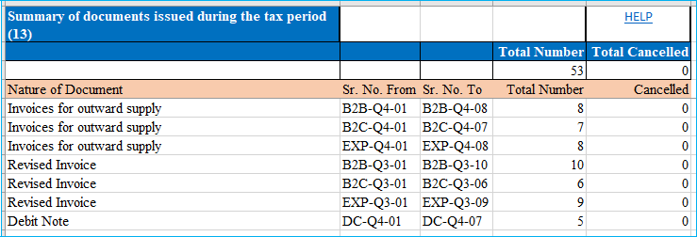

Field details for DOCS:

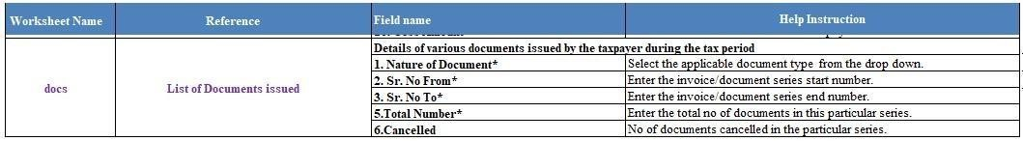

Note:
  - You need to fill up only those sections / sheets which are relevant to you. Ensure that you delete the existing sample data from other sections and those may be left blank. Do not change any sheet or field name in the Header or format of the Excel file. Save the excel sheet after entering the data.
  - In case, you need to add multiple line item for single invoice in the excel sheet, the excel row must have the repeated invoice details which is common for multiple line items like GSTIN/UIN, Invoice Number, Invoice Date and Place of Supply. Once the excel sheet is imported, Returns Offline tool takes care of mapping the line item details with respective invoice. If the repeated invoice details are not together and the same is imported to the Returns Offline tool, then the mapping of invoice details will be improper.
Designed and Developed by GSTN Page 65 of 117

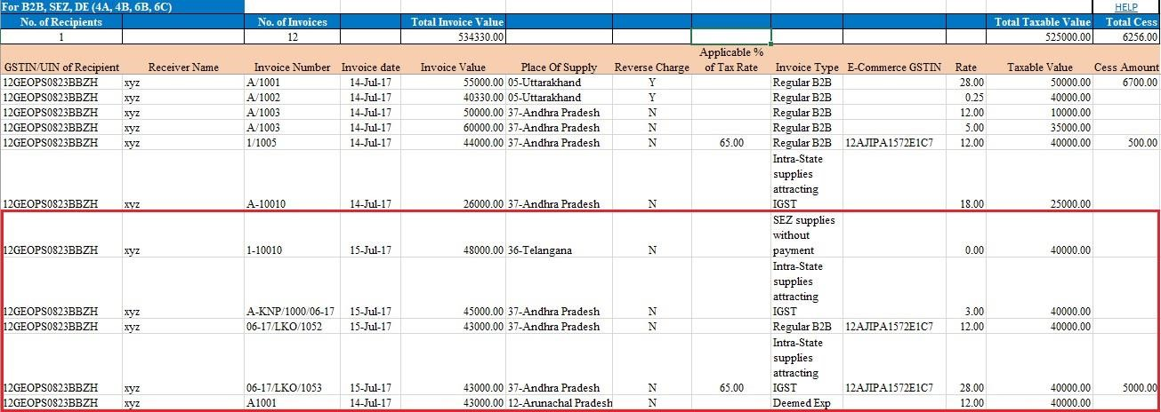

- After entering relevant data into relevant worksheets, you can import the worksheets into
Offline Tool. Click the IMPORT FILES button to import the FORM GSTR-
1_Excel_Workbook_Template.xlsx file in the Returns Offline tool.

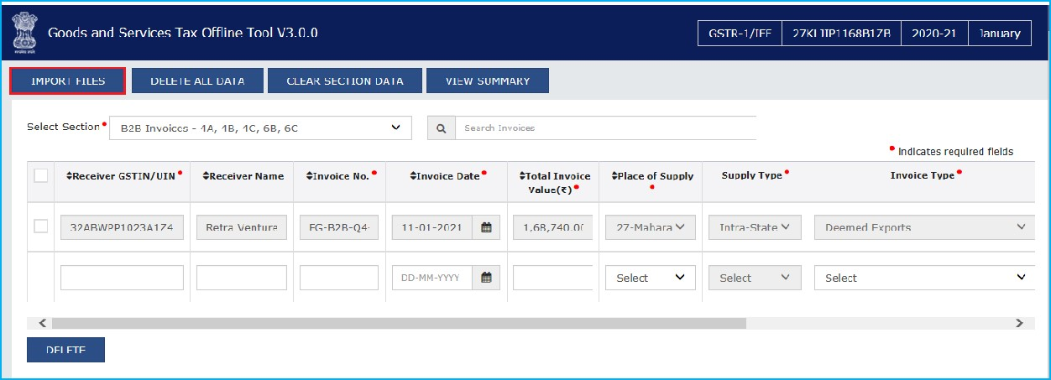
- Click the IMPORT EXCEL button. Note:
    - Through Import Returns – All sections in one Go, you can upload invoice data entered in the respective worksheets for all sections at one go.
    - Through Import Returns – One section at a time, you can upload invoice data entered in the respective sheets one section at a time.
    - Click the HELP button to read the instructions and to import excel successfully. On clicking of HELP button, below page is displayed. After reading the instructions, click the IMPORT EXCEL button to import the excel.
Designed and Developed by GSTN Page 66 of 117

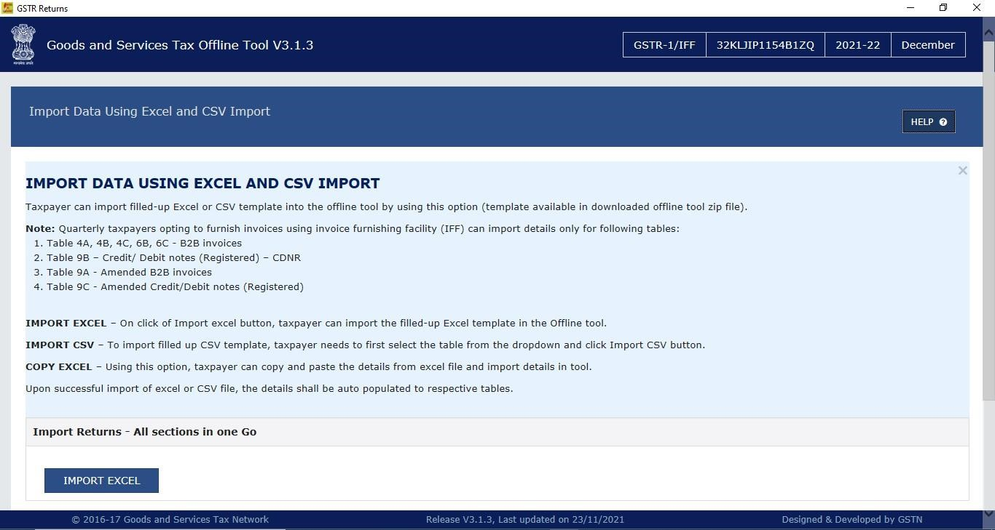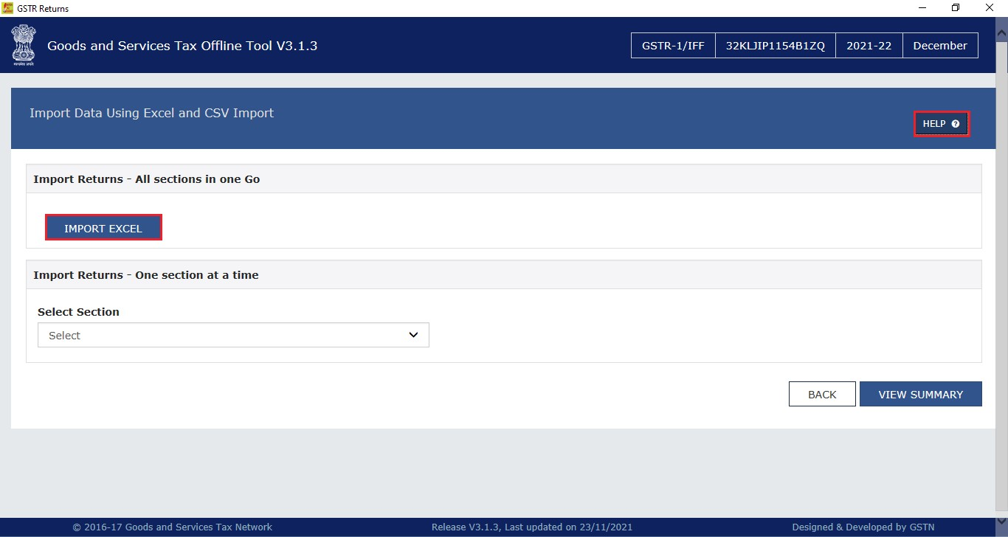5. Browse and select the FORM GSTR-1_Excel_Workbook to import data from the excel workbook. Click the Open to import the excel into offline tool.

Note:
    - In case you have more than 19,000 invoice data, you need to import the same in more than one lot. Hence naming the workbook is important to ensure that you Import data correctly.

Designed and Developed by GSTN Page 67 of 117
Returns Offline Tool
    - It may be a good practice that you name the Workbooks as per Month for ease of search and upload before uploading the invoices. Else you may keep all Workbooks of a month in one sub-folder of FORM GSTR-1/ IFF invoice Folder on your computer.

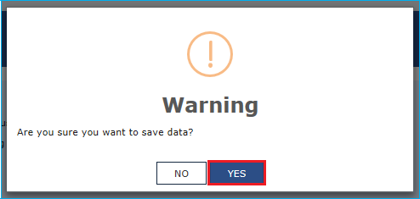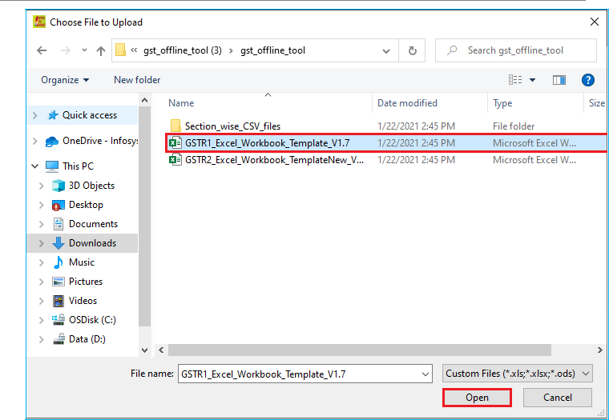

6.

Click

Yes

to

proceed.

7.

On

successful

import,

a

success

message

is

displayed.

Designed and Developed by GSTN Page 68 of 117



- Click the BACK button. Notice that the invoices present in the excel sheet are populated in the screen. The EDIT button allows to edit the data. The Delete button allows deleting a record that has been added erroneously. To delete the data, select the checkbox for the invoice and click the DELETE button.

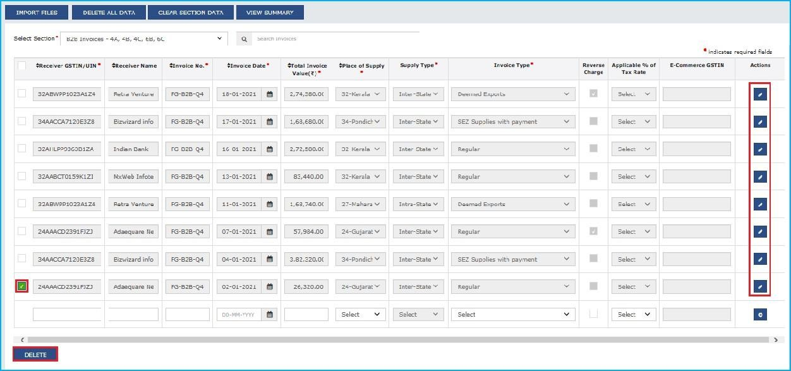

  - Errors are displayed, if the excel sheet contains erroneous data.
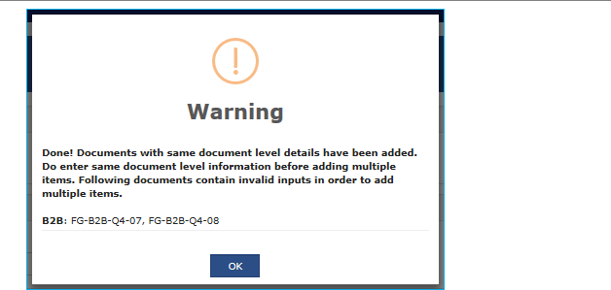

Note:
    - Make sure invoices entered in the excel sheet are unique and there are no duplicate invoice details entered in the excel sheet.
    - Date format is in dd-mm-yyyy format.

  - Make the corrections and import the rectified excel worksheet again. In case of duplicate invoices, the existing invoices are updated with the duplicate/ latest invoice data.

Click here to go back to Main Menu
Designed and Developed by GSTN Page 70 of 117

D.3 Option 3: Copy Data from Excel Workbook and Paste in the Tool

To copy and paste the invoice data from the Excel workbook sheet wise, perform the following steps:
- Open the excel sheet which has Invoice data in the desired format (based on the sample file).

Note: Use of different format of excel template, without validations leads to rejection of data in the Tool. Hence, taxpayers are advised to use excel templates provided on the GST Portal to avoid rejection of data. Do not change any field in the Header or format of the Excel file.
The excel file is in the same format as prescribed in the respective Return Forms. Changing fields will lead to error when you upload the data on the GST Portal.

- Press the Ctrl+C Keys (Shortcut key for copy) on the keyboard to copy the header part and the data from the excel sheet.

Note: Ensure that the header begins from row 1, column A (i.e., cell A1) along with first 3 rows the invoices are selected together while copying it. You have to copy paste the invoices section wise only.

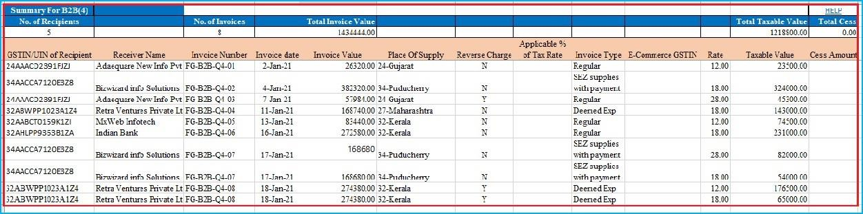

- Click the IMPORT FILES button in the Returns Offline tool.

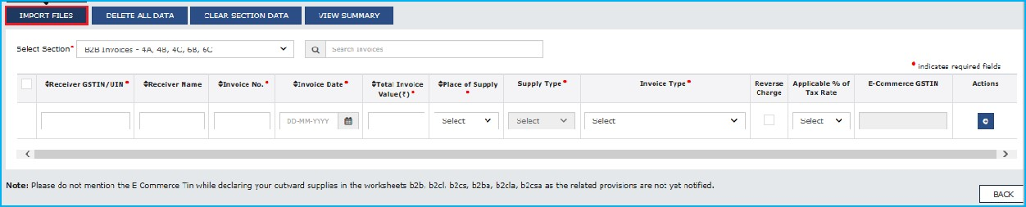
- Import Data Using Excel and which CSV Import page is displayed. From the Select Section drop-down list, select the section for you want to upload the invoices. Click the COPY EXCEL button.

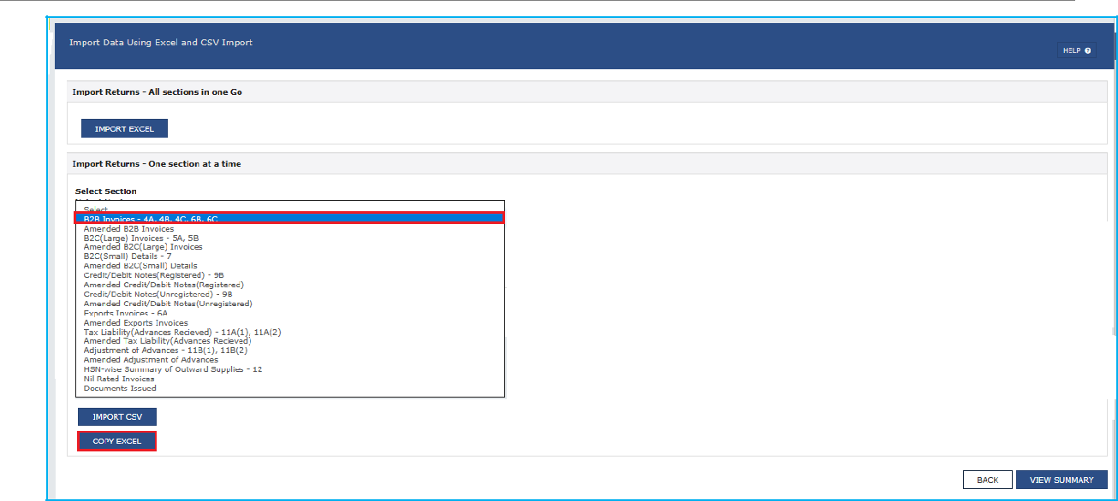

Note: Below screen is displayed in case taxpayer has opted for Quarterly filing of Form GSTR-1/ IFF.

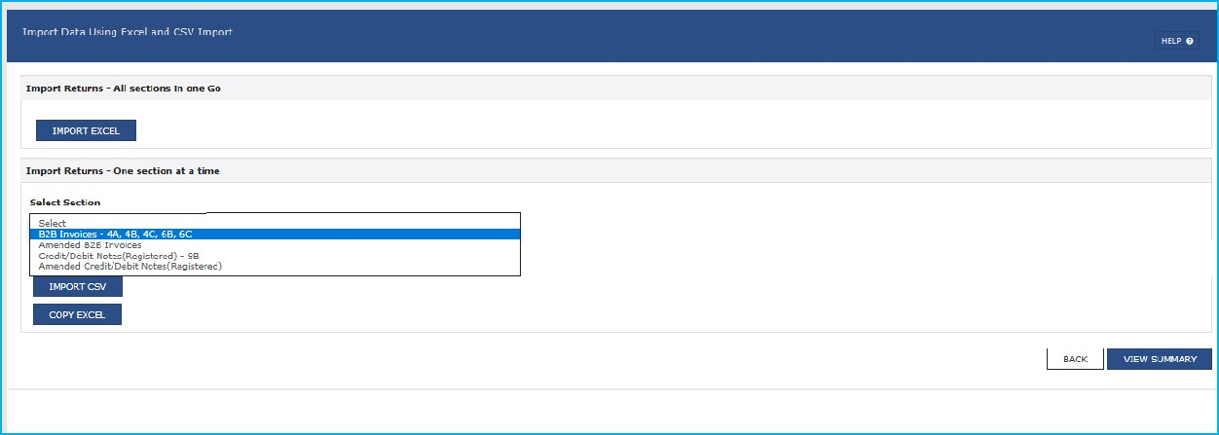

- A pop-up window is displayed. In the Click here and press the Ctrl+V Keys to paste data from Excel field, press the Ctrl+V Keys (Short Cut key for Paste) on the keyboard to paste the data copied from the excel sheet.

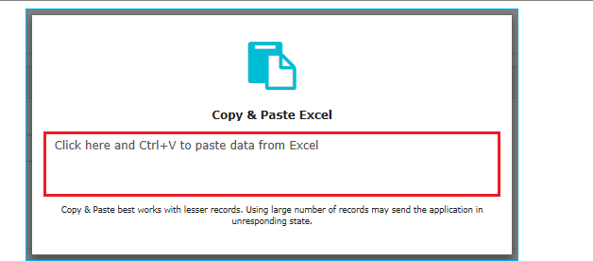

- Confirmation message is displayed. Click the PROCEED button to add the invoices.

Note:
  - In-built validations in the Returns Offline tool verifies the data copied by the user. On successful validation, the invoice data are copied to the offline tool.
  - Data that fails these validations can’t be processed further. To validate such invoices, go back to excel and check if the structure of GSTIN, invoice no. and invoice date entered are in specified format. Delete the duplicate invoice data if there is any.
  - Save the excel workbook and copy and paste the invoice data from the Excel workbook as you did earlier.

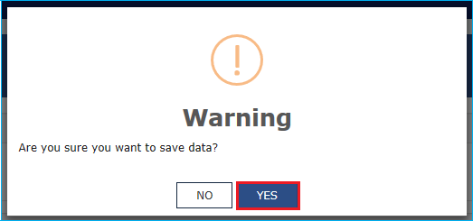

- A success message is displayed.



- Click the BACK button. Notice that the invoices present in the excel sheet are populated in the screen.

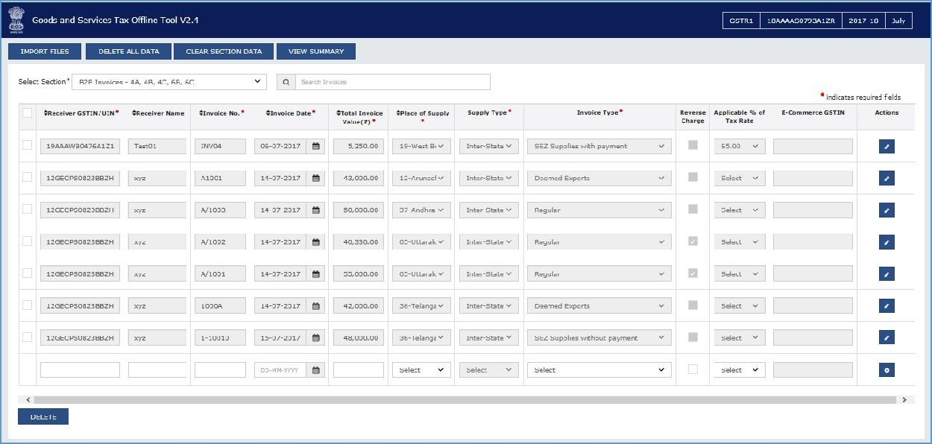

- The EDIT button allows to edit the data. The Delete button allows deleting a record that has been added erroneously. To delete the data, select the checkbox for the invoice and click the DELETE button.

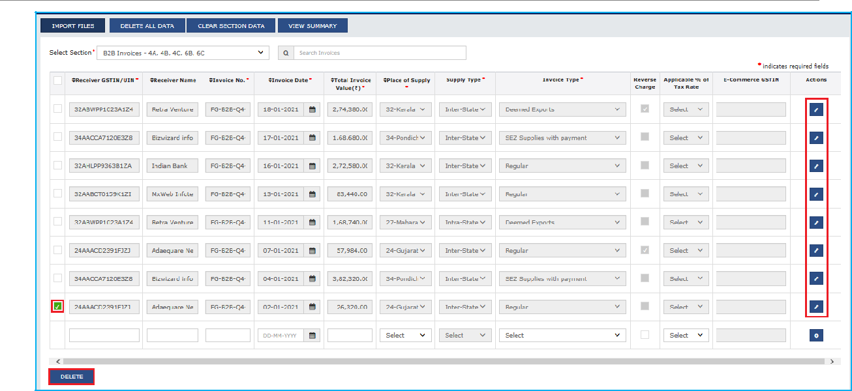

- To delete all data, click the DELETE ALL DATA button.

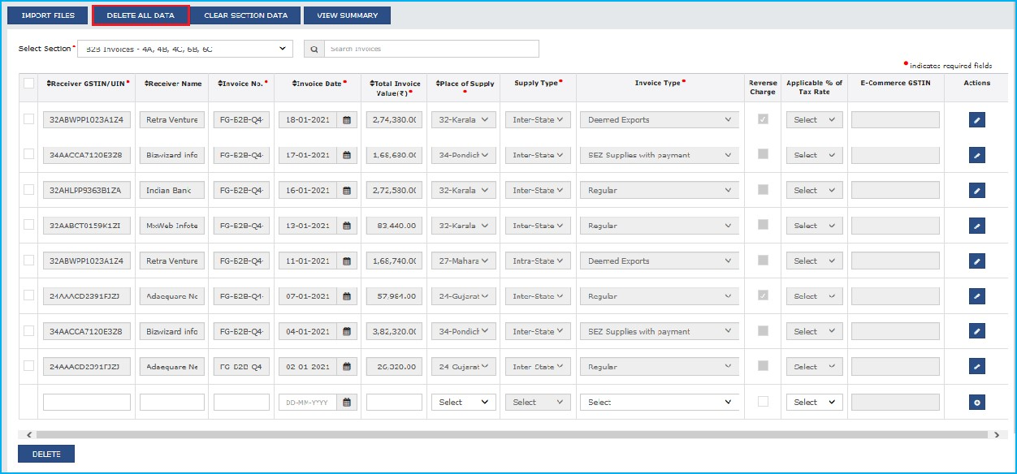

Click here to go back to Main Menu

D.4
Option

4:

Import

the

CSV

file

in

the

Tool

To import the invoice data from the CSV file (CSV files are part of Returns offline tool downloads), perform the following steps:
- Open the CSV template downloaded as part of Returns Offline tool and create data in CSV file for the applicable section of the return.
Note: The data in the CSV file must be in the same format as prescribed in the respective Return forms. Format is available in the sample CSV file. The process to enter details is same as explained above for excel sheets. Click here to know more.
- Click the IMPORT FILES button to import the CSV file in the Returns Offline tool.

- From the Select Section drop-down list, select the appropriate section. Under Return Import - One section at a time section, select the IMPORT CSV button.

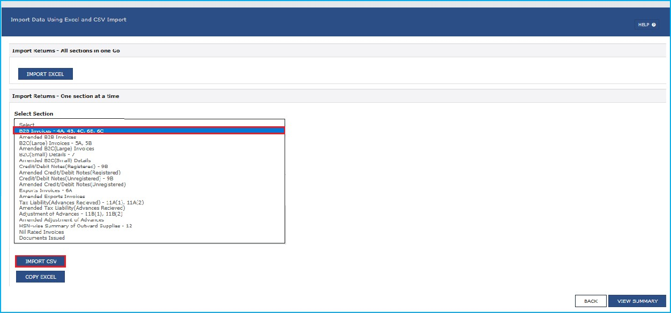

Note: Below screen will be displayed in case taxpayer has opted for Quarterly filing of Form GSTR-1/ IFF.

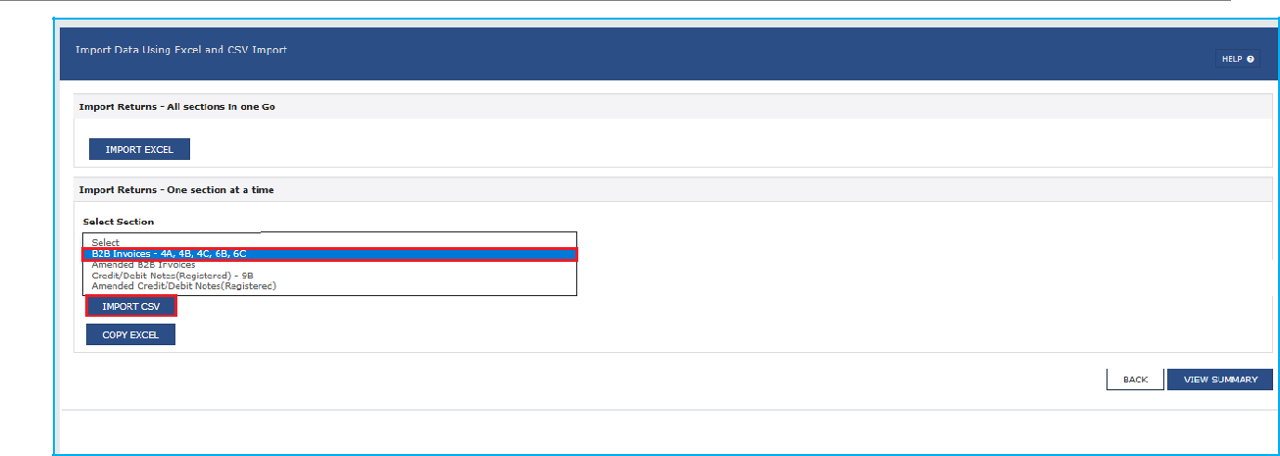

- Browse and select the applicable CSV file to import data from CSV. Click Open to import the csv file.

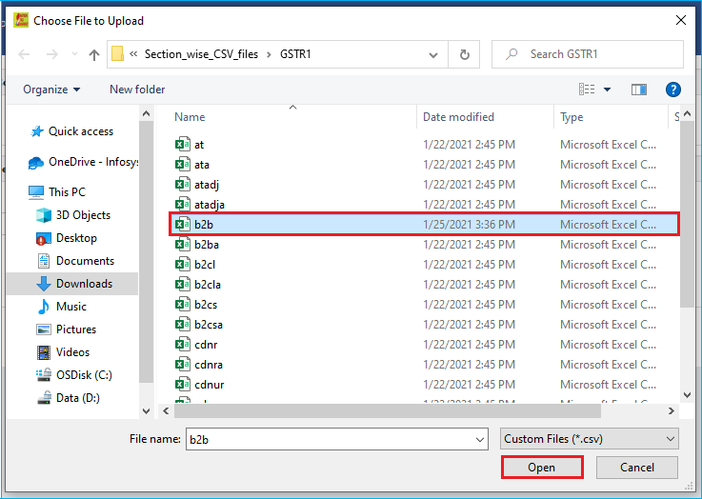

- A confirmation message is displayed. Click the Yes button to save imported invoice details.

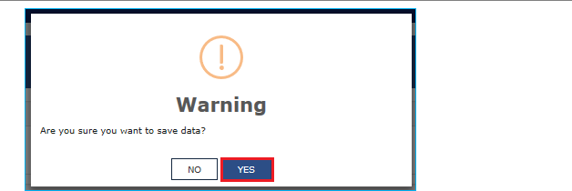

- On successful import, a success message is displayed.



- Click the BACK button. Notice that the invoices present in the csv file are populated in the screen. The EDIT button allows to edit the data. The Delete button allows deleting a record that has been added erroneously. To delete the data, select the checkbox for the invoice and click the DELETE button.

Note:
  - Make sure invoices entered in the excel sheet are unique and there are no duplicate invoice details entered in the excel sheet.
  - Date format is in dd-mm-yyyy format.

- Make the corrections and import the rectified CSV again. In case of duplicate invoices, the existing invoices are updated with the duplicate/ latest invoice data.
- Click the VIEW SUMMARY button to generate the file containing the invoices uploaded here.

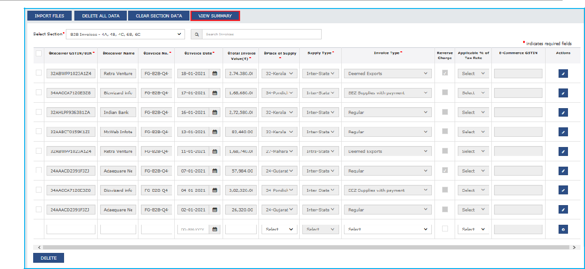

Note:
  - To delete single record, Select the checkbox against the record and click delete.
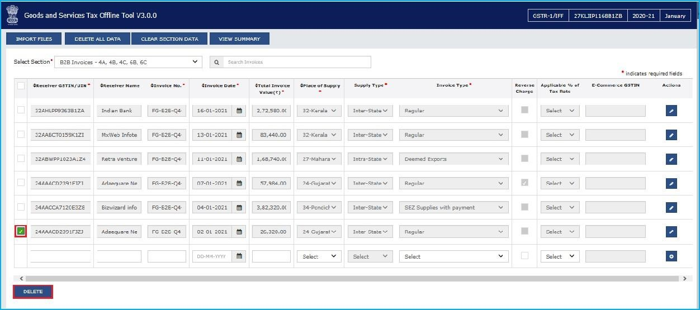

  - You can delete all the data uploaded in all sections of the Offline tool with DELETE ALL DATA.

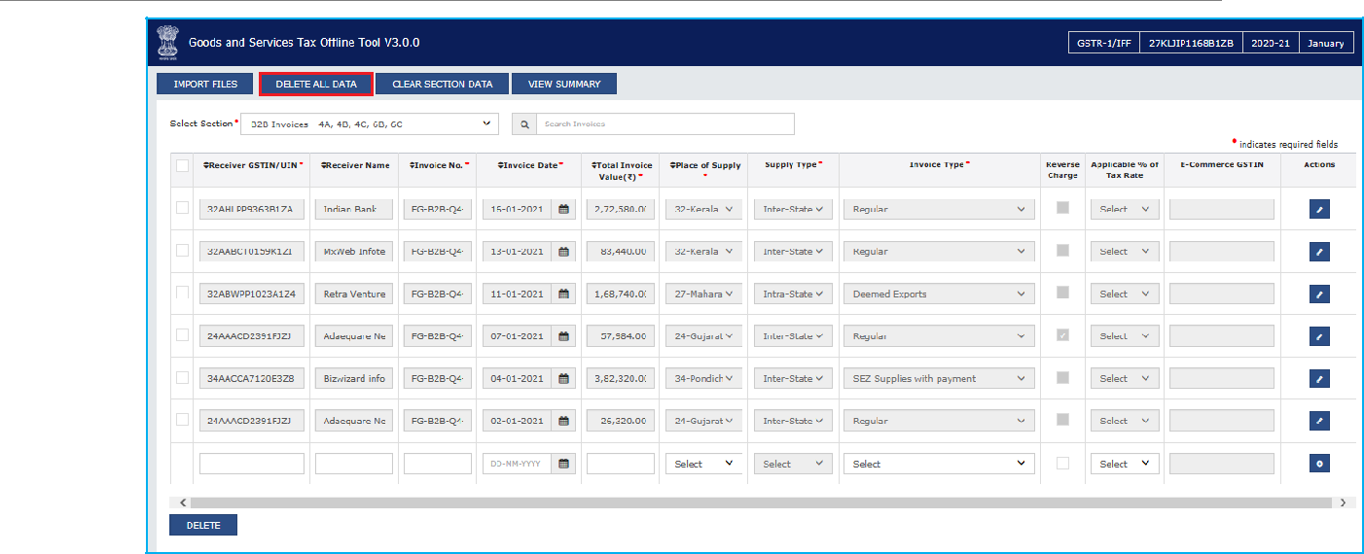

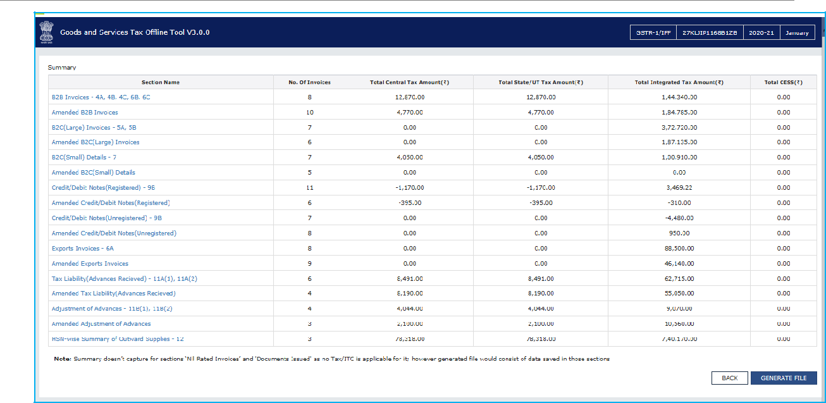
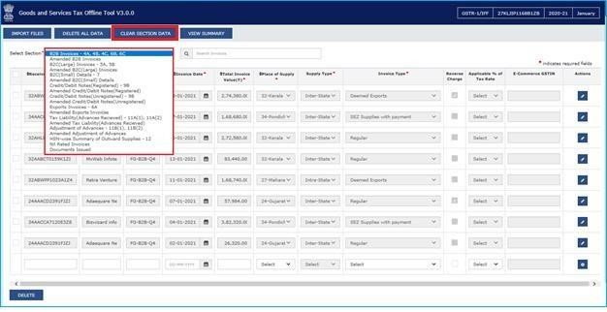
  - Clear Section Data is used to delete section wise data. Select the section for which you wish to delete the data from the drop-down list. Click CLEAR SECTION DATA.
10.

Click the
VIEW SUMMARY
button to generate the file containing the invoices uploaded
here. Summary is displayed. Number of invoices against relevant sections of the Return is
displayed.

Designed

and

Developed

by

GSTN

Page

80

of

117

Returns

Offline

Tool

Click here to go back to Main Menu

Designed and Developed by GSTN Page 81 of 117

E. Generating JSON File to Upload on GST Portal

Once you have checked the summary, you are ready to generate the JSON file, of all details entered, to be uploaded on GST Portal. To generate JSON file, perform the following steps:

- Click the GENERATE FILE button.

Note: Size of generated JSON file must not be greater than 5 MB. If the JSON file is more than 5 MB, then:
  - Delete some of the invoices in order to generate the JSON again with file size less than 5 MB.
  - As a next step, you can add the deleted invoices afresh in the returns offline tool and generate the JSON file again, to upload the same on the GST Portal.
  - You can follow the same process to generate multiple JSON files with file size less than 5 MB unless all invoices are converted into JSON format to be uploaded on GST Portal. You must be careful while naming the saved JSON files to distinguish them.

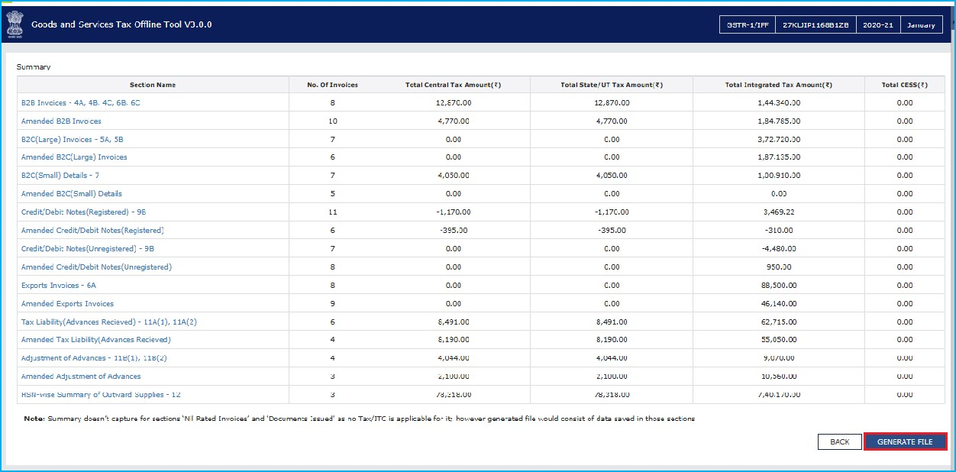

- The GST Compliant file generated by the Returns Offline tool (JSON format) will have to be saved on your computer for uploading the same on GST portal. Click the Save button.

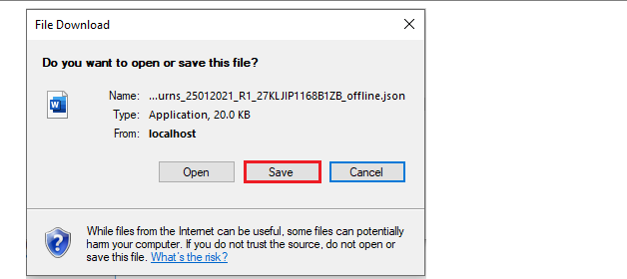

- Browse and select the path to save the .JSON file which needs to be uploaded in the GST Portal.

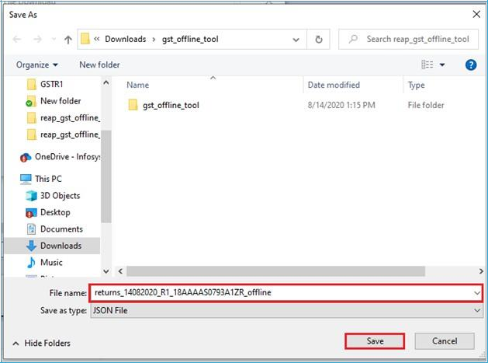

Note: Tool will create JSON file with same name format, in case second lot of invoices are uploaded in the Returns Offline tool for the same month and a new JSON file is generated. So, you need to rename the file manually every time.

Click here to go back to Main Menu

F. Uploading Generated JSON on GST Portal
After generating the JSON successfully, you need to upload json file on the GST Portal. To upload the .json file on GST Portal, perform the following steps:

- Access the https://gst.gov.in/ URL. The GST Home page is displayed. Login to the GST Portal with valid credentials. Click the Services > Returns > Returns Dashboard option.

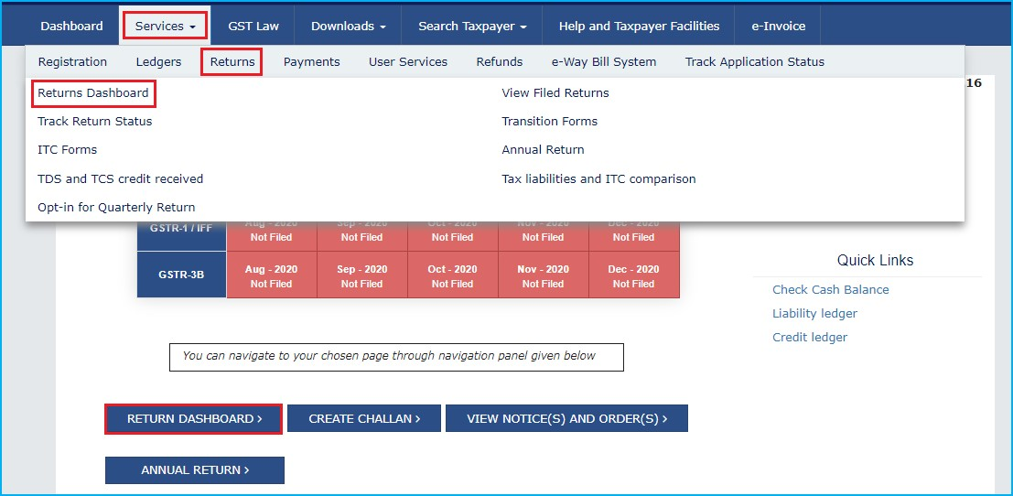

- The File Returns page is displayed. In the Financial Year drop-down list, select the financial year for which the return has to be uploaded. In this example, we will select this as 2020-21. In the Quarter and Period drop-down list, select the relevant quarter and period for which the return has to be uploaded. In this example, we will select Quarter 4 (Jan - Mar) and period as January. Click the SEARCH button.

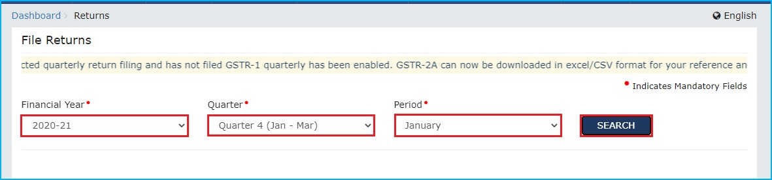

Note: In case the taxpayer have opted for quarterly filing of Form GSTR-1/ IFF, then for this example we need to select 2020-21, Quarter 4 (Jan - Mar) and January(M1)/ February(M2)/ March(M3) as the case may be.

- Applicable returns of the selected tax period is displayed. In the Outward Supplies made by the Taxpayer FORM GSTR-1/ IFF tile, click the Prepare offline button.

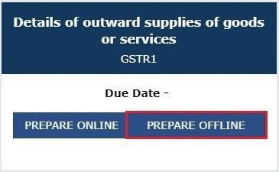

Note: Below screen will be displayed only for taxpayers who have opted for quarterly filing of Form GSTR-1/ IFF.

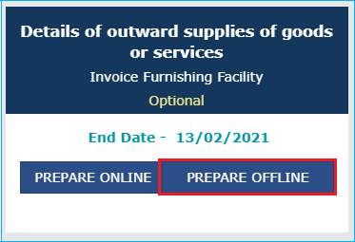

- The Upload page is displayed. Click the Choose File button.

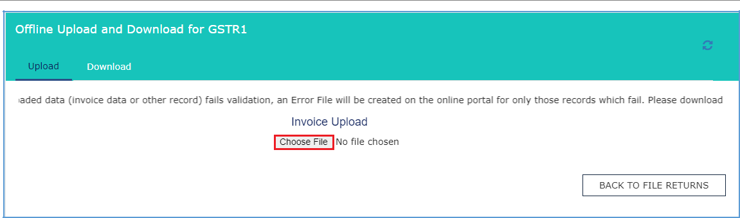
Designed and Developed by GSTN Page 85 of 117

Returns Offline Tool

Note: Below screen will be displayed only for taxpayers who have opted for quarterly filing of Form GSTR-1/ IFF. Click the HELP button to read the instructions and upload/ download JSON successfully on the GST Portal.

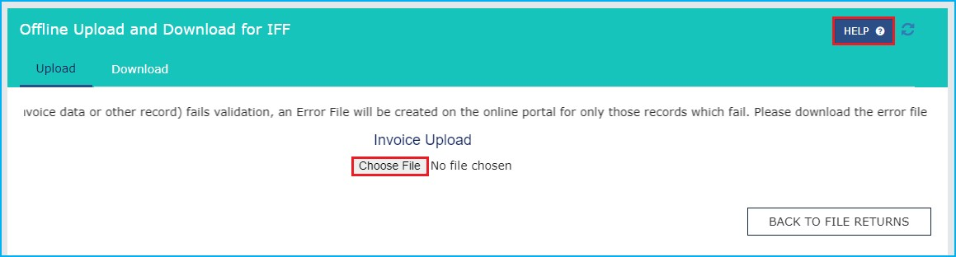

- Browse and navigate the file .JSON to be uploaded from your computer. Click the Open button. Note: In case taxpayer have more than one JSON file or the JSON file is of size more than 5 MB, then they must upload it in multiple chunks.

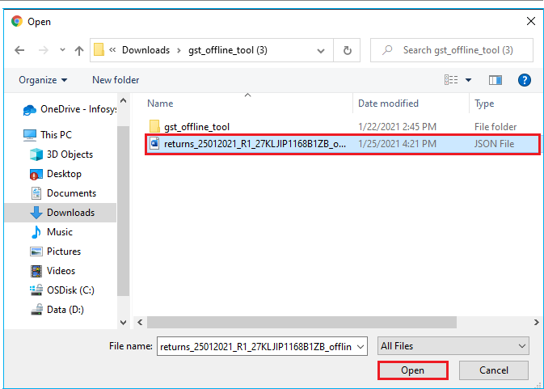

- After uploading the invoices on GST Portal, a reference ID Number will be generated, and the status of invoice will display as In-Progress.

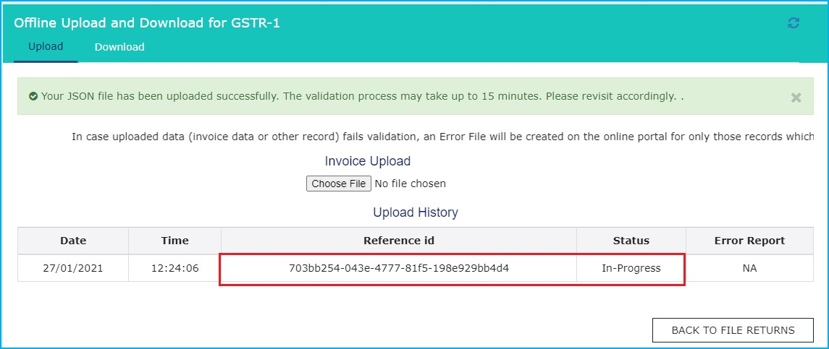
Note: Below screen will be displayed only for taxpayers who have opted for quarterly filing of Form GSTR-1/ IFF.

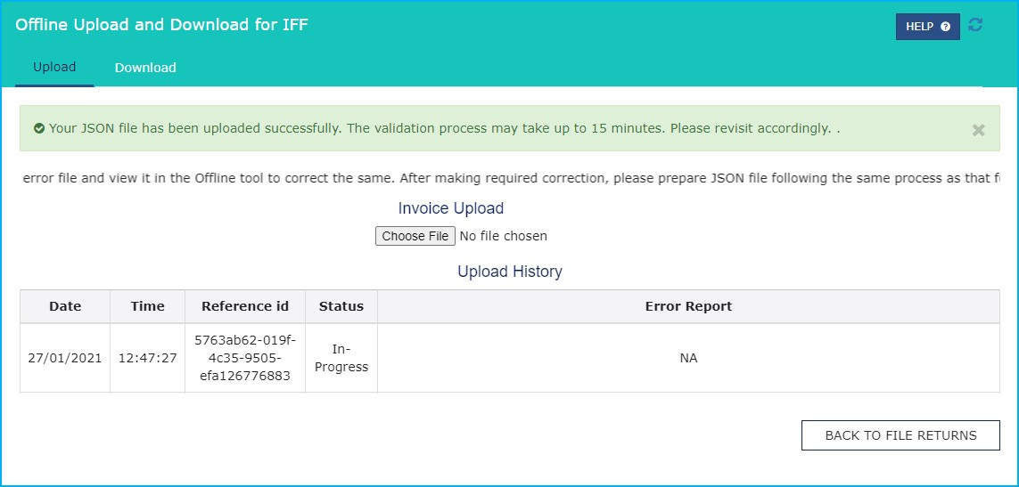
Designed and Developed by GSTN Page 87 of 117 Returns Offline Tool

- After validating the invoices, the message is displayed as invoices are being processed.

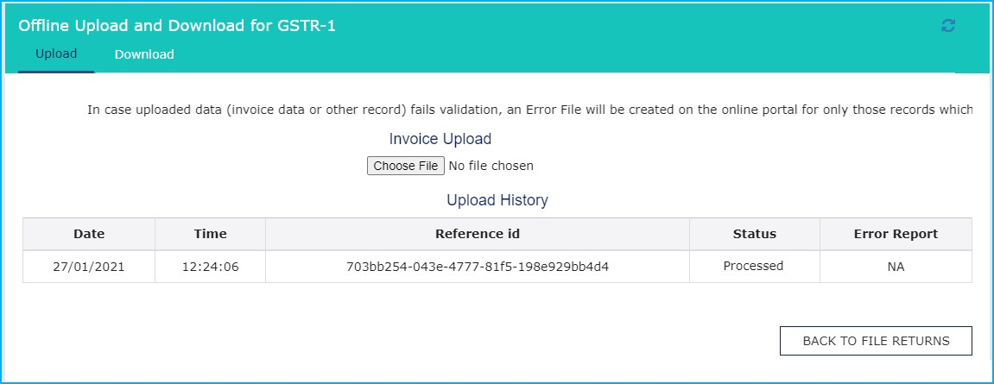

Note: Below screen will be displayed only for taxpayers who have opted for quarterly filing of Form GSTR-1/ IFF.

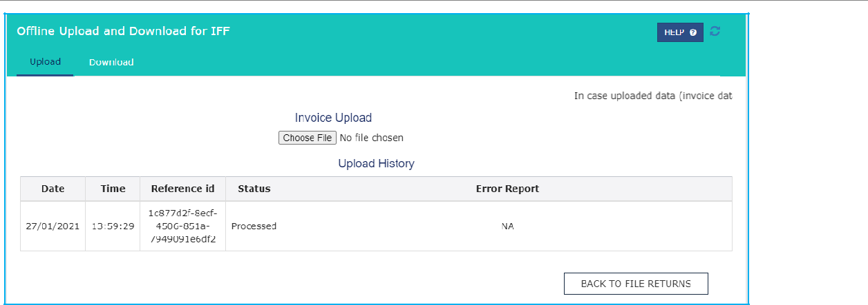

Note: There will a gap of few minutes between the time you upload the invoice data on the GST Portal, and it appears under the relevant section on the Returns dashboard. After upload, a transaction ID is generated, against which you can track your upload processing status. This happens as the GST Portal will perform the following processing functions before adding the invoice in respective section and enabling you to see the data populated in the relevant tables of FORM GSTR-1/ IFF:
  - Correctness of GSTIN of receivers (Valid GSTINs etc.)
  - Duplicate entries of Invoice number for all returns filed by you in past months of the Financial Year in which you are filing the data
  - Other sanity checks on the data uploaded by you

- Go to the B2B invoices in the FORM GSTR-1/ IFF tile. Notice the B2B invoices are uploaded.

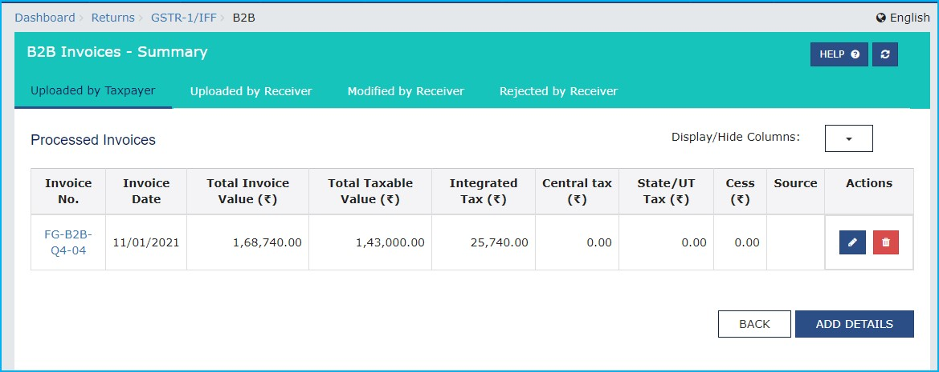

- Similarly, you can view uploaded invoices for other sections as well.

Note: In case data uploaded through JSON on GST Portal (invoice data or other record) fails validation, an Error Report will be created on the GST Portal for only those records
which have failed validations. Click here to know about ERROR FILES Click here to go back to Main Menu
G. Downloading Error File of FORM GSTR-1/ IFF and Opening it in the Tool

In case data uploaded through JSON on the portal (invoice data or other record) fails validation as defined in the GST Portal, an Error File will be created for only those records which have failed validations. The error file will be available in a hyperlink as given in the below screen on the upload offline page in the GST Portal, after login. Initially the Status of the error file will be shown as In-Progress.

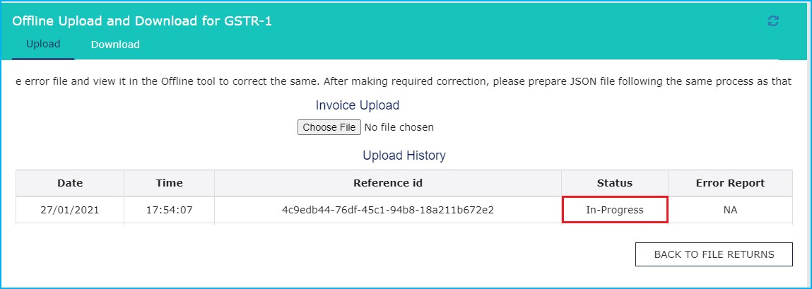
Returns Offline Tool

Note: In case taxpayer has opted quarterly filing of Form GSTR-1/ IFF, then below screen is displayed.

- After some time, the Status will be changed to Processed or Processed with Error. If the
JSON uploaded on GST Portal is successfully validated, then the status will change to
Processed. In case uploaded JSON fails validation, then the status will change to Processed with Error and the Error Report column will display a link to Generate error report.

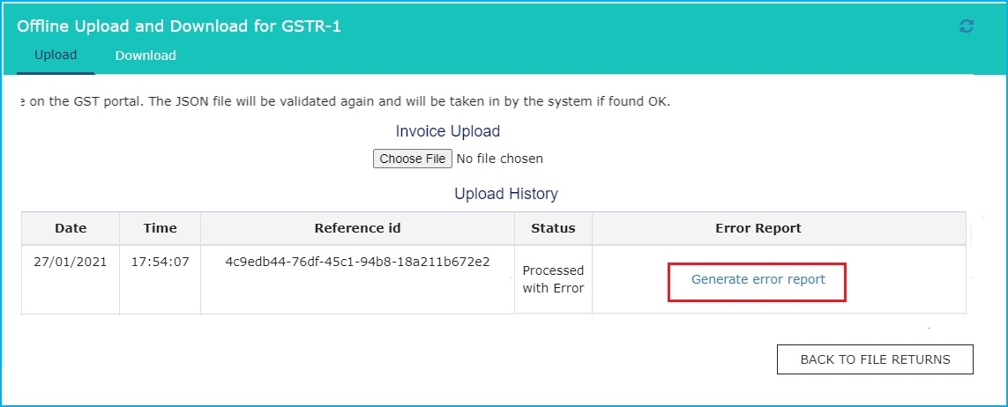

Note: In case taxpayer has opted quarterly filing of Form GSTR-1/ IFF, then below screen is displayed.

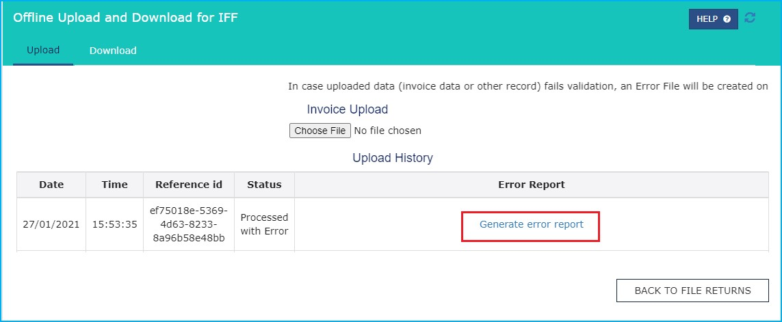
- Once the error report is generated, the Error Report column will display a link to Download error report.

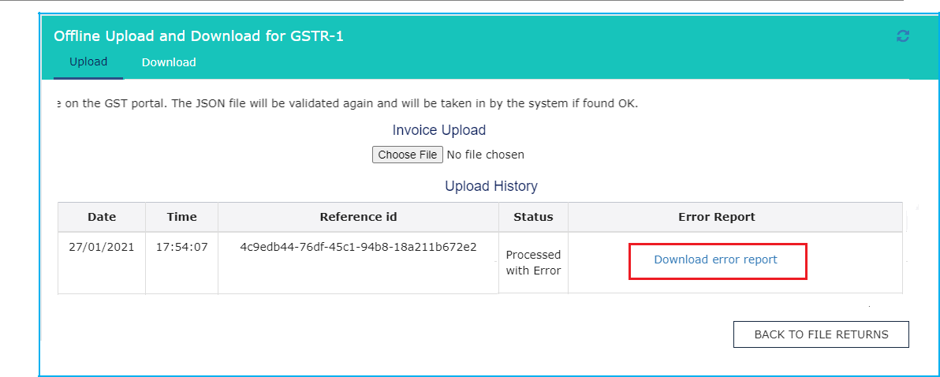

Note: In case taxpayer has opted quarterly filing of Form GSTR-1/ IFF, then below screen is displayed.

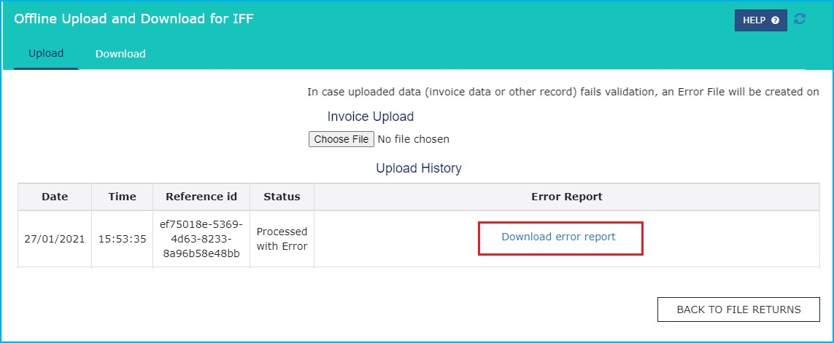
Page 91 of 117

- The error file can be downloaded from the link and errors can be viewed in the Offline tool to correct the same. Let us take an example where error file is already generated, and you need to open it using the Returns Offline tool. To open error file using the Returns Offline tool, double click the Offline tool icon on your desktop, the Offline tool Home Page will be displayed.
- In the Open Downloaded Error file from GST portal tab, click the OPEN button.

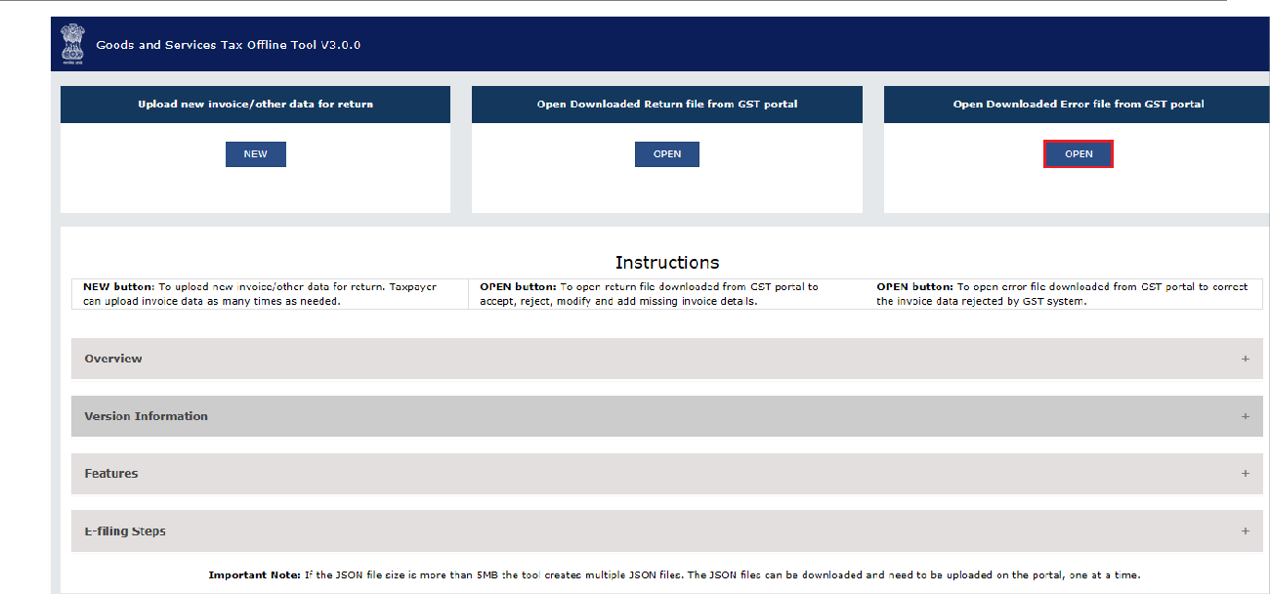

- Browse and select the downloaded error file in zip format and click the OPEN button.

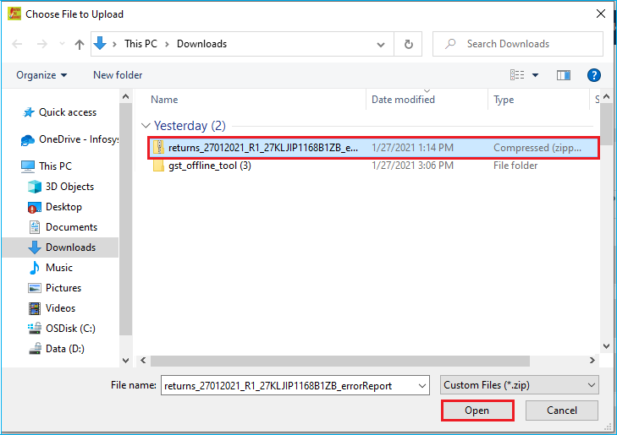
Page 92 of 117
- Details of the file which have you have downloaded from the GST Portal is displayed.
- Select Yes or No if you are SEZ Taxpayer. Select Yes or No if you are Quarterly Taxpayer. Click the PROCEED button.

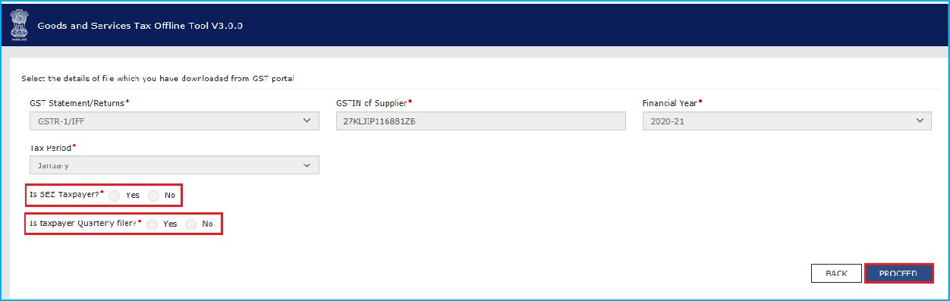

- The sections where there are errors are only populated in the summary page. Click the section hyperlink to view the errors.

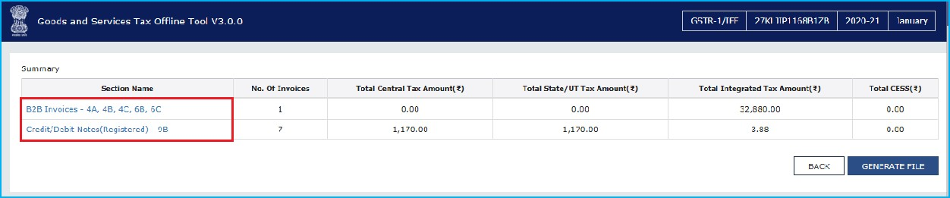

- Notice that the error message is displayed against the respective Invoice number. Read each error message carefully and then click the EDIT button to edit the details and make the required corrections in the invoices/details.

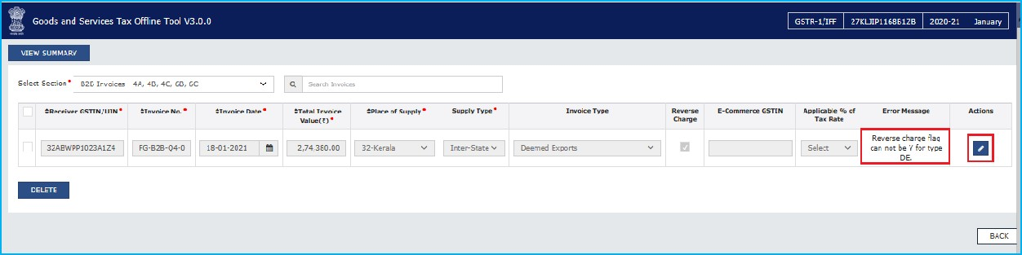

- After you have modified the invoices, click the SAVE button.
Note: You can click the Delete button to delete the invoice.

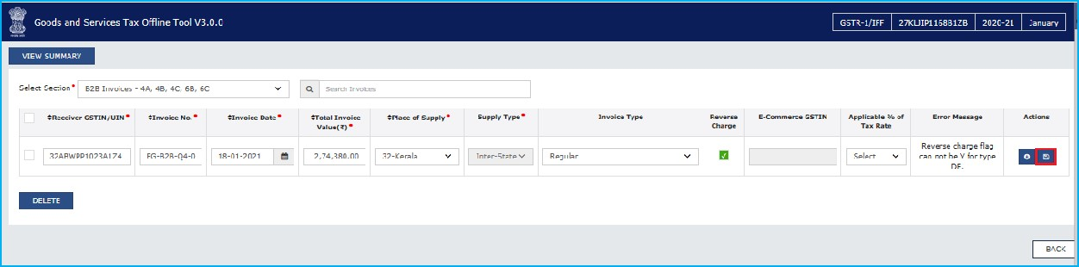

- To modify the details or records at rate level, click on the ‘+’ button and navigate to the rate level records. Do the necessary corrections and click the UPDATE button.

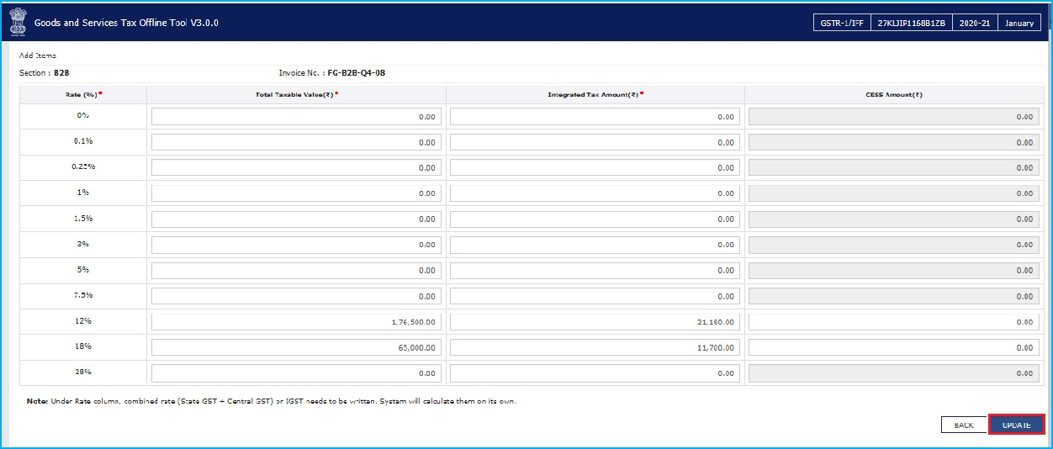

- A success message is displayed. The status of the error message is changed to Modified (M). Similarly, you can modify the other invoice data from other sections.

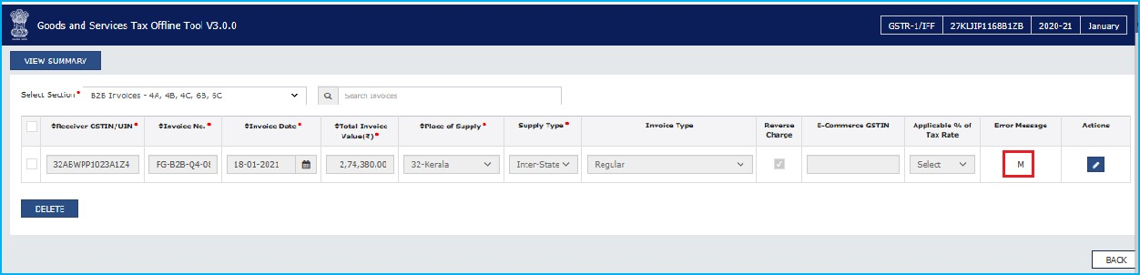
- Once all the errors are rectified, click the VIEW SUMMARY button to view the summary.

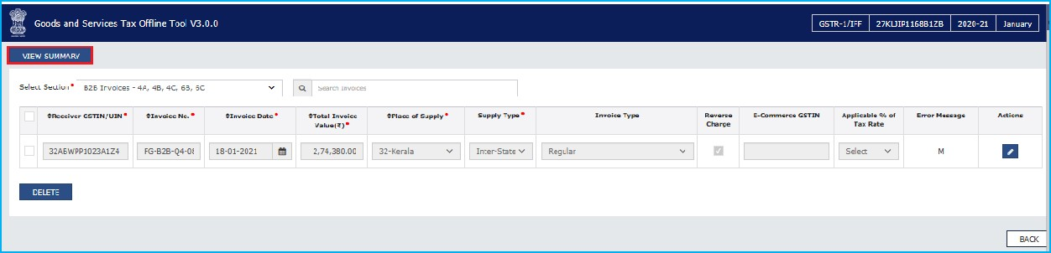
.

- The Summary page is displayed, click the GENERATE FILE button.

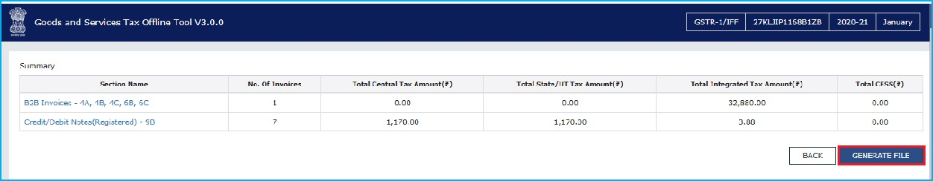

- The GST Compliant file generated by the Returns Offline tool (JSON format) will have to be saved in your computer for uploading the same on GST portal. Click the Save button.

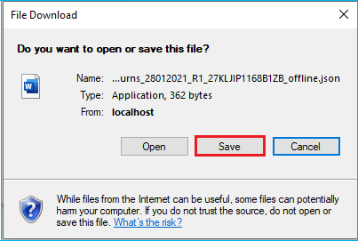
- Browse and select the path to save the .JSON file which needs to be uploaded in the GST Portal.

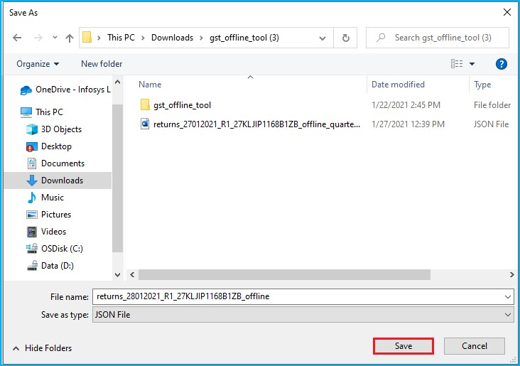

- Login to the GST Portal with your credential and upload the JSON file as discussed in the above section. The JSON file will be validated again and will be taken in by the GST Portal after the due validations. Once JSON file is uploaded, click below links so that you can: Upload JSON on GST Portal

Click here to go back to Main Menu

H. Downloading FORM GSTR-1/ IFF Return File and Opening it in the Tool (if needed)

The Form GSTR-1/ IFF return file can be downloaded from GST portal and viewed in the Offline tool to modify, add or delete invoice details, uploaded earlier by you. After making required changes, a JSON file needs to be prepared, following the same process as that for regular invoice data, and upload the JSON file on the GST portal. The JSON file will be validated again and will be populated in selected Form GSTR-1/ IFF tiles on the GST Portal, after the due validations.
- Login to the GST Portal with valid credentials. Click the Services > Returns > Returns Dashboard option. Alternatively, you can click Returns Dashboard.

- The File Returns page is displayed. In the Financial Year drop-down list, select the financial year for which the FORM GSTR-1/ IFF return has to be downloaded.
- In the Quarter and Period drop-down list, select the quarter and period for which the FORM GSTR-1/ IFF return has to be downloaded. Click the SEARCH button.

- Applicable returns of the selected tax period are displayed. In the Details of outward supplies of goods or services FORM GSTR-1/ IFF tile, click the PREPARE OFFLINE button.

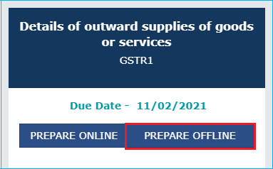

Note: In case taxpayer has opted quarterly filing of Form GSTR-1/ IFF, then below screen is displayed.

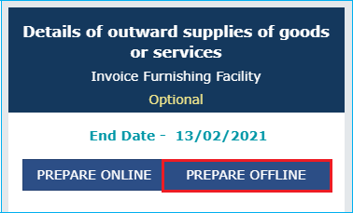

- The Offline Upload and Download for FORM GSTR-1/ IFF page is displayed. Click the DOWNLOAD tab.



Note: In case taxpayer has opted quarterly filing of Form GSTR-1/ IFF, then below screen is displayed.

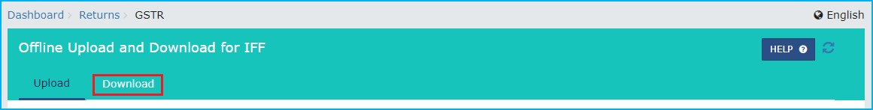

- Click the GENERATE JSON FILE TO DOWNLOAD button.

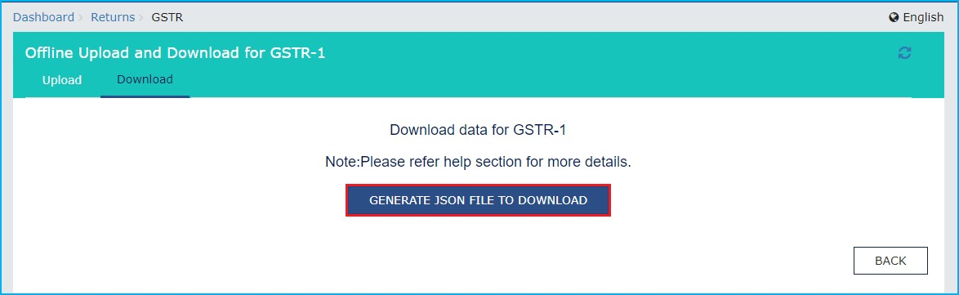

Note: In case taxpayer has opted quarterly filing of Form GSTR-1/ IFF, then below screen is displayed.

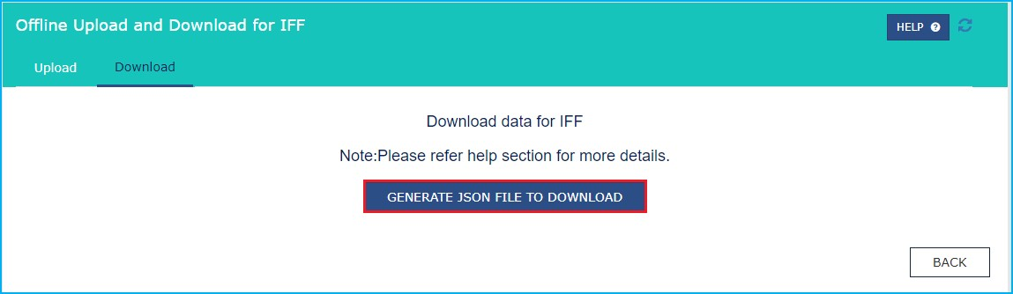

- A message is displayed that the request has been accepted and will take 20 minutes to generate the file.
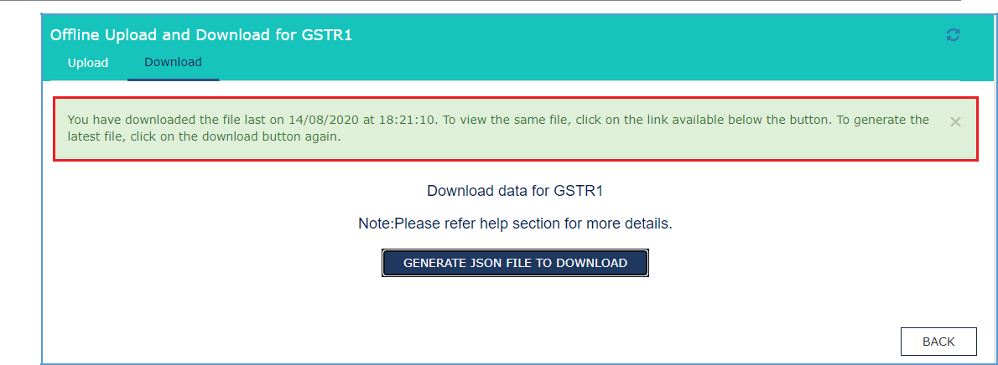
Designed and Developed by GSTN Page 99 of 117
Note: In case taxpayer has opted quarterly filing of Form GSTR-1/ IFF, then below screen is displayed.

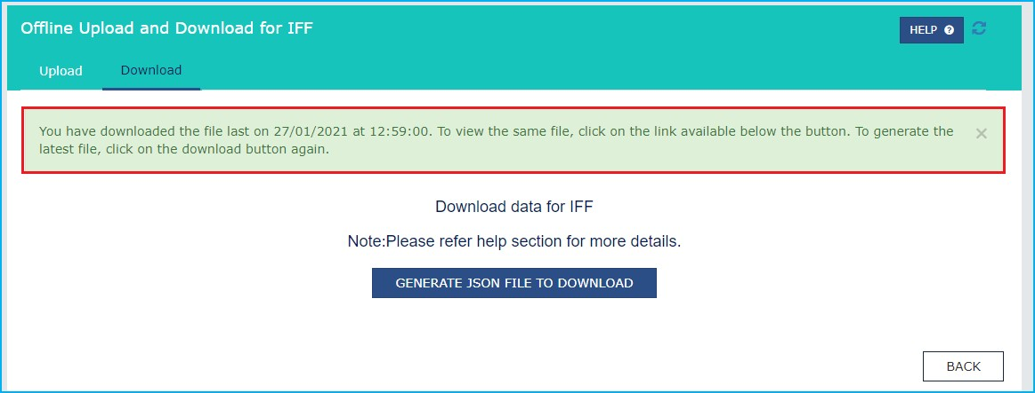

- Click the Click here to download link. Return file is downloaded in the zip format.

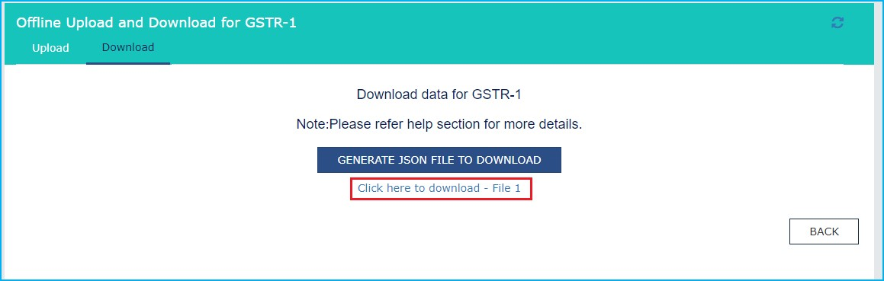

Note: In case taxpayer has opted quarterly filing of Form GSTR-1/ IFF, then below screen is displayed.

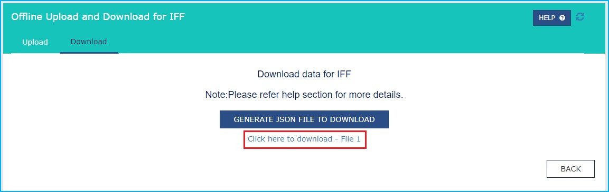
Designed and Developed by GSTN Page 100 of 117

- Let us take an example where FORM GSTR-1/ IFF return file is already downloaded from the GST Portal and you need to open it using the Returns Offline tool. To open downloaded return file from GST Portal using the Returns Offline tool, double click the Offline tool icon on your desktop, the Offline tool Home Page will be displayed.
- In the Open Downloaded Return file from GST portal tab, click the OPEN button.

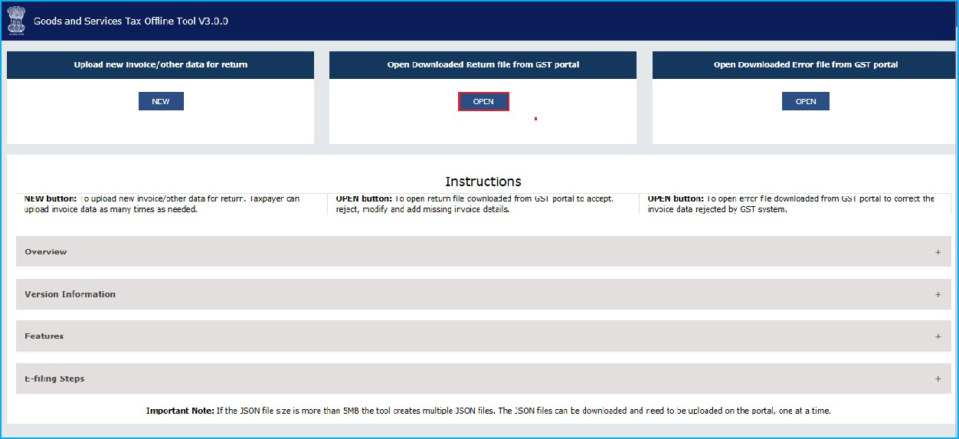

- Browse and select the downloaded return file in zip format and click the OPEN button.

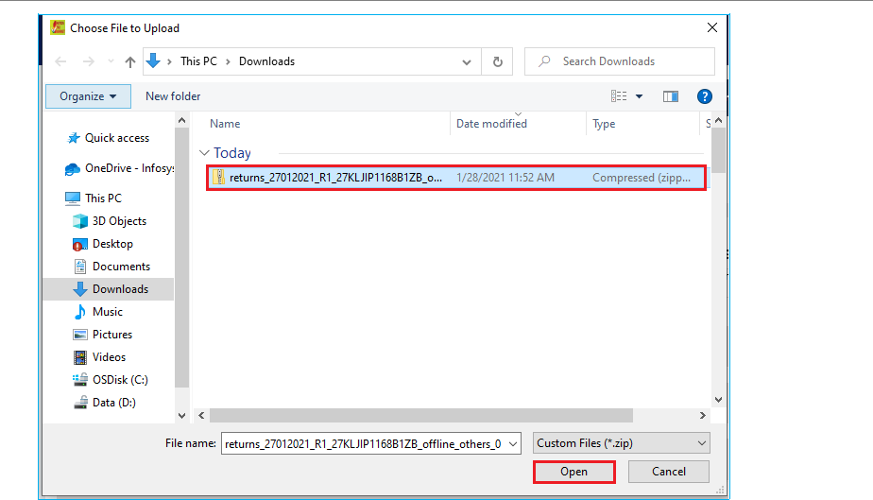
Designed and Developed by GSTN Page 101 of 117

- Details of the file which have you have downloaded from the GST Portal is displayed.
- Select Yes or No if you are SEZ Taxpayer.
- Select Yes or No if you are Quarterly Taxpayer. Click the PROCEED button.

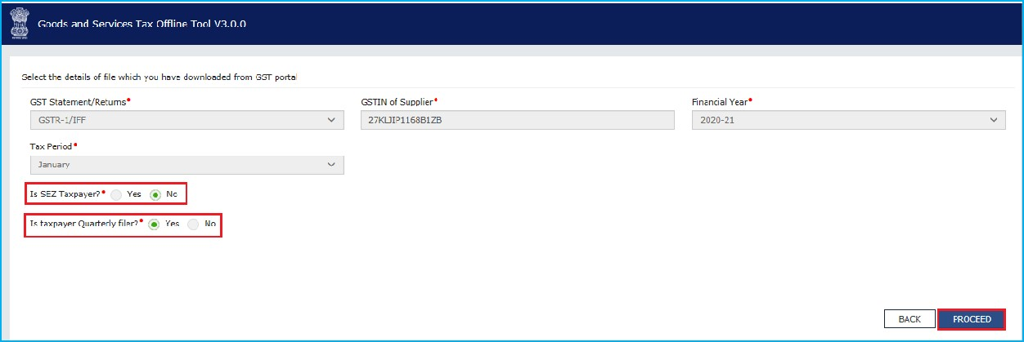

- The Summary page is displayed. Select the link for the desired Section Name to modify, add or delete invoice details.
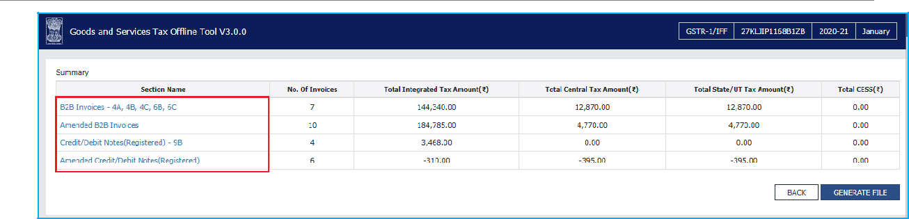

- Once section details are displayed, click below links so that you can:
  - Modify Invoices Details
  - Add Invoices Details
  - Delete Invoices Details

Click here to go back to Main Menu

H.1
Modify

Invoices

Details

- Click the EDIT button to edit the invoices and make the required corrections in the invoices/ details uploaded/added earlier by you in GST Portal.

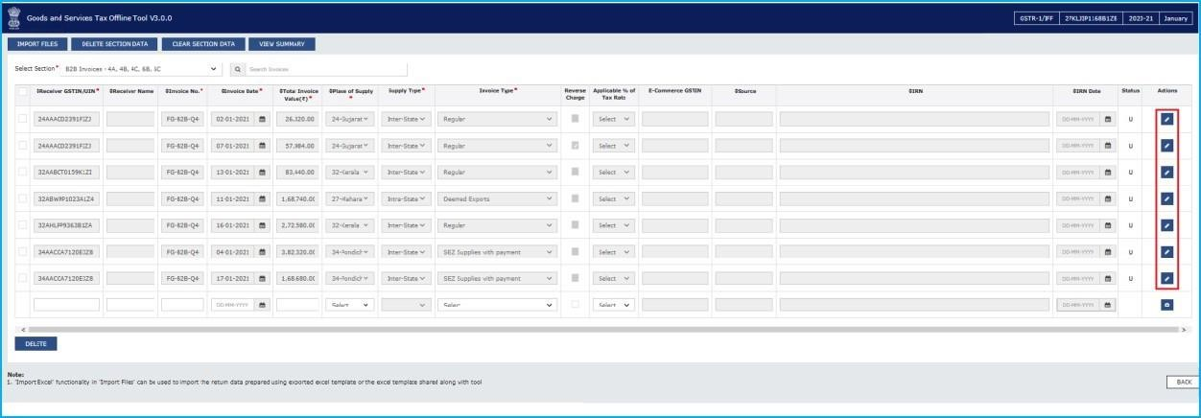

- To modify the details or records at rate level, click on the’ +’ button and navigate to the rate level records.

Note: You can make the changes at field level and click the SAVE button to save the invoice details.

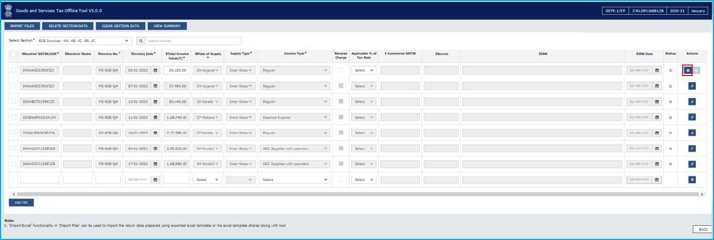

- Do the necessary corrections and click the UPDATE button.

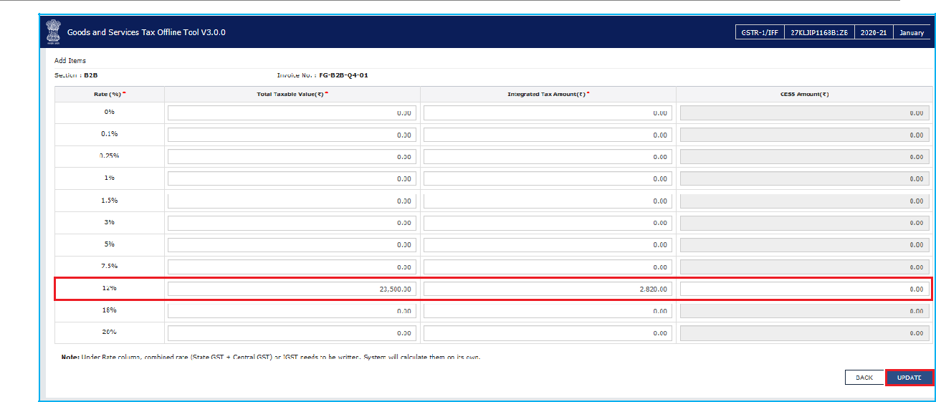
- A success message is displayed.

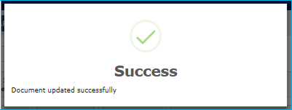

- The status is changed to Edited (E).

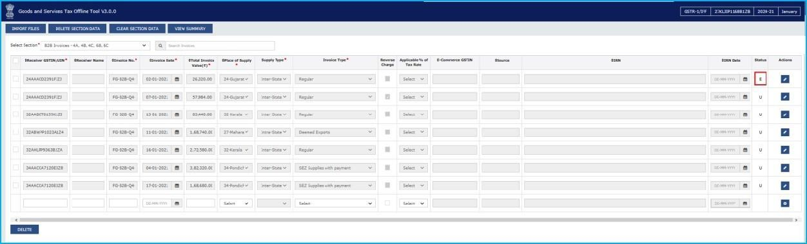

- Similarly, you can modify invoice and other returns data from other sections.

H.2
Add

Invoices

Details

- Enter the invoice details. Click the ADD button.

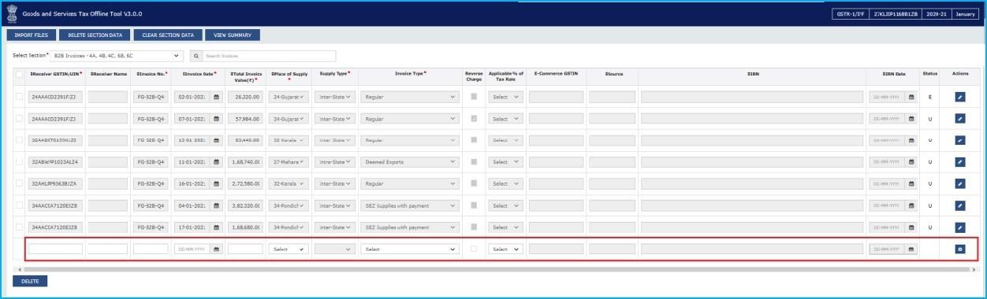

- Add the necessary details and click the SAVE button.

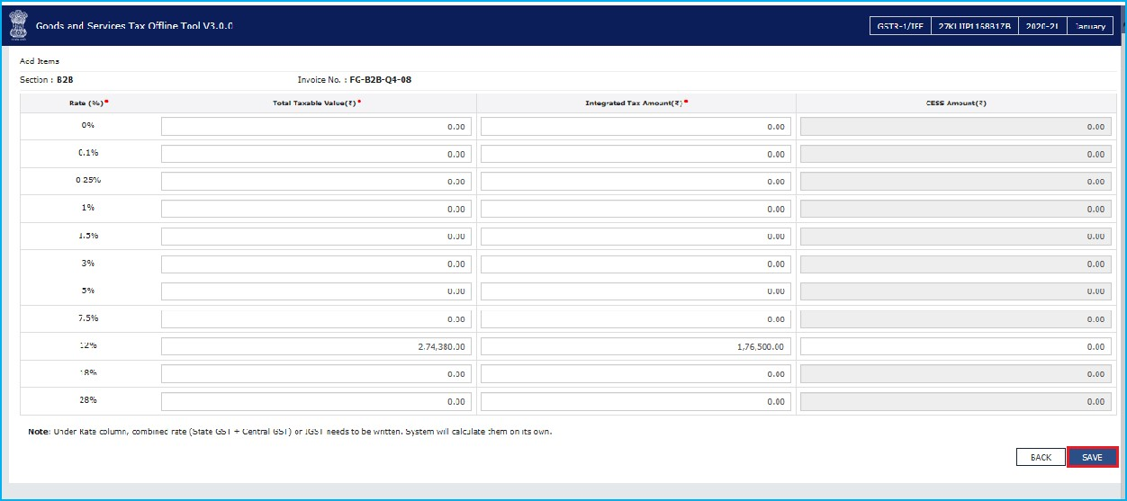

- A success message is displayed, and invoice details are added.



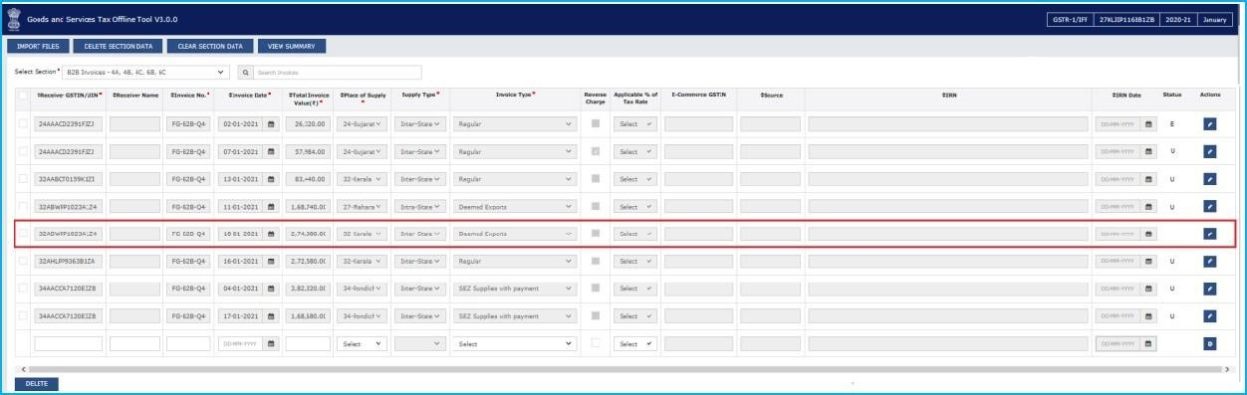

Note: You can also click the IMPORT FILES button to import the invoice data using the Excel and CSV import as discussed above.

- Similarly, you can add the invoice and other returns data from other sections.
Designed and Developed by GSTN Page 106 of 117

H.3

Delete

Invoices

Details

- You can delete the data already uploaded on the GST Portal by downloading the return file and opening the same in the Tool. Select the checkbox for the invoice to be deleted. Click the DELETE button.

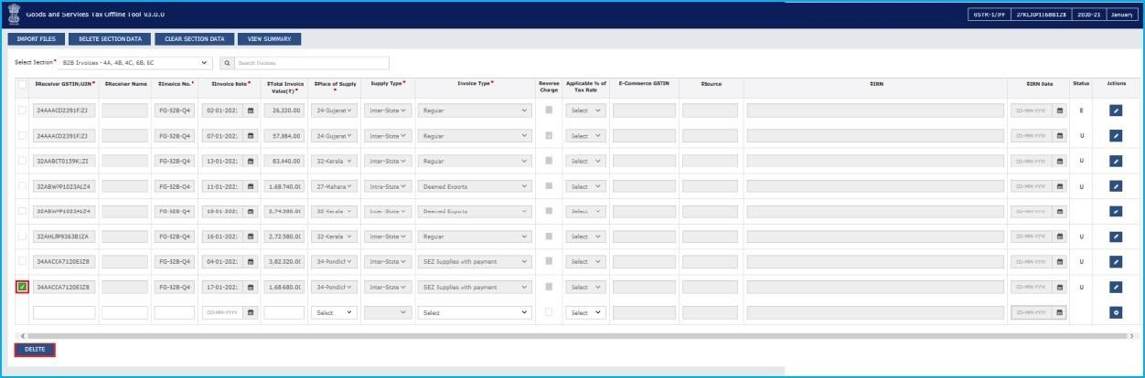

- A success message is displayed, and invoice details are deleted.

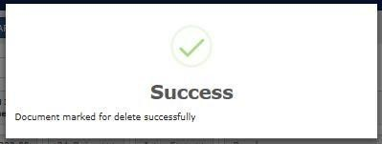

- The status of such invoice will be marked as D. Similarly, you can delete existing invoice data already uploaded on the GST Portal which is downloaded and opened in the Tool.

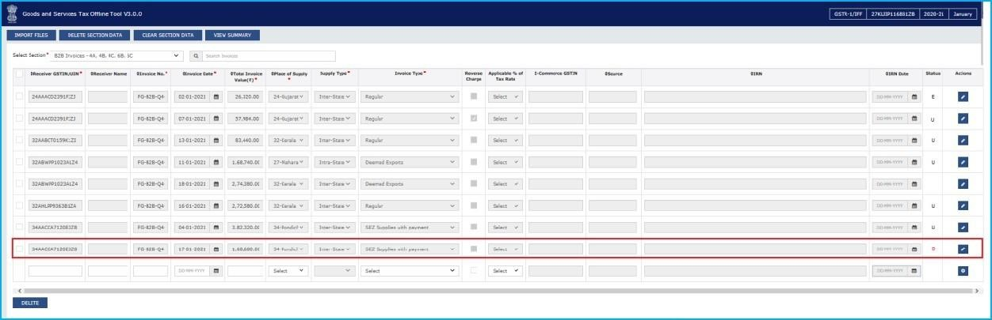

Note: You can select the checkbox as shown in the screenshot below to select multiple invoices to delete at one go. Click the DELETE button to delete all invoices.

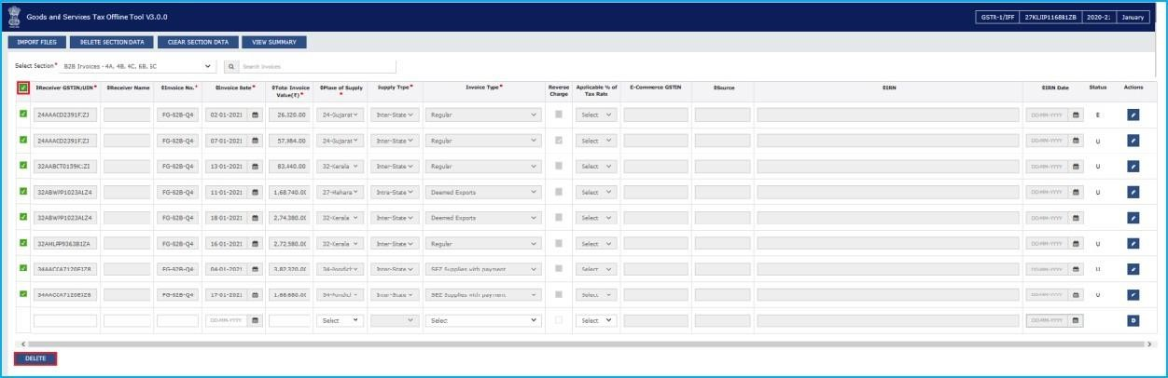

- Once all the corrections are done, click the VIEW SUMMARY button.

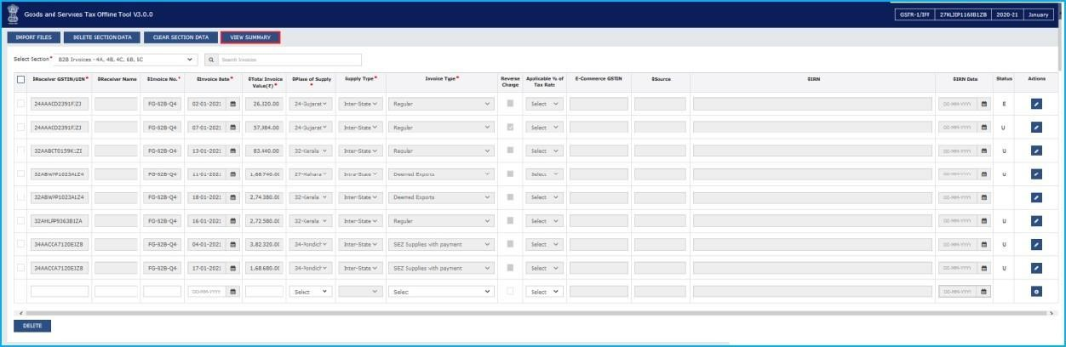
.
- The Summary page is displayed, click the GENERATE FILE button.

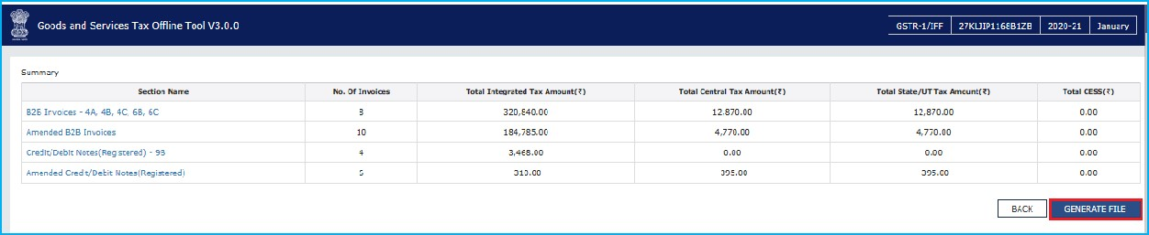

- The GST Compliant file generated by the Returns Offline tool (JSON format) will have to be saved in your computer for uploading the same on GST portal. Click the Save button.

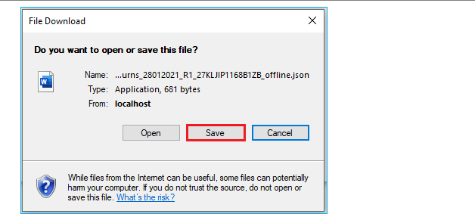

- Browse and select the path to save the .JSON file which needs to be uploaded in the GST Portal.

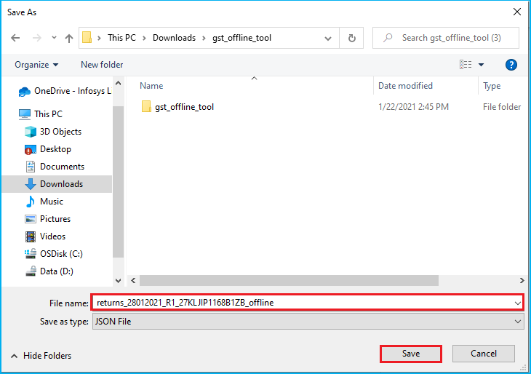
- Login to the GST Portal with your credential and upload the JSON file as discussed in the above section.

Click here to go back to Main Menu

Click here to see how to upload JSON on GST Portal

I. Downloading Form GSTR 2A File and Opening it in the Tool (if required)

The Form GSTR 2A file can be downloaded from GST portal and the details can be viewed in the Offline tool. The downloaded file can be opened in Offline tool to view invoices and credit/debit notes uploaded by your supplier in their FORM GSTR-1/ IFF. You would not be able to take any action on the data populated as Form GSTR-2A is view only return.
- Login to the GST Portal with valid credentials. Click the Services > Returns > Returns Dashboard command. Alternatively, you can click Returns Dashboard.

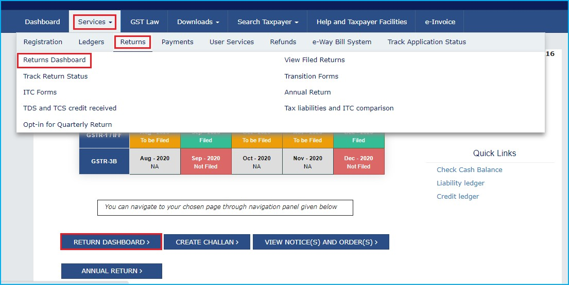

- The File Returns page is displayed. In the Financial Year drop-down list, select the financial year for which the GSTR2A return has to be downloaded. In the Quarter and Period drop-down list, select the quarter and period for which the GSTR2A return has to be downloaded. Click the SEARCH button.

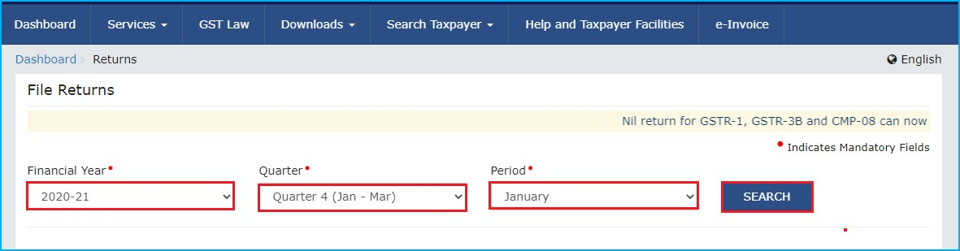

- Applicable returns of the selected tax period are displayed. In the Auto Drafted details GSTR2A tile, click the DOWNLOAD button.

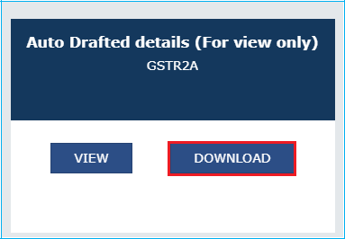

- Click the GENERATE JSON FILE TO DOWNLOAD button to generate the JSON. It may take upto 20 minutes for the file to be generated. Once the file is generated, the link will appear to download. Download the file.

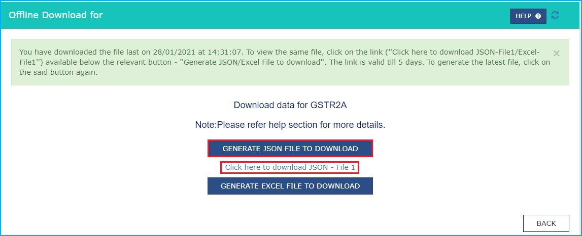

- Let us take an example where GSTR2A return file is already downloaded from the GST Portal and you need to open it using the Returns Offline tool. To open downloaded return file from GST Portal using the Returns Offline tool, double click the Offline tool icon on your desktop, the Offline tool Home Page will be displayed.
- In the Open Downloaded Return file from GST portal tab, click the OPEN button.

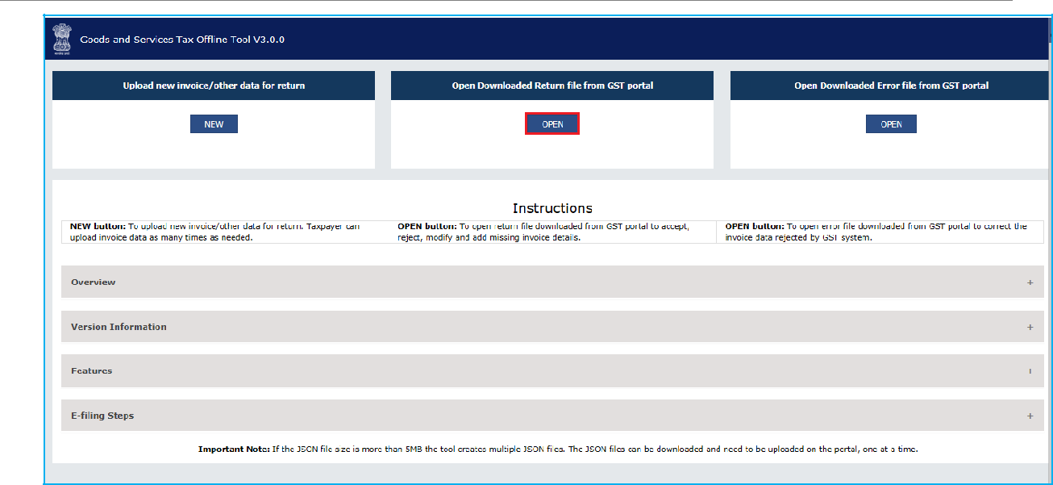
- Browse and select the downloaded return file in zip format and click the OPEN button

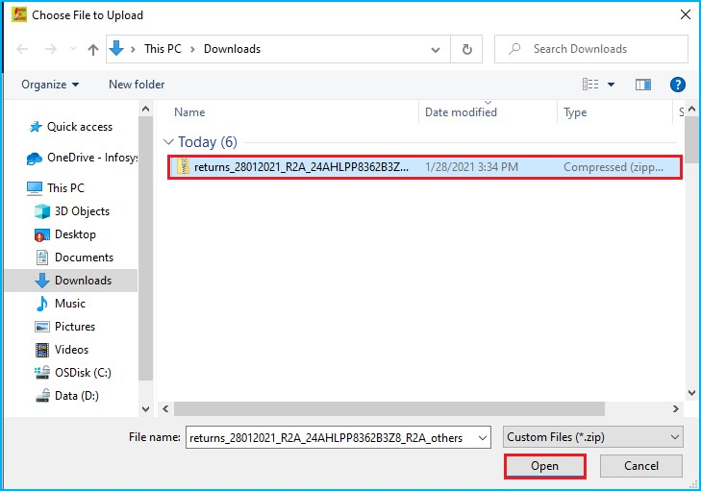

- Details of the file which have you have downloaded from the GST Portal is displayed. Click the PROCEED button.
Designed and Developed by GSTN Page 112 of 117
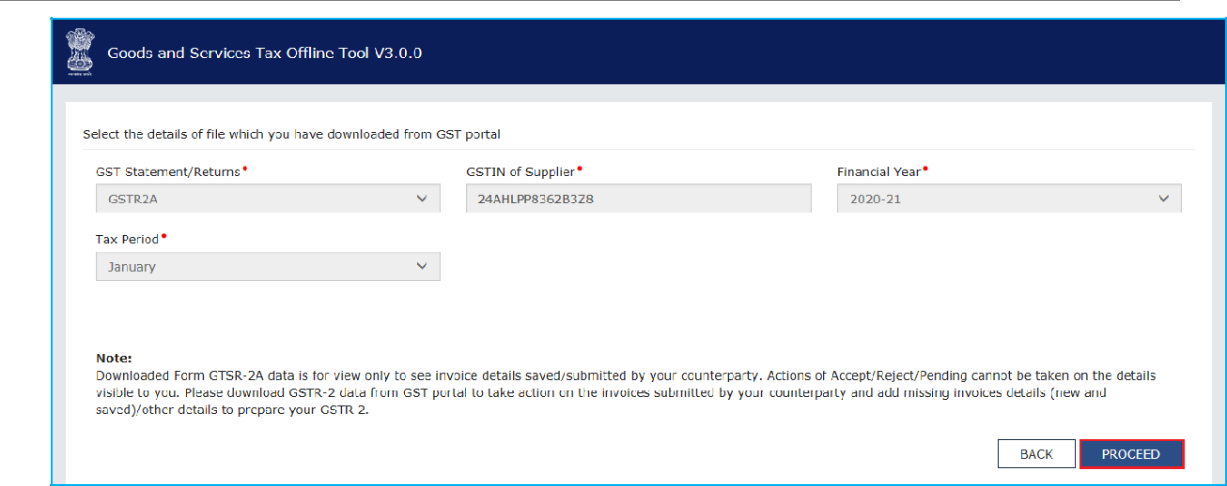

- The Summary page is displayed. Select the link for the desired Section Name to view further details.

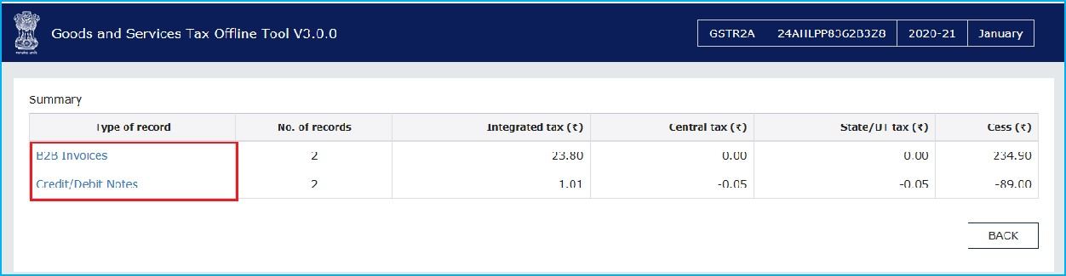

- The details for the section selected is displayed. To view the details or records at rate level,
click the ’+’ button and navigate to the rate level records.

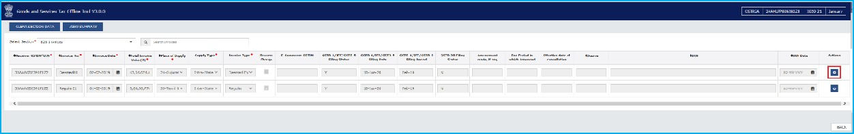

- The rate level details are displayed. Click the BACK button to go back to the previous page.
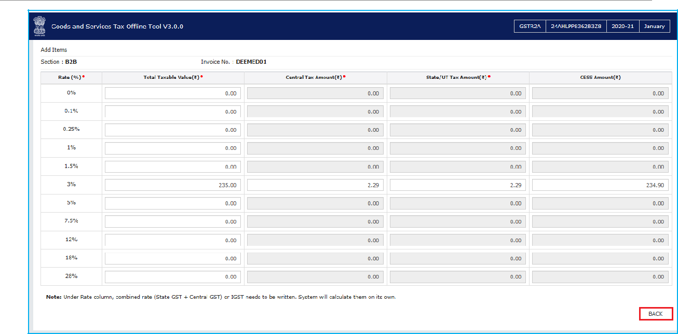

8. Similarly, you can view details for other sections as well.

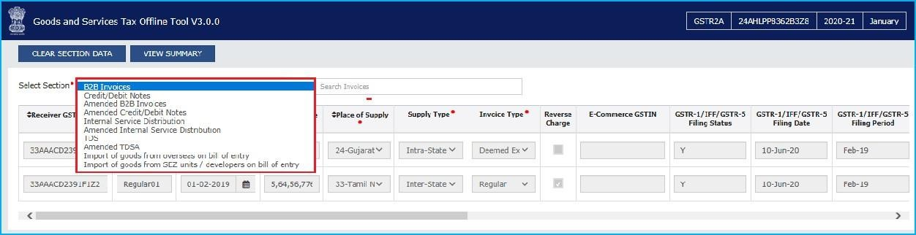

Click here to go back to Main Menu

J. Troubleshooting Common Errors Encountered

Offline tool validates the uploaded data while saving and displays errors if any based on the validations implemented in the Returns Offline tool. Some of the validations and error messages are explained and shown in the screenshots below.
- Please ensure you are entering the date in correct format. Expected formats are dd-mm- yyyy. If you are facing errors in selecting dates in given format, then you can refer the below word document to change the format of date.
- Invoice value must be greater than INR 2,50,000 in case of B2CL (interstate supply to Unregistered person}. In case invoice value is less than INR 2,50,000, then an error is displayed. you need to enter the amount more than INR 2,50,000 in cases of B2CL.

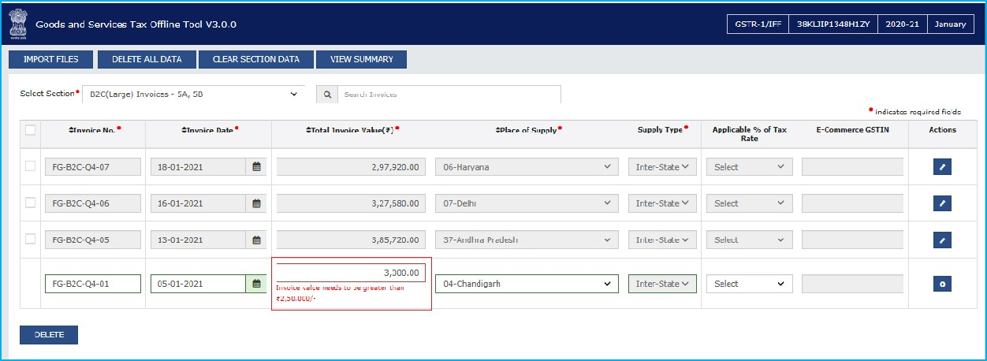

- Wrong input of GSTIN or Duplicate Invoice Number: Returns Offline tool may not be able to validate the GSTIN, whether the same is active or inactive on the day of data entry, but an error is displayed in case the same is not in the standard format (while entering it in offline tool).

Similarly, if an invoice is uploaded twice in the same tax period in the Tool, then the earlier details gets overwritten. However, if the same invoice is existing in the earlier tax period then the Tool may not be able to identify the duplication and error message will be populated only when the data is uploaded on the GST Portal.

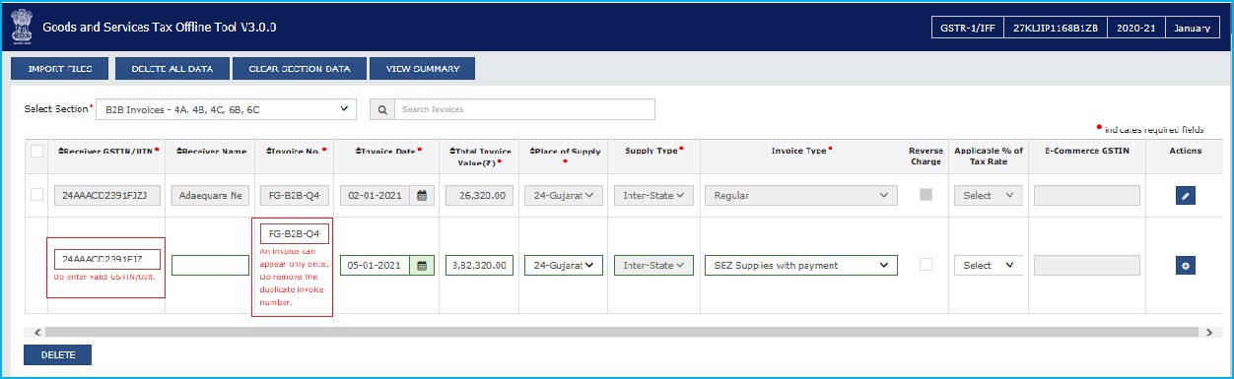

- If anything is entered other than numeric value in the HSN/SAC of Supply field, then the Tool displays an error.

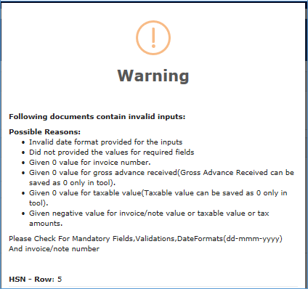

- If excel or csv files contain future dates or if the format of the data is not correct, then the Tool displays an error.

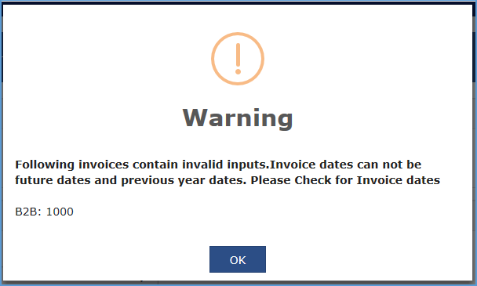
- Some other general mistakes which can be avoided by the users in filling the details resulting in errors are:
  - Date of invoice is after the date of Tax Period
  - Error like “Receiver GSTIN needs to be different from Supplier GSTIN.”, may arise if the taxpayer enters his/her GSTIN details in ‘Receiver GSTIN/UIN’ field in the Tool.
  - No Invoice exists against corresponding Credit/debit note in case of Supplies to
Registered Taxpayers or Interstate Large Customers
  - Selection of wrong section while importing csv or copy excel feature.
  - While entering multi rate in B2B, SEZ, DE (4A, 4B, 6A, 6C), B2C (Large), CDNR, CDNUR, exp sections using excel or csv, data for all columns must be entered in consecutive rows except rate, taxable value and cess.
  - For invoice type SEZ supplier with/without payment and Deemed Exp, E-Com GSTIN is not allowed.

Click here to go back to Main Menu
Designed and Developed by GSTN Page 117 of 117

